­­

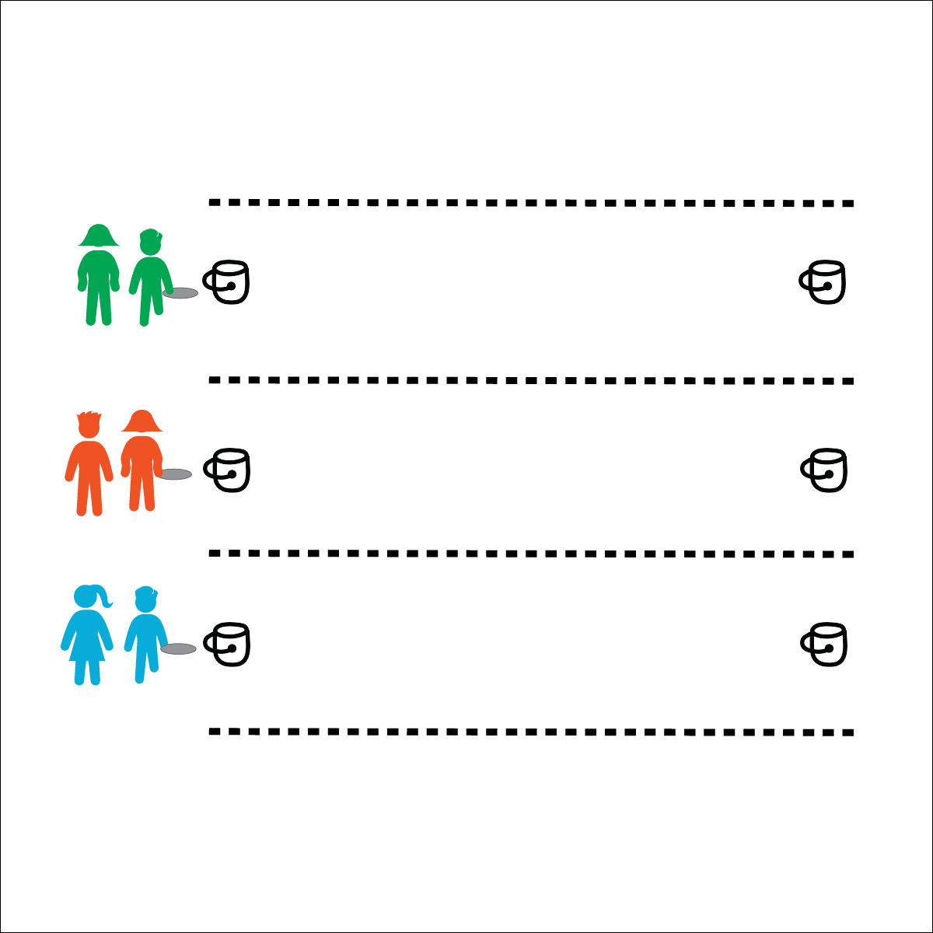



* **Working with Others** (K) Shares equipment and space with others. (1) Works independently with others in a variety of class environments. (2) Accepts responsibility for class protocols with personal and cooperative behavior as well as performance actions. (3) Works cooperatively with others. (4) Accepts “players” of all skill levels into the physical activity. (5) Accepts, recognizes, and actively involves others with both higher and lower skill abilities into physical activities and group projects. (6) Accepts differences among classmates in physical development, maturation, and varying skill levels by providing encouragement and positive feedback.

**Activity Procedures:**

1. This activity is the Pie Pan Race. The object for your team to move in a relay-race format to fill your starting bucket with water from your ending bucket.
2. When you hear the start signal, the first person on your team will move down to your ending bucket with the pan. Fill the pan with water and then quickly move back to your team’s starting bucket.
3. Dump the remaining water into the bucket and then hand the pan to the next racer on your team.
4. Each race will last for 60 seconds (or any time you designate). The team with the most water in their starting bucket wins the race.

**Modifications:**

* Students must move from bucket to bucket while holding the pan above their heads.
* Students form a cooperative line and must move the pan from one bucket to the next by handing it off from player to player.

**Equipment:**

* 1 aluminum pie or casserole pan per team
* 2 buckets per team
* Water
* Stopwatch (optional)

**Set-Up:**

1. Puncture 1 hole in each aluminum pan. The hole should be just large enough for a steady stream of water to leak from the bottom.
2. Use buckets to create a start and end lines for each team. Fill each ending bucket with water.
3. Create teams of 3–4 students, 1 team behind each starting bucket.

**PIE PAN RACE**

* **Personal & Social Responsibility:** I will work safely with the Pie Pan Race equipment and with my teammates.
* Move Safely
* Work Quickly
* Have Fun