­­

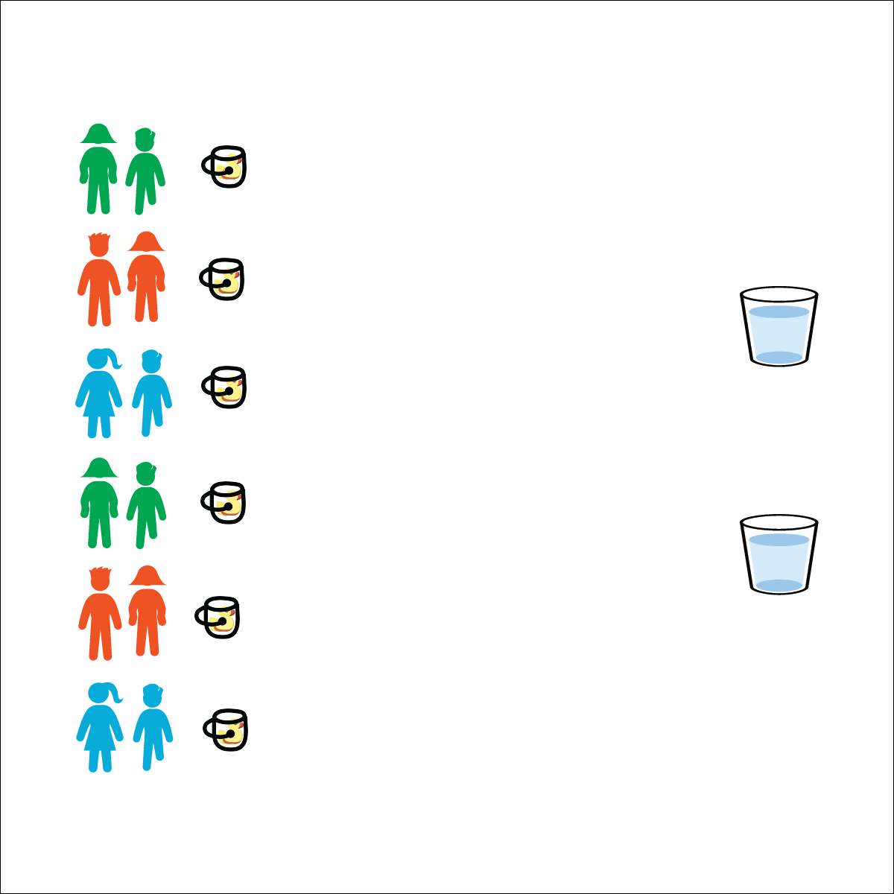

* Move Quickly and Safely
* Hand Off the Cups (Don’t Toss Them)
* Control the Water

**Equipment:**

* 6 buckets
* 6 large plastic cups
* 1 or 2 large containers filled with enough water to fill 6 buckets
* 6 rubber ducks

**Set-Up:**

1. Create starting lines using the buckets, with 1 rubber duck in the bottom of each bucket.
2. Place large containers of water a reasonable distance from the buckets.
3. Create teams of 2–4 players, each team at a bucket with a large plastic cup.

* **Personal & Social Responsibility:** I will recognize and adhere to the rules and etiquette of the Rubber Duck Relay.

**Activity Procedures:**

1. This activity is the Rubber Duck Relay. The object of the game is to be the first team whose rubber duck’s beak is lifted above the rim of your team’s bucket.
2. On the start signal, the 1st player in line will run to the water container, fill the cup, and then run back to pour the water in their team’s bucket.
3. As soon as the water is poured, pass the cup to the next player and repeat in relay-race format.
4. There will be 1 duck judge assigned to each team. As soon as the duck’s beak is clearly above the rim of the bucket, the judge will yell, “STOP!”

**Modification:**

* Poke a small hole in the bottom of each cup.
* Students must move from container to bucket with the full cup held above their heads.



* **Standard 4 [E5.3-5]** Recognizes the role of rules and etiquette in physical activity with peers (3); Exhibits etiquette and adherence to rules in a variety of physical activities (4); Critiques the etiquette involved in rules of various game activities (5).

**RUBBER DUCK RELAY**