­­

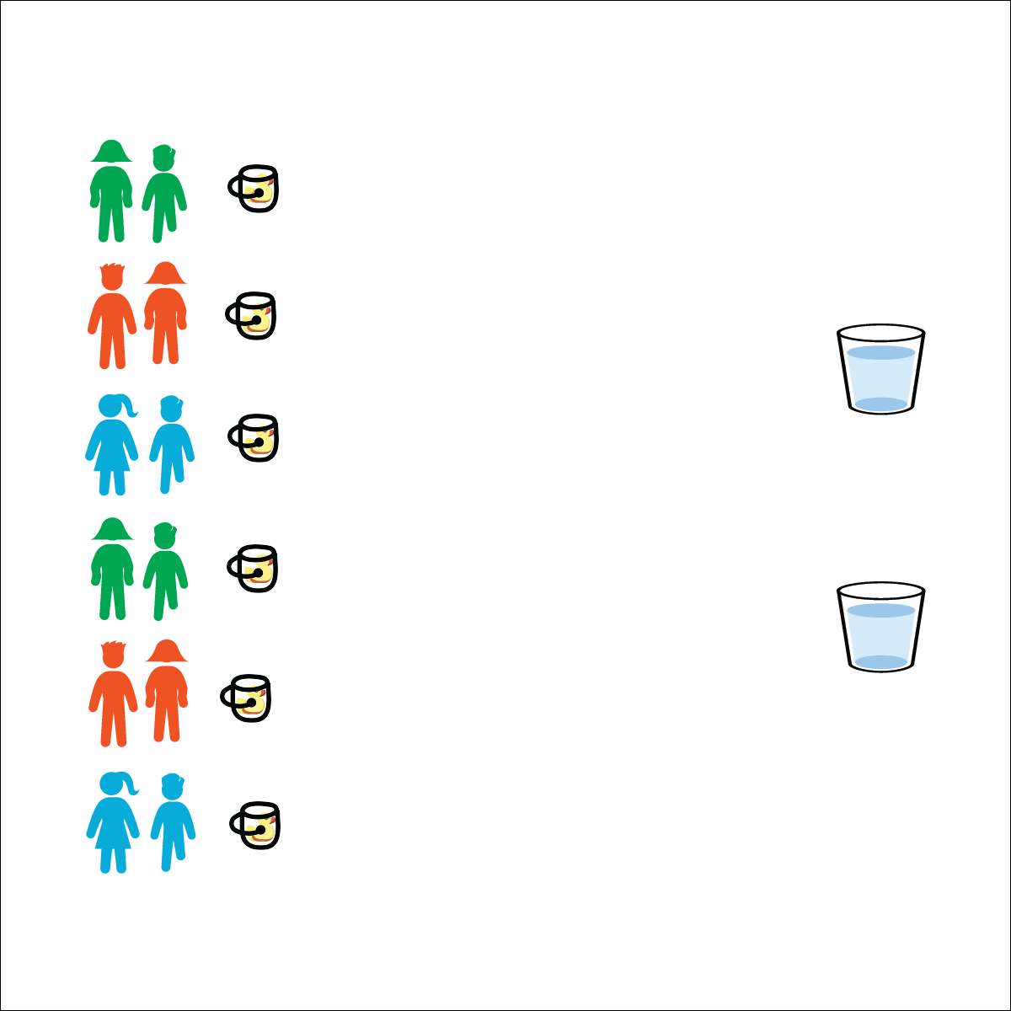



* **Working with Others** (K) Shares equipment and space with others. (1) Works independently with others in a variety of class environments. (2) Accepts responsibility for class protocols with personal and cooperative behavior as well as performance actions. (3) Works cooperatively with others. (4) Accepts “players” of all skill levels into the physical activity. (5) Accepts, recognizes, and actively involves others with both higher and lower skill abilities into physical activities and group projects. (6) Accepts differences among classmates in physical development, maturation, and varying skill levels by providing encouragement and positive feedback.

**Activity Procedures:**

1. This activity is the Rubber Duck Relay. The object of the game is to be the first team whose rubber duck’s beak is lifted above the rim of your team’s bucket.
2. On the start signal, the 1st player in line will run to the water container, fill the cup, and then run back to pour the water in their team’s bucket.
3. As soon as the water is poured, pass the cup to the next player and repeat in relay-race format.
4. There will be 1 duck judge assigned to each team. As soon as the duck’s beak is clearly above the rim of the bucket, the judge will yell, “STOP!”

**Modification:**

* Poke a small hole in the bottom of each cup.
* Students must move from container to bucket with the full cup held above their heads.

**Equipment:**

* 6 buckets
* 6 large plastic cups
* 1 or 2 large containers filled with enough water to fill 6 buckets
* 6 rubber ducks

**Set-Up:**

1. Create starting lines using the buckets, with 1 rubber duck in the bottom of each bucket.
2. Place large containers of water a reasonable distance from the buckets.
3. Create teams of 2–4 players, each team at a bucket with a large plastic cup.

* Move Quickly and Safely
* Hand Off the Cups (Don’t Toss Them)
* Control the Water
* **Personal & Social Responsibility:** I will recognize and adhere to the rules and etiquette of the Rubber Duck Relay.

**RUBBER DUCK RELAY**