­­

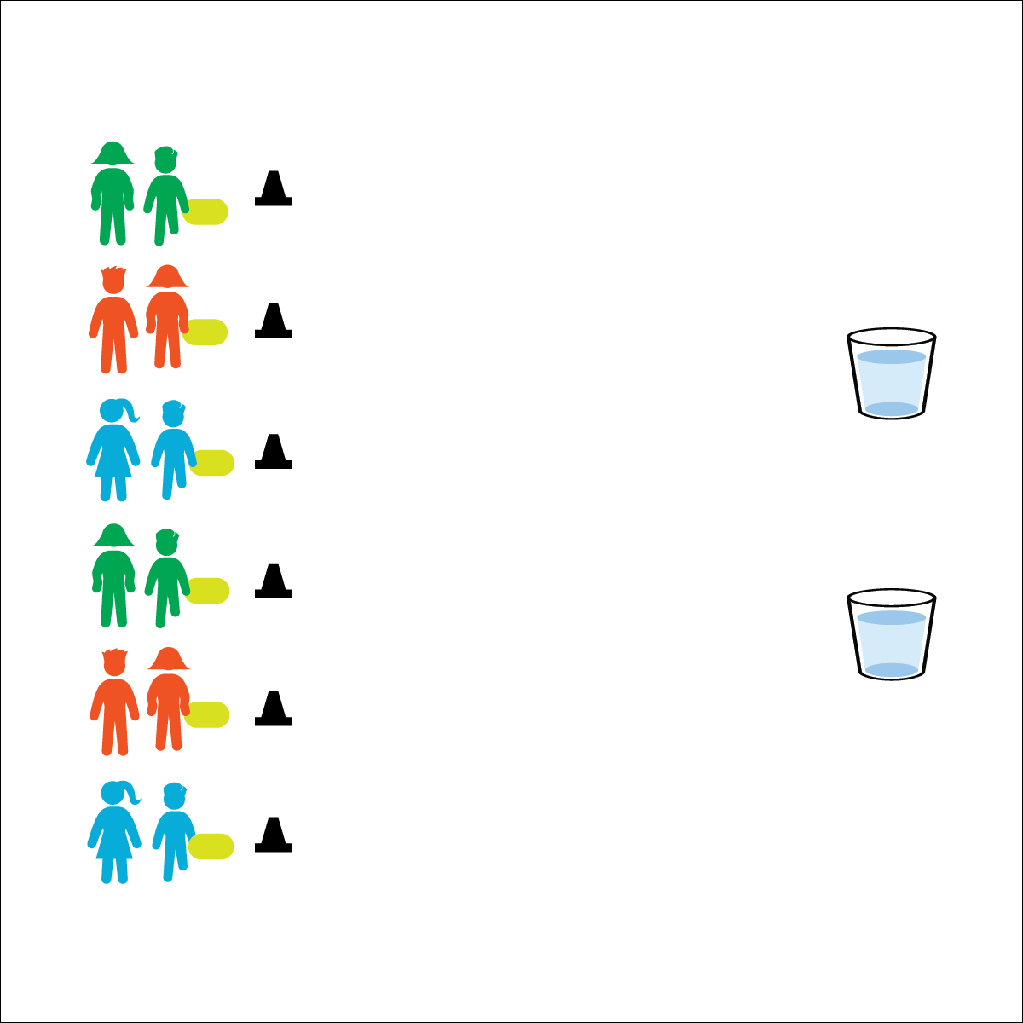

**PARTNER SPONGE CHALLENGE**

**Equipment:**

* 1 extra-large sponge per pair of students
* 1 cone per pair of students
* 1–3 large containers filled with plenty of water
* Students in swimsuits
* Stopwatch

**Set-Up:**

1. Create starting lines using the cones.
2. Play on a safe surface that does not get slippery when wet.
3. Place large containers of water a reasonable distance from the cones.
4. Pair students, each pair at a cone with a sponge.

* Fill the Sponge
* Move Safely
* Squeeze the Sponge
* **Personal & Social Responsibility:** I will work safely with my partner and my classmates.

**Activity Procedures:**

1. This activity is the Partner Sponge Challenge. You’ll have 90 seconds to soak your partner using the large sponge.
2. On the start signal, partner 1 will run with the sponge to the water and then back to your cone. When partner 1 returns, she/he will hold the sponge above partner 2’s head and squeeze the water out of the sponge. As soon as the sponge is (relatively) empty, partner 2 will take it to the water, fill it, and return to squeeze the water on top of the partner 1’s head.
3. On the stop signal, teacher judges will determine which pair is the most wet.

**Modification:**

* Use small drink cups instead of sponges.
* Assign 1 teacher per team. The object is to get your team’s teacher as wet as possible.



* **Standard 4 [E6.3-5]** Works independently and safely in physical activity settings (3); Works safely with peers and equipment in physical activity settings (4); Applies safety principles with age-appropriate physical activities (5).