­­

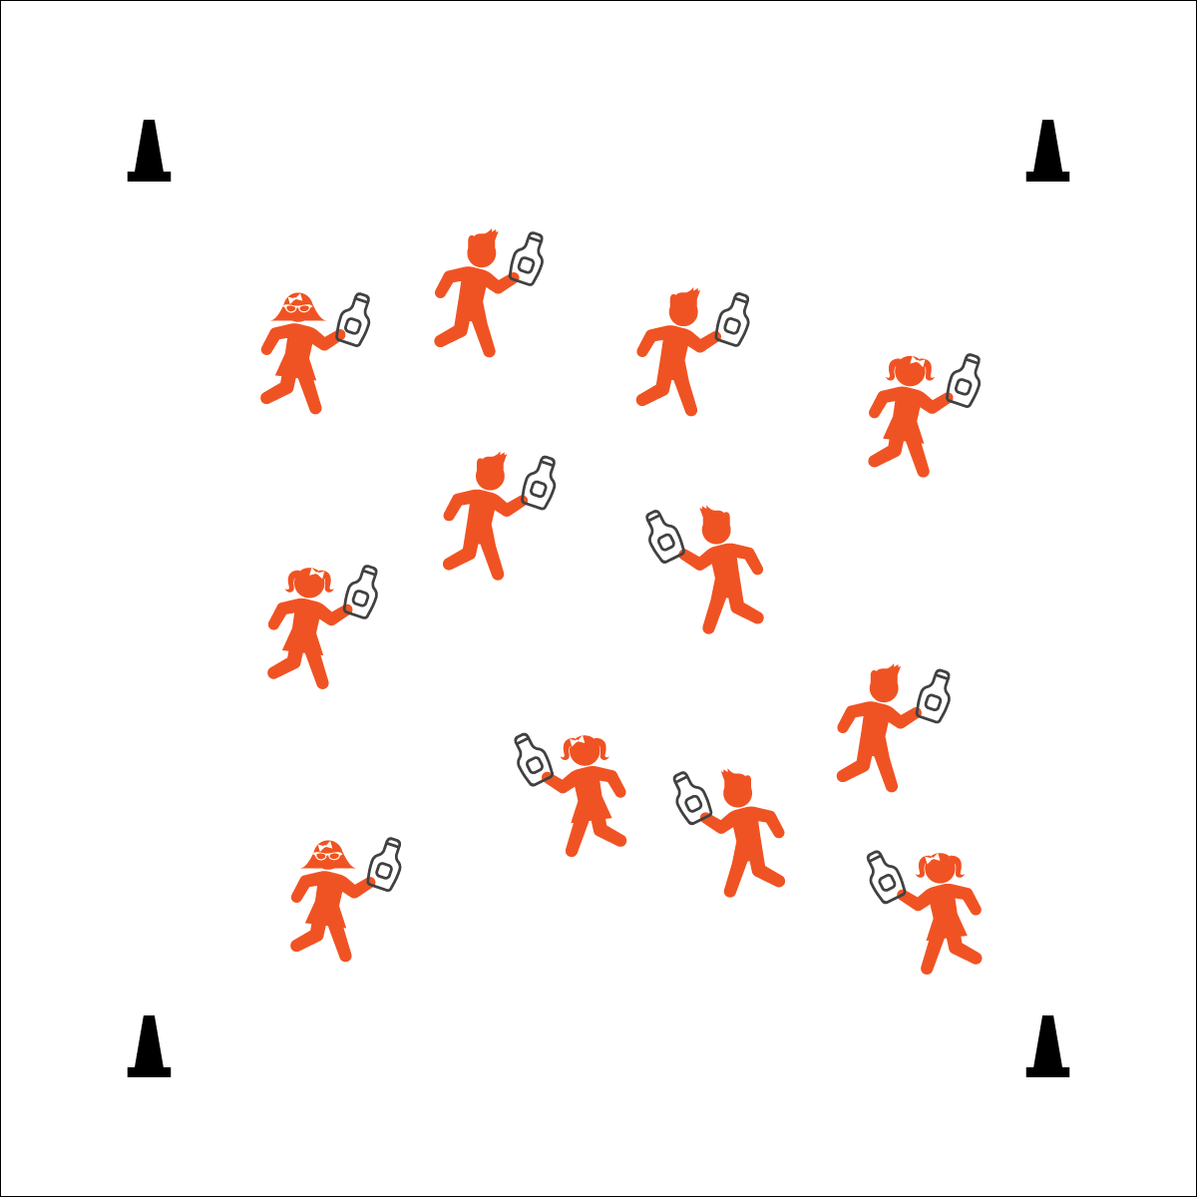

**KETCHUP BOTTLE TAG**

* Speed Walk Only
* Squirt Below the Neck
* Refill and Go

**Equipment:**

* 1 clean ketchup bottle (or another clean squeeze bottle) per student
* Students in swimsuits
* 4 cones to create boundaries

**Set-Up:**

1. Create a large activity area using cones.
2. Play on a safe surface that does not get slippery when wet.
3. Scatter students in the activity area, each student with a clean ketchup bottle full of water.
4. Provide a “refill station” with several teachers refilling bottles.

* **Personal & Social Responsibility:** I will work safely with my classmates by tagging only below the neck.

**Activity Procedures:**

1. This activity is Ketchup Bottle Tag. The object of the game is to tag other players by squirting them with your ketchup bottle.
2. On the start signal, begin at a speed-walking pace.
3. When your ketchup bottle is empty, move to a refill station and hold plank position as long as you can while your teacher refills your bottle.

**Modification:**

* Use any type of clean squirt bottles.
* Designate several teachers as Ketchup Bottle Targets. Students only tag teachers.



* **Etiquette**(K) Recognizes the established protocol for class activities. (1) Exhibits the established protocols for class activities without reminders. (2) Recognizes the role of rules and etiquette in teacher-designed physical activities. (3) Recognizes the role of rules and etiquette in physical activity with peers. (4) Exhibits etiquette and adherence to rules in a variety of physical activities. (5) Critiques the etiquette involved in rules of various game activities. (6) Identifies the rules and etiquette for physical activities/games and dance activities.