LACROSSE: CLEAN YOUR YARD

STUDENT TARGETS
- Skill: I will cooperate with my teammates to collect as many items as possible.
- Cognitive: I will discuss the importance of cooperation.
- Fitness: I will stay actively engaged during all activities.
- Personal & Social Responsibility: I will work safely with my peers and the equipment.

EQUIPMENT & SET-UP | 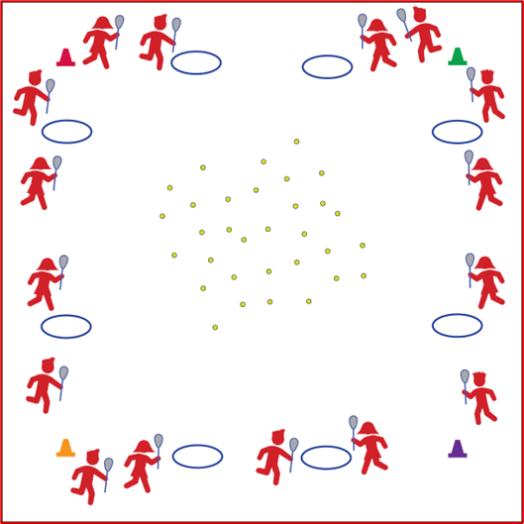
Equipment:
- 1 lacrosse stick per 2 students
- 2–4 balls and bean bags per student
- 1 hula hoop per 2 students
- 4 cones
Set-Up:
- Create a large activity area using cones to represent the boundaries of the “yard.”
- Scatter balls and bean bags around the yard.
- Space hula hoops around the perimeter of the yard.
- Pair students, each pair with a lacrosse stick, and assign each pair to a hoop.

ACTIVITY PROCEDURES
- It is time to visit Canada! Lacrosse has its origins in a tribal game played by Eastern Woodlands Native Americans and by some Plains Indian tribes in what is now Canada and the Northeast United States.
- Today’s lacrosse activity is called Clean Up Your Yard.
- The objective of this activity is to work with your partner to collect the most balls and bean bags.
- On the start signal, the first person from each team will jog into the yard and use the lacrosse stick to scoop up one ball or bean bag and return it to their hoop using cradling skills.
- Once the ball is inside the hoop, safely pass the lacrosse stick to your partner and they will jog to scoop up another ball and return it to the hoop.
- This will continue until all the balls and bean bags have been collected and the yard is clean. The team who collects the most items is the winner!

TEACHING CUES
- CUE 1: Keep lacrosse stick low and parallel to ground.
- CUE 2: Scoop low, quick, and through.
- CUE 3: Bring up to cradle.

PRIORITY OUTCOMES
- (K-2) Discusses the enjoyment of playing with family and friends.
- (3-5) Describes the positive social interactions that come when engaged with others in physical activity.

DEBRIEF QUESTIONS
- DOK 1: What does cooperation mean?
- DOK 2: What are some benefits of cooperation?
- DOK 3: How is cooperation related to the success of a team?

