BASKETBALL: DRIBBLE STOPPERS

STUDENT TARGETS
- Skill: I will demonstrate the critical cues for dribbling while avoiding defenders.
- Cognitive: I will discuss the importance of safety.
- Fitness: I will stay actively engaged during all activities.
- Personal & Social Responsibility: I will personally exhibit and be able to discuss the importance of responsible behaviors.

EQUIPMENT & SET-UP | 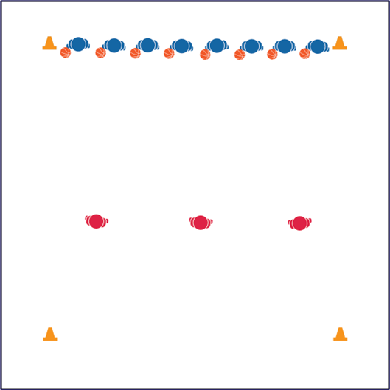
Equipment:
- 1 basketball per student
- 4 cones

Set-Up:
- Create a large activity area using cones to represent the boundaries.
- Students with a ball line up on 1 end of the activity area in between 2 cones.
- Designate 2–4 players as defenders that begin in the center of the activity area.

ACTIVITY PROCEDURES
- It is time to visit the United States! Basketball is the only major sport that originated strictly in the United States. It was invented by James Naismith in 1891 at what is now known as Springfield College.
- Today’s basketball activity is called Dribble Stoppers.
- The object of the activity is to dribble through open space while protecting your basketball from defenders. When the music starts, students will start dribbling across the activity area to the other side while avoiding the defenders. Defenders must maintain defensive ready position using side-slides and drop-steps to move throughout the activity area.
- If your ball is tagged by a defender (any touch on the ball) or it goes out of bounds, retrieve your ball, place it on the ball rack, and re-enter the game as a defender.
- When all untagged players are safe on the other side of the activity area, we’ll repeat in the opposite direction. The last remaining student with a ball is the winner!

TEACHING CUES
- CUE 1: Protect the ball while dribbling.
- CUE 2: Use a defensive ready position when working as a defender.

PRIORITY OUTCOMES
- (K-2) Discusses the reasons for participating in physical activity with friends.
- (3-5) Describes the social benefits gained from participating in physical activity.

DEBRIEF QUESTIONS
- DOK 1: What is social responsibility? What is personal responsibility?
- DOK 2: How is personal responsibility similar to social responsibility? How is it different?
- DOK 3: How is responsibility related to the success of a team?

