VOLLEYBALL: VOLLEY BATTLESHIP

STUDENT TARGETS
- Skill: I will accurately underhand serve the ball into a designated space.
- Cognitive: I will discuss the challenge that comes from learning new physical activities.
- Fitness: I will stay actively engaged throughout this activity.
- Personal & Social Responsibility: I will use good sportsmanship by shaking hands or giving a high five to the other team after each game.

EQUIPMENT & SET-UP | 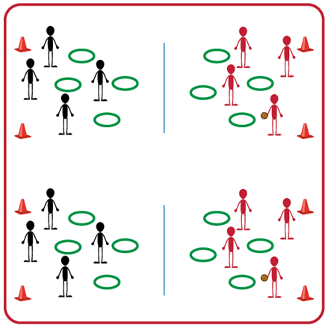
Equipment:
- Jump Rope or net for each set of 2 teams
- 1 Hoop per student
- 4 boundary cones for each set of 2 teams
- 1 foam ball for each set of 2 teams
Set-Up:
- Divide students into equal teams (e.g., 5v5 or 4v4).
- Two equal teams will play against one another. Divide the space for each set of two teams into equal areas with the jump rope or net in the middle and 4 cones to set the boundaries.
- Each student will begin with a hula hoop. Teams face each other on opposite sides of the jump rope in their activity space.

ACTIVITY PROCEDURES
- It is time to visit Japan! Indoor volleyball was granted Olympic status in 1957 by the International Olympic Committee (IOC), and volleyball made its Olympic debut at the 1964 Games in Tokyo.
- Today’s volleyball activity is called Volley Battleship. The object of the game is to eliminate your opponents' hula hoops first by serving the foam ball into one of the other team’s hoops.
- On the start signal, each student will choose a spot within the boundary cones to place their hula hoop on the ground (on their side of the activity space). Teams will take turns trying to serve the ball into one of their opponents’ hoops. If a serve lands in one of your team's hoops you will remove that hoop from your side.
- The game ends when one team loses all of their hoops or if you hear the stop signal.
- If you are still playing when you hear the stop signal, each team will count any remaining hoops on their side. The team with the most hoops left will be the winner!

TEACHING CUES
- CUE 1: Hold ball in non-dominant hand and have non-dominant foot in front to serve.
- CUE 2: Pull arm back and swing to strike low with palm.

PRIORITY OUTCOMES
- (K-2) Describes positive feelings that result from physical activity participation.
- (3-5) Discusses the challenge that comes from learning new physical activities.

DEBRIEF QUESTIONS
- DOK 1: Did you find it challenging to serve the ball into the hoop targets?
- DOK 2: How did the amount of force you used impact whether your serve landed in the hoop or not?
- DOK 3: If your serve hit the ground in front of the hoop you were aiming at, what could you do differently on your next attempt?

