GYMNASTICS: BALANCE TAG

STUDENT TARGETS
- Skill: I will keep my body still while balancing on different body parts.
- Cognitive: I will discuss the challenge that comes from learning new physical activities.
- Fitness: I will stay actively engaged throughout this activity.
- Personal & Social Responsibility: I will demonstrate respect for my classmates by showing good sportsmanship if tagged.

EQUIPMENT & SET-UP | 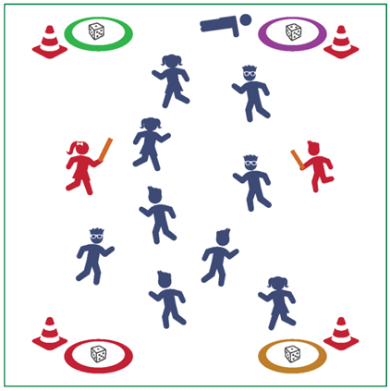
Equipment:
- Cones for boundaries
- 4 hoops
- 4 dice
- 2-3 foam noodles for taggers

Set-Up:
- Place cones around the perimeter of the tag area and place a hoop with a die inside on each of the four corners.
- Identify 2-3 taggers and have them begin with a foam noodle outside of the cones.
- All other students spread out inside the coned area.
ACTIVITY PROCEDURES
- It is time to visit Germany! Educator Johann Guts-Muths was the founder of a system of gymnastics that was introduced into schools in Germany in the 19th century. Mr. Guts-Muths wrote several books and manuals outlining his system of gymnastics and exercise focused on youth.
- Today’s gymnastics activity is called Balance Tag. This is a tag game that will also help us practice the skill of balancing, which is very important in the sport of gymnastics.
- On the start signal, everyone inside the boundary cones will begin walking or jogging. The taggers will complete 5 jumping jacks outside of the cones before they begin.
- If you are tagged, you will go to one of the 4 hoops at the corners and roll the die. The number you roll is how many body parts you will balance on for 5-10 seconds. After completing the balance, you will return to the game.
- We will switch out the taggers every few minutes and identify a new locomotor skill each time we choose new taggers.

TEACHING CUES
- CUE 1: Tight muscles will help maintain control when balancing.
- CUE 2: Move safely and be aware of your surroundings when inside the boundary cones.

PRIORITY OUTCOMES
- (K-2) Describes positive feelings that result from physical activity participation.
- (3-5) Discusses the challenge that comes from learning new physical activities.

DEBRIEF QUESTIONS
- DOK 1: What strategies did you use to stay safe while moving during the tag game?
- DOK 2: It can sometimes be challenging to hold still when trying to balance. What were some things that you thought were challenging, and how did you overcome those challenges to complete the balance?

