SOFTBALL: RACE BASE SOFTBALL

STUDENT TARGETS
- Skill: I will hit the softball into fair territory.
- Cognitive: I will discuss the benefits of teamwork and cooperation.
- Fitness: I will stay actively engaged throughout this activity.
- Personal & Social Responsibility: I will discuss the role of rules and etiquette in physical activities.

EQUIPMENT & SET-UP | 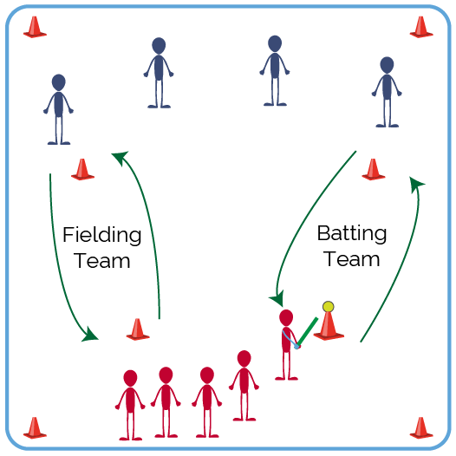
Equipment:
- 1 large cone or batting tee
- 2-3 types of balls (e.g., Wiffle, foam, etc.)
- 2-3 types of striking implements (e.g., bat, racket, etc.)
- Bases or low-profile cones

Set-Up:
- Divide students into 2 equal teams.
- In a large activity area, place 2 home plates 20 feet apart from one another.
- Align 1st and 3rd base with each other, placed 40 feet from each home plate.
- Teacher decides whether to use a cone/tee to bat or a pitched ball.
ACTIVITY PROCEDURES
- It is time to visit Ireland! Softball, baseball, and other modern bat, ball, and running games like cricket were developed from folk games in early Ireland, Britain, and Continental Europe.
- Today’s softball activity is called Race Base Softball. The object of this game is to score as many runs as you can by having all your teammates run around 1st base and back to home plate, before the fielding team gets the ball and has all their teammates run around 3rd base and the fielding home plate. We’ll play Rock, Paper, Scissors to see who the home team is. Visiting team bats first.
- Batting teams use their own pitchers (or a tee). Batter 1 hits the ball into fair territory. Then the batter leads the entire team in a straight line to first base and back to home plate. 1 point is scored for each team member who makes it across home plate before the opposing team can make an “out.”
- To make an out, the fielding team retrieves the ball and the player with the ball leads the team around 3rd base to the fielding home plate. Once all the fielding team players make it past home, it’s an out.
- Caught fly balls are not automatic outs; both teams must run no matter what.
- The team with the most points at the end of the game are the winners!

TEACHING CUES
- CUE 1: Spread out when in the field to cover all of the open space.
- CUE 2: Stay alert when running the bases in order to keep a safe distance between runners.

PRIORITY OUTCOMES
- (K-2) Recognizes the role of rules and etiquette in teacher-designed physical activities.
- (3-5) Discusses the role of rules and etiquette in physical activities with peers.

DEBRIEF QUESTIONS
- DOK 1: How can you recognize proper etiquette during group activities or games?
- DOK 2: How does etiquette affect the physical activity experience for participants?

