HANDBALL: SWITCH

STUDENT TARGETS
- Skill: I will demonstrate throwing and catching cues to pass and shoot accurately.
- Cognitive: I will identify and discuss ways cooperation leads to team success.
- Fitness: I will remain actively engaged throughout the activity.
- Personal & Social Responsibility: I will communicate with teammates using positive and encouraging language.

EQUIPMENT & SET-UP | 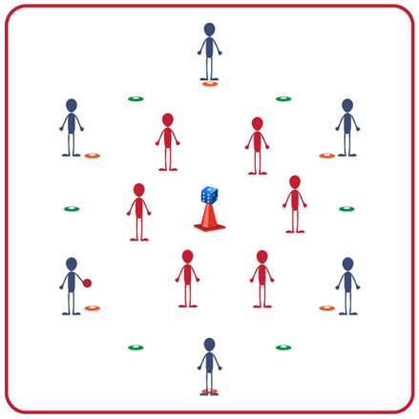
Equipment:
- 1 target per 12 students (cone with a ball or die on top)
- 1 foam ball per 12 students
- 8-12 spot markers per 12 students
Set-Up:
- Create 1 activity area per 12 students with a target in the center of each area.
- Use spot markers to create a shooting circle 6-8 feet from target. This delineates the offensive area (outside of the spots) and the defensive area (inside the spots).
- Create teams of 6 students. One team begins inside the spots on defense and one team begins outside the spots on offense.

ACTIVITY PROCEDURES
- It is time to visit Denmark! Indoor handball was invented in the 1940’s in Denmark and made its Olympic debut at the 1972 Games.
- Today’s handball activity is called Switch. The object of the game is for the offense to score points by knocking the die (or ball) off the cone. When the die is knocked off the cone, your team gets the number of points that are facing up on the die. Three passes must be made before a shot is taken.
- When a point is scored or an interception is made (defense gains possession), players yell “SWITCH!” On this signal, teams switch positions; offense becomes defense and defense becomes offense. Play doesn’t stop while players rotate in/out so you will need to move quickly and be ready!
- Defensive teams must stay inside the spot markers but may move throughout the defensive area. Offense must stay outside spot markers but may move throughout the offensive area.
- The team with the most points at the end of the game are the winners!

TEACHING CUES
- CUE 1: Move quickly when switching between offense and defense to get into position.
- CUE 2: Use verbal and non-verbal communication to help your team work together successfully.

PRIORITY OUTCOMES
- (K-2) Works cooperatively with others.
- (3-5) Engages in physical activity with responsible interpersonal behavior (e.g., peer to peer, student to teacher).

DEBRIEF QUESTIONS
- DOK 1: What does cooperation mean?
- DOK 2: How does cooperation lead to the success of a team during physical activities?

