TRACK AND FIELD: JAVELIN RELAY

STUDENT TARGETS
- Skill: I will cooperate with my teammates to complete the relay and build the hoop tower.
- Cognitive: I will identify and discuss ways cooperation leads to team success.
- Fitness: I will remain actively engaged throughout the activity.
- Personal & Social Responsibility: I will communicate with teammates using positive and encouraging language.

EQUIPMENT & SET-UP | 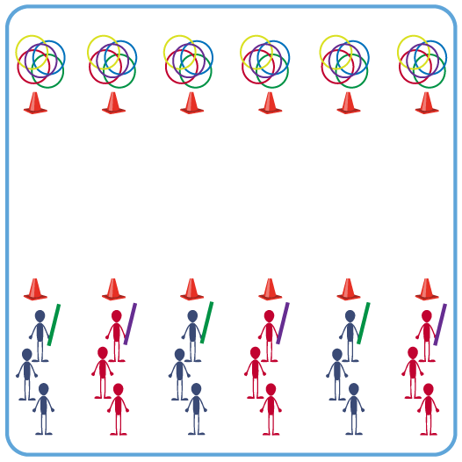
Equipment:
- 12 cones to create start/finish for relay lines
- 36 hula hoops (6 for each relay line)
- 6 pool noodles (1 for each relay line)

Set-Up:
- Space 6 cones in a line on each side of the activity area (across from each other). The cones on the opposite side from the starting line should also have 6 hoops each.
- Create 6 groups of students, 1 group at each cone. Each group lines up in a straight line behind their cone. First person in each line begins with a pool noodle.
ACTIVITY PROCEDURES
- It is time to visit Greece! Track and Field is the oldest form of organized sport and was a part of the very first Olympic Games that occurred in Greece.
- Today’s track and field activity is called the Javelin Relay. The object of the game is for each team to get all 6 hoops across the activity area and then create a Hoop Tower.
- On the start signal, the first teammate in line throws the javelin (pool noodle) as far as they can towards the ending cone across from where you began. After throwing the javelin, they run to the back of the line so there is a new leader. The new leader moves the team’s line to where the javelin landed, picks it up and throws it again helping it get closer to the ending cone with each throw. This continues until the javelin is all the way across the space past the ending cone.
- The team picks up one of their hoops and brings it back with them to the starting cone. Continue this process with a new teammate as the leader. Repeat until all 6 hoops have been collected.
- Finally, teams work cooperatively to build a hoop tower by their starting cone using the 6 hoops. First team to complete their hoop tower wins!

TEACHING CUES
- CUE 1: Move quickly when changing leaders so you can throw the javelin again as soon as possible.
- CUE 2: Use positive and encouraging communication to help your team work together successfully.

PRIORITY OUTCOMES
- (K-2) Works cooperatively with others.
- (3-5) Engages in physical activity with responsible interpersonal behavior (e.g., peer to peer, student to teacher).

DEBRIEF QUESTIONS
- DOK 1: What does cooperation mean?
- DOK 2: How does the way you cooperate with teammates help with your team’s success?

