FOOTBALL: FOOTBALL FREEZE TAG

STUDENT TARGETS
- Skill: I will perform a variety of locomotor skills safely.
- Cognitive: I will discuss ways that following directions keeps us safe.
- Fitness: I will remain actively engaged throughout the activity.
- Personal & Social Responsibility: I will communicate with teammates using positive and encouraging language.

EQUIPMENT & SET-UP | 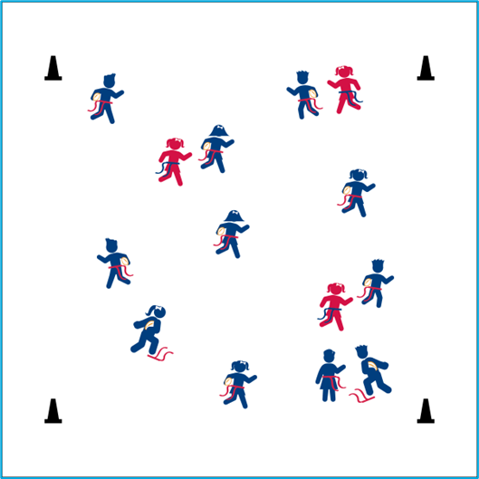
Equipment:
- I flag belt (or 2 scarves) per student
- 1 foam football per student
- 4 cones as boundaries

Set-Up:
- Use 4 cones to create a large activity area.
- Scatter students in open space, each student wearing a flag belt (or substitute 2 scarves for belts) and carrying a football.
- Designate 2–4 players as defensive taggers. Taggers do not carry footballs.
ACTIVITY PROCEDURES
- It is time to visit the United Kingdom! The sport we know and love as football is more properly called gridiron football, for the vertical yard lines that mark the field. Closely related to two ancient English sports, rugby and soccer, gridiron football originated at universities in North America in the late 19th century.
- Today’s football activity is called Football Freeze Tag. The object of the game is to avoid having your flag belt pulled by a defender. You can identify the defenders because they will be the ones who are not carrying a football. We will move using a variety of different locomotor movements.
- If your flag is pulled, freeze with your flag at your feet and make a Heisman-Trophy pose (teacher should demonstrate). You become unfrozen when another player comes over, hands you your belt and says, “Amazing season, kid!” Then put your belt back on and get back in the game. Defenders cannot tag someone while they are helping a classmate become unfrozen.
- The Heisman Trophy is awarded to the best player in college football who demonstrates a season of outstanding play along with a high level of integrity. Let’s all work hard to pursue excellence with integrity!

TEACHING CUES
- CUE 1: Carry your football in your elbow, hugging it to your chest.
- CUE 2: Be aware of your surroundings to ensure we all stay safe while moving.

PRIORITY OUTCOMES
- (K-2) Follows directions for safe participation and proper use of equipment without reminders.
- (3-5) Exhibits responsible behaviors in physical activity settings.

DEBRIEF QUESTIONS
- DOK 1: Why is it important to follow directions?
- DOK 2: How is following directions during Football Freeze Tag related to keeping us safe?

