TORCH RACE TIC-TAC-TOE

STUDENT TARGETS
- Skill: I will move safely from the starting cone to the game grid.
- Cognitive: I will discuss how physical activity can assist with stress management.
- Fitness: I will remain actively engaged throughout the activity.
- Personal & Social Responsibility: I will communicate with teammates using positive and encouraging language.

EQUIPMENT & SET-UP | 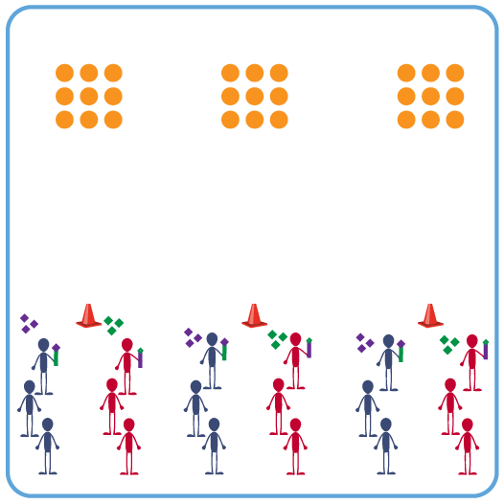
Equipment:
- 9 spot markers per 2 teams of students
- 4 bean bags of a matching color per team
- 1 starting cone per 2 teams
- 1 cut foam noodle per team (to act as the torch)
Set-Up:
- Place 1 set of 9 spot markers in a 3X3 grid on one end of the activity area.
- Place 1 cone 10-15 yards from the spots as a starting line.
- Organize 2 teams of 3-4 students at each cone. Each team has a set of 4 bean bags of a matching color, that is different from their opponent.
- Each team begins with a cut foam noodle to act as their torch.
ACTIVITY PROCEDURES
- It is time to light the Olympic Torch! The Olympic flame first became a tradition of the modem Olympic Games when a flame was lit and remained burning at the entrance to the Olympic Stadium throughout the 1928 Amsterdam Games. The lighting of the flame captured the public's imagination and has remained a traditional event for the Opening Ceremony of the Games.
- This activity is called Torch Race Tic-Tac-Toe. The object of the game is for your team to use your bean bags to create tic-tac-toe and win the game.
- On the start signal, the first player on each team will balance a bean bag on their torch (foam noodle) and sprint to the game grid and place their bean bag on a spot marker. As soon as the first player returns and hands the torch to the next person in line, the second player places a bean bag on the torch and runs down to place it strategically on the game grid. Both teams continue in this way until all 8 bean bags are placed on the game grid.
- After all bean bags are in play, players can sprint to the game grid and strategically move 1 bean bag at a time until a team wins, or until you hear the stop signal. But don’t forget to carry your torch with you each time you move to the game grid!
TEACHING CUES
- CUE 1: You must have the torch (foam noodle) to move to the game grid for your team.
- CUE 2: Be strategic with where you place your bean bags, you may need to play defense vs offense!

PRIORITY OUTCOMES
- (K-2) Follows directions for safe participation and proper use of equipment without reminders.
- (3-5) Exhibits responsible behaviors in physical activity settings.

DEBRIEF QUESTIONS
- DOK 1: What are some things you like to do when you feel anxious or stressed?
- DOK 2: How can physical activity help when someone is feeling anxious or stressed?

