OLYMPIC RINGS RELAY

STUDENT TARGETS
- Skill: I will throw a disc with proper form.
- Cognitive: I will discuss how to work cooperatively with my teammates when rotating between roles.
- Fitness: I will remain actively engaged throughout the activity.
- Personal & Social Responsibility: I will accept responsibility for my behaviors and actions.

EQUIPMENT & SET-UP | 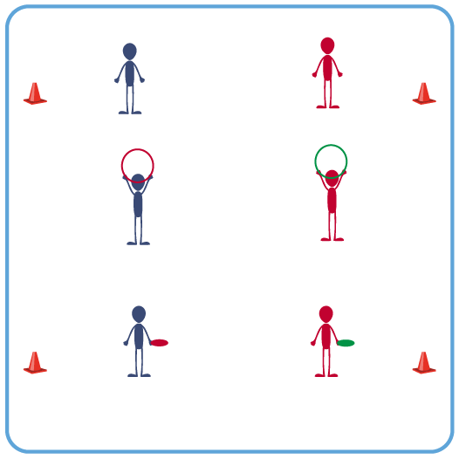
Equipment:
- 1 foam disc per team of 3 students
- 1 hula hoop per team of 3 students
- 2 cones for the starting line

Set-Up:
- Group students into teams of 3.
- Provide each team with 1 hula hoop and 1 flying disc.
- Number students as player 1, 2, and 3.
1 starts as thrower; 2 as holder; 3 as catcher. If there are any groups of 4, you can have 2 students hold the hoop as player 2.
- Create a start line using 2 cones. All groups begin on the start line.
ACTIVITY PROCEDURES
- The Olympic Rings represent the union of the 5 continents and the meeting of athletes from throughout the world at the Olympic Games. The 5 colors of the rings (blue, yellow, black, green, red) represent the colors of the flags from the original participating countries from the 5 continents.
- This activity is called Olympic Rings Relay. The object is for your team to score points by throwing the disc through the Olympic Ring (hoop) and catch it before it hits the ground.
- All 3 players begin on the start line. Player 1 has the disc, player 2 has the ring, and player 3 is ready to catch the disc. On the start signal, player 2 will hold the ring up as a target.
- Player 1 will stay at the start line and attempt to throw the disc through the ring while player 3 tries to move and catch the disc before it hits the ground.
- Score 2 points if the disc goes through the ring and is caught by player 3. Score 1 point if the disc does not go through the ring but is still caught by player 3, or if the throw goes through the ring but is not caught.
- Rotate after each throw: Thrower to holder; holder to catcher; catcher runs to the start line and becomes the thrower.

TEACHING CUES
- CUE 1: The holder can move the hoop and/or their feet to help get the disc to go through the hoop.
- CUE 2: Throwing shoulder toward the target, step with same foot, and snap wrist as you throw.

PRIORITY OUTCOMES
- (K-2) Accepts responsibility for class protocols with personal and cooperative behavior as well as performance actions.
- (3-5) Works cooperatively with others.

DEBRIEF QUESTIONS
- DOK 1: How would you describe a good teammate?
- DOK 2: What is something that you did today to be a good teammate?

