­­

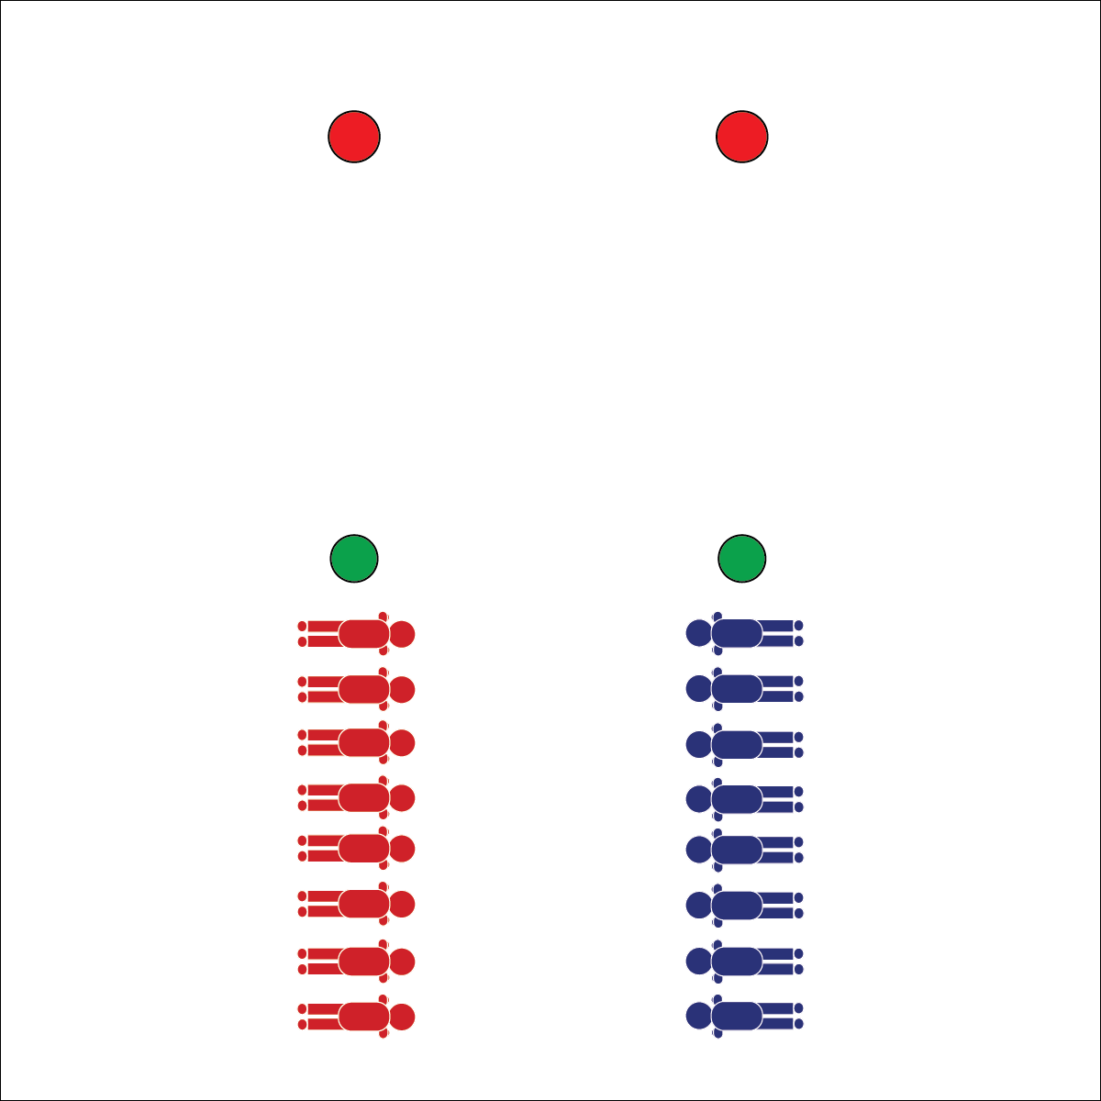

**PLANK RACES**

* **Skill:** I will perform plank position with perfect technique.
* **Cognitive:** I will identify the energy systems used in muscular strength and endurance activities.
* **Fitness:** I will maintain exercise form and adjust my level of appropriate challenge based on fatigue.
* **Personal & Social Responsibility:** I will participate  
  safely with attention to exercise form and injury   
  prevention.
* Focus on Form
* Give Your Best Effort
* Compete with Respect, Kindness, and Fun

**Equipment:**

* 4 cones to create start and finish lines

**Set-Up:**

1. Create 2 parallel lines as start and finish lines. Increase or decrease the distance based on class size and fitness level.
2. Divide the class into 2 teams. Each team in a line behind the starting line.

**Activity Procedures:**

1. It’s time for Plank Races. On the ready signal, all students will drop into plank position, shoulder to shoulder in a single-file line at the starting line.
2. On the go signal, the student at the back of each line will get up, run to the front of the line, and then resume plank position before yelling, “GO!” The next student at the end of the line will then repeat this pattern until all students are across the finish line.

**Grade Level Progression:**

**L1:** Prompt students to describe and demonstrate plank position with an emphasis on proper alignment and injury prevention.

**L2:** Provide instruction and discussion about the energy systems used in muscular strength and muscular endurance activities.



Adjust, Alignment, Energy Systems, Aerobic Glycolysis, Anaerobic Glycolysis, Exercise Form, Fatigue, Plank, Safety



* **Standard 3 [H8.L1-2]:** Relates physiological responses to individual levels of fitness and nutritional balance (L1); Identifies the different energy systems used in a selected physical activity (e.g., ATP-PC, anaerobic/glycolysis, aerobic) (L2).
* **Standard 4 [H5.L1]** Applies best practices for participating safely in physical activity, exercise, and dance (e.g., injury prevention, proper alignment, hydration, use of equipment, implementation of rules, sun protection) (L1).



* **DOK 1:** What would you include on a list about aerobic glycolysis? What about a list for anaerobic glycolysis?
* **DOK 2:** How would you compare and/or contrast aerobic glycolysis with anaerobic glycolysis?
* **DOK 3:** How are these energy systems related to your personal fitness?

**PLANK RACES**



* Replace planks with another isometric exercise appropriate for all students in your class.
* Modify the distance of the race.
* Modify the size of the teams and method for traveling from end to end.



**Help students examine similarities and differences:** Energy systems are big ideas that can be intimidating to students in physical education classes. Provide the definitions of aerobic glycolysis and anaerobic glycolysis, and then use the exploration of the similarities and differences to help students process the information they’re learning.