­­

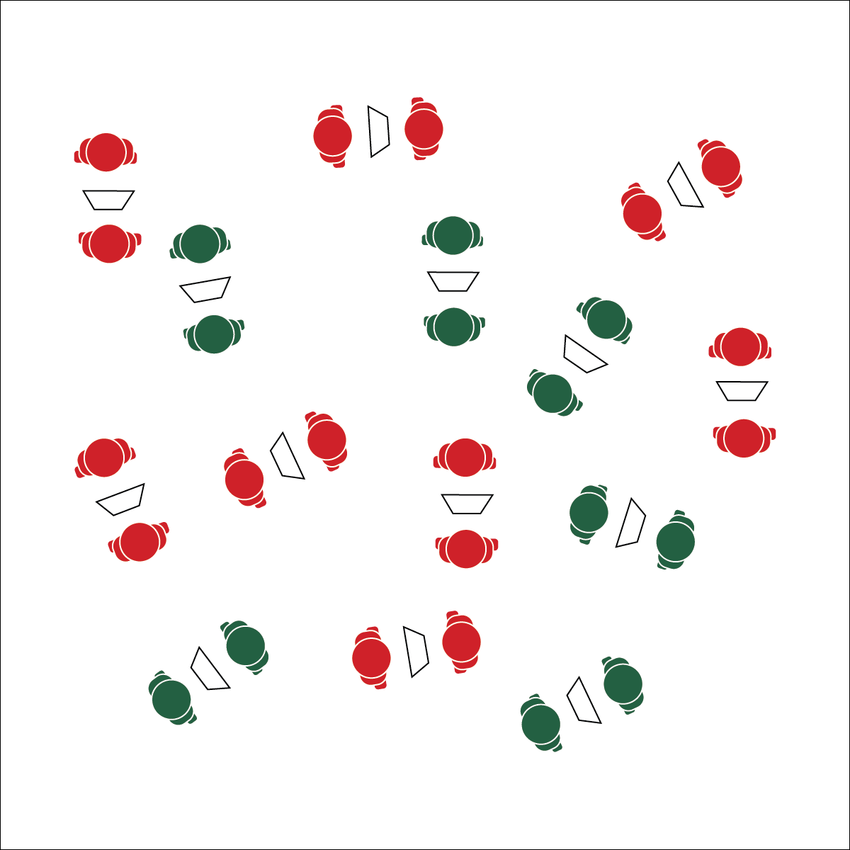

**Activity Procedures:**

1. Let’s get a burst of fitness-enhancing exercise with Down-Up Reps! As soon as you and your partner have a chart and find open space, you can begin your reps. With your partner, choose your level of fitness challenge.
2. Partner A will begin by completing the repetitions for Round 1. When the repetitions are complete, Partner A will rest, and Partner B will begin the exercise. When Partner B has completed the repetitions for Round 1, she/he will rest while Partner A moves on to Round 2. The pattern continues until all 9 rounds have been completed.
3. This is called Down-Up Reps because the number of reps decreases down and then increases back up to the original starting point.

**Grade Level Progression:**

**L1:** Take time to calculate or review personal target heart rate information. Use heart rate monitor technology to monitor time in zone.

**L2:** Prompt students to set an exertion goal for the activity using the perceived exertion card. At the end of the activity, students give thumbs up if they reached their exertion goal. If heart rate monitoring technology is available, students compare their perceived exertion with heart rate zone data.

**Equipment:**

* 1 Down-Up Rep Chart per pair of students

**Set-Up:**

1. Students in pairs scattered in open space.
2. Each pair with a Down-Up Rep Chart.

* Focus on Form
* Pace for the Zone
* **Skill:** I will pace activity based on my target heart rate zone.
* **Cognitive:** I will calculate my target heart rate and identify my target zone.
* **Fitness:** I will discuss the concept of heart rate zones.
* **Personal & Social Responsibility:** I will participate  
  safely with attention to exercise form and injury   
  prevention.

**DOWN-UP REPS**



Benefit, Fitness, Heart Rate Zone, Perceived Exertion, Repetition, Technique



* Modify the Down-Up Rep Chart to meet the needs of the students in your class.
* Provide visual and auditory demonstrations for each exercise on the Down-Up Rep Chart.



* **Standard** **3 [H3.L 2]:** Applies rates of perceived exertion and pacing (L2).
* **Standard 3 [H10.L1-2]:** Calculates target heart rate and applies HR information to personal fitness plan (L1); Adjusts pacing to keep heart rate in the target zone, using available technology (e.g., pedometer, heart rate monitor) to self-monitor aerobic intensity (L2).
* **Standard 4 [H5.L1]** Applies best practices for participating safely in physical activity, exercise, and dance (e.g., injury prevention, proper alignment, hydration, use of equipment, implementation of rules, sun protection) (L1).



* **DOK 1:** How would you describe target heart rate?
* **DOK 2:** How is your target heart rate affected by your fitness goals?
* **DOK 3:** How would you adapt a Down-Up Rep Chart based on different fitness goals (e.g., weight loss vs athletic performance)?

**DOWN-UP REPS**



**Help students record and represent knowledge:** The ultimate goal of fitness education is the routine application of both knowledge and skill in a physically active lifestyle. Providing your students with opportunities to design fitness activities and routines based on what they’ve experienced in class is a great way for them to create their own representations of that they’ve learned.