­­

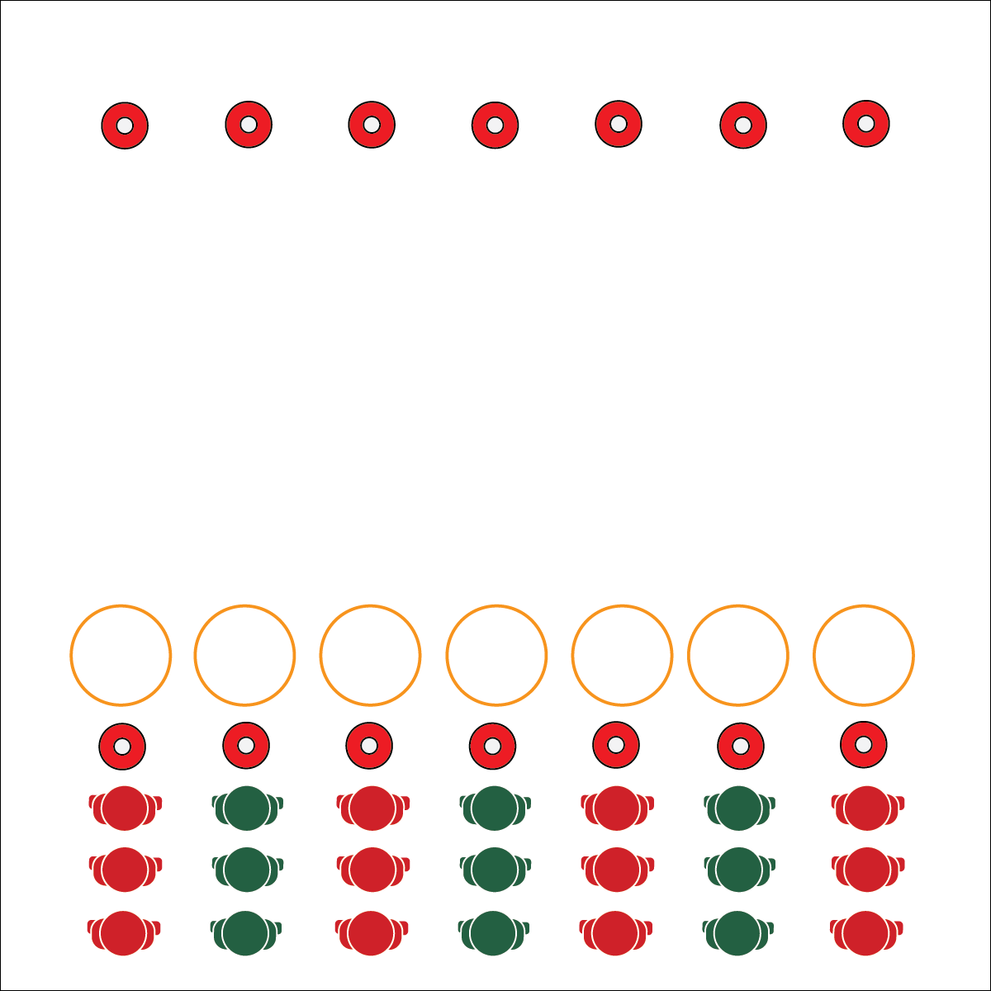

**FLIPPER SPRINTS**

* **Skill:** I will pace activity based on my target heart rate zone.
* **Cognitive:** I will calculate my target heart rate and identify my target zone.
* **Fitness:** I will discuss possible applications for heart rate technology in my personal fitness routine.
* **Personal & Social Responsibility:** I will participate  
  safely with attention to exercise form and injury   
  prevention.
* Pace for the Zone
* Move Safely
* Dive for Deeper Discussion

**Equipment:**

* 2 cones per team
* 1 hoop per team

**Set-Up:**

1. Create 2 parallel lines of cones 20 meters apart.
2. Place a hoop in front of each cone.
3. Create teams of 2–4 players, each team at a cone.

**Activity Procedures:**

1. It’s time for a fun race called Flipper Sprints. The object of the race is to flip your hoop all the way to the other cone.
2. On the start signal, the first person in line will flip the hoop toward the opposite cone, jump in and out of the hoop, and then sprint around the far cone and back again.
3. When the runner returns to the line, the next teammate will run to the hoop, flip it 1 more time toward the opposite cone, jump in and out of the hoop, and then sprint around the far cone and back again.
4. Continue this pattern until the hoop has been flipped all the way to the far cone. The first team whose hoop reaches the far cone wins.

**Grade Level Progression:**

**L1:** Utilize tires or heavy hoops in this activity with an emphasis an exercise alignment for proper squats.

**L2:** Prompt students to develop the application of heart rate monitoring in their out-of-school fitness routines.



**Help students practice skills, strategies, and processes:** Personal fitness devices generate billions of dollars in revenue each year in the home fitness market. Exploring the functionality of these devices is a critical part of modern physical education instruction. By using heart rate monitoring systems as a part of the physical education classroom, you’re helping students practice the skills and strategies commonly used for personal fitness assessment and motivation.



* **DOK 1:** What is a heart rate monitor?
* **DOK 2:** How could you apply heart rate monitor technology in your personal fitness plan?
* **DOK 3:** What facts would you select to support the use of a heart rate monitor for personal fitness? Can you elaborate on why you chose those facts?



* **Standard 3 [H10.L1-2]:** Calculates target heart rate and applies HR information to personal fitness plan (L1); Adjusts pacing to keep heart rate in the target zone, using available technology (e.g., pedometer, heart rate monitor) to self-monitor aerobic intensity (L2).
* **Standard 4 [H5.L1]** Applies best practices for participating safely in physical activity, exercise, and dance (e.g., injury prevention, proper alignment, hydration, use of equipment, implementation of rules, sun protection) (L1).



Heart Rate Monitor, Heart Rate Zone, Pace, Personal Fitness Plan

**FLIPPER SPRINTS**



* Change the locomotor movement used in this activity.
* Modify the distance between cones.