­­

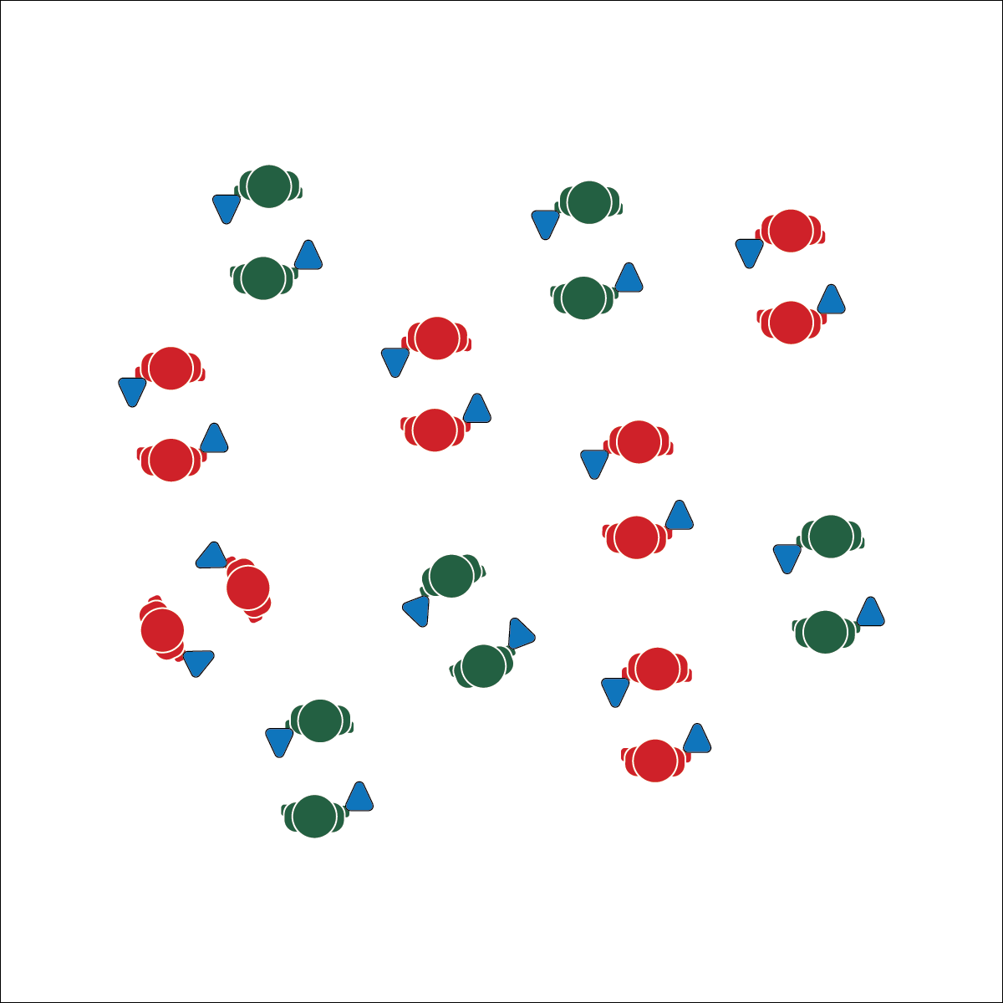

**Activity Procedures:**

1. Today’s fitness activity is called Cone Flip Chaos. The object is to compete against a partner by flipping your cone onto its base before your partner does, and then quickly finding a new partner to challenge.
2. The winner of each challenge round will automatically move to find a new partner. The losing partner will perform 10 jumping jacks before looking for a new partner.
3. You earn 1 flip attempt for every 3 jumping jacks you perform. You can perform any number of consecutive jumping jacks you want, as long as you end on a multiple of 3. For example, if you do 3 jumping jacks you earn 1 flip attempt. If you do 9 consecutive jumping jacks you earn 3 flip attempts.
4. The cone MUST flip 1 or more full rotations in order to be considered a fair flip.
5. Jumping jacks are a basic exercise for teaching this activity to students. Once they learn the rules and know how to play, change the activity to develop any area of health- or skill-related fitness you choose.

**Grade Level Progression:**

**L1:** Prompt students to choose an activity to replace jumping jacks in order to improve the health-related fitness component of their choice.

**L2:** Discuss perceived exertion and how it can be used to modify the activity to make it easier or more challenging.

* Pace for the Zone
* Move Safely
* Think Fitness

**Equipment:**

* 1 cone per student (9” plastic cones are preferred – like [this one](http://www.usgames.com/economy-cones). Experiment with different types of cones to meet the needs of your students.)

**Set-Up:**

1. Students scattered throughout the activity area, each student with a cone.

* **Skill:** I will pace activity based on my target heart rate zone.
* **Cognitive:** I will calculate my target heart rate and identify my target zone.
* **Fitness:** I will discuss the concept of perceived exertion with my classmates.
* **Personal & Social Responsibility:** I will participate  
  safely with attention to exercise form and injury   
  prevention.

**CONE FLIP CHAOS**



**Help students process content:** The set of DOK Debrief Questions that are included with this activity prompt students to systematically engage in drawing conclusions about the RPE Scale. Their responses represent a student-centered approach with the expectation that students will work with and demonstrate understanding of the content, not simply listen to discussion or lecture.



* **DOK 1:** How would you perform a set of jumping jacks to illustrate the different levels of the Rate of Perceived Exertion Scale?
* **DOK 2:** How would you compare and/or contrast the various levels of the RPE Scale with one another?
* **DOK 3:** How would you modify this activity if your goal was maintaining your basic aerobic and muscular endurance? How would you modify it if your goal was improving aerobic fitness and performance capacity? Provide reasoning for your modifications.



* **Standard 3 [H3.L 2]:** Applies rates of perceived exertion and pacing (L2).
* **Standard 3 [H10.L1-2]:** Calculates target heart rate and applies HR information to personal fitness plan (L1); Adjusts pacing to keep heart rate in the target zone, using available technology (e.g., pedometer, heart rate monitor) to self-monitor aerobic intensity (L2).
* **Standard 4 [H5.L1]** Applies best practices for participating safely in physical activity, exercise, and dance (e.g., injury prevention, proper alignment, hydration, use of equipment, implementation of rules, sun protection) (L1).

**CONE FLIP CHAOS**



* Allow students to choose the shape and size of the cone that they use. Provide cones with larger/smaller bases.



Energy Systems, Aerobic Glycolysis, Anaerobic Glycolysis, Energy Systems, Health-Related Fitness, Nutritional Balance, Physiological Response