­­

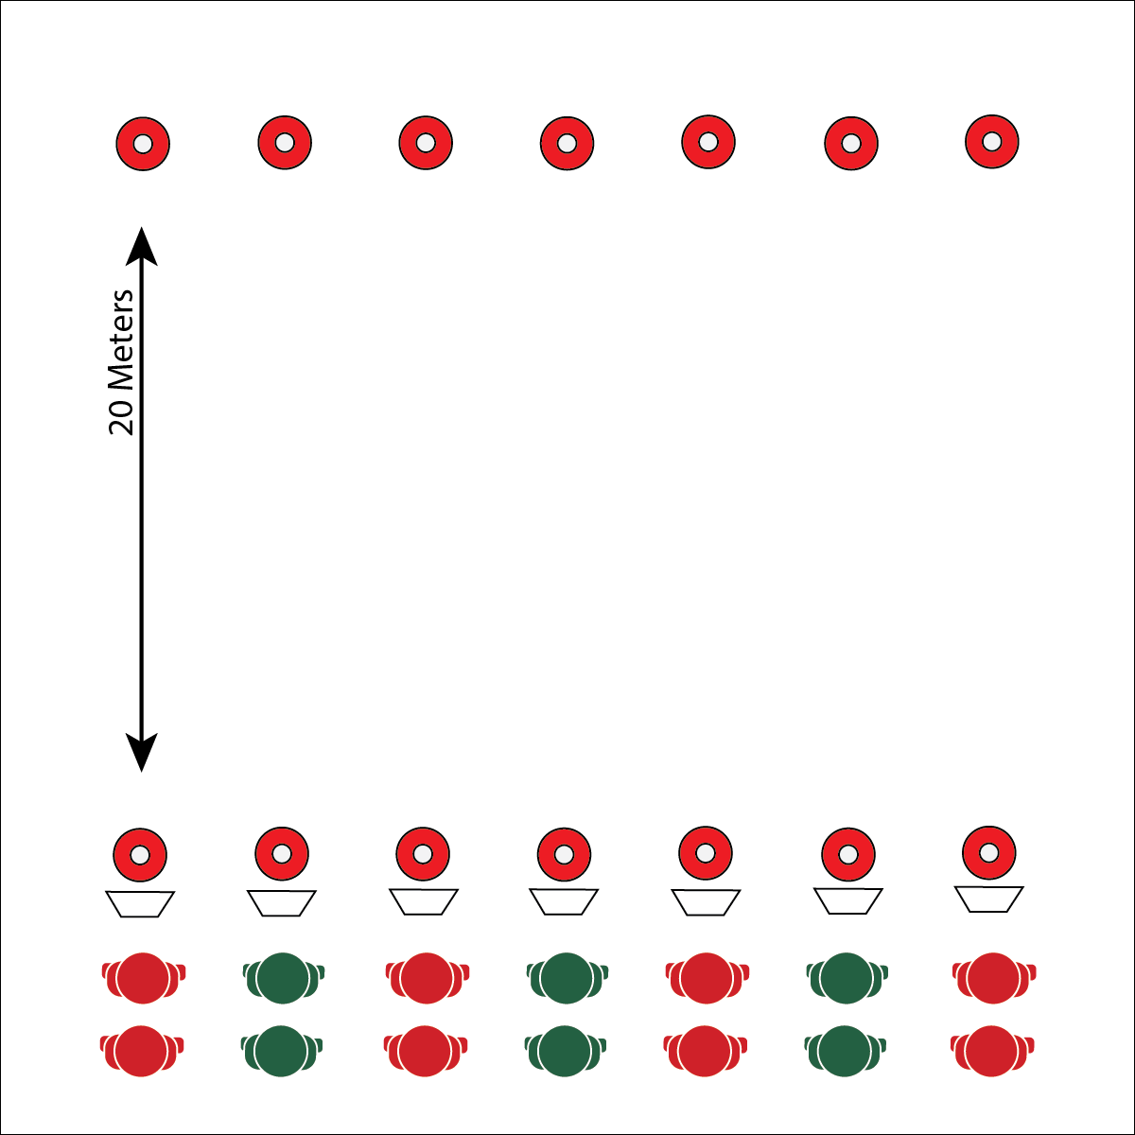

* Focus on Form
* Pace for the Zone
* **Skill:** I will pace activity based on my target heart rate zone.
* **Cognitive:** I will calculate my target heart rate and identify my target zone.
* **Fitness:** I will discuss the concept of perceived exertion with my classmates.
* **Personal & Social Responsibility:** I will participate  
  safely with attention to exercise form and injury   
  prevention.

**PARTNER REP BURN-OUT**

**Equipment:**

* 2 cones or floor markers per pair of students
* 1 Burn-Out Chart per pair
* Music and music player
* Task tents (optional)

**Set-Up:**

1. Create 2 parallel lines of cones 20 meters apart.
2. Pair students, each pair at a cone on 1 side of the activity area. Each pair with a Burn-Out Chart.

**Activity Procedures:**

1. It’s time for our Plug & Play Fitness activity called Partner Rep Burn-Out. The object of this activity is for you and your partner to complete 100 repetitions of each exercise listed on the Burn-Out Chart.
2. When the music starts, Partner A will begin the exercise listed on the chart while Partner B begins to jog down and around the 20-meter cone.
3. When Partner B returns, Partner A will tell her/him how many reps have been completed. The partners will switch roles, and Partner B will continue the exercise, counting reps up from the number completed by Partner A.
4. Repeat until together you’ve completed 100 reps of the exercise, they then move on to the next exercise listed on the chart. This pattern continues until the music stops.

**Grade Level Progression:**

**L1:** Take time to calculate or review personal target heart rate information. Use heart rate monitor technology to monitor time in zone.

**L2:** Using projected heart rate data, students track personal heart rate data and pace their activity to maximize time in the target heart rate zone.

**PARTNER REP BURN-OUT**



* **DOK 1:** What is perceived exertion?
* **DOK 2:** What do you know about the different levels of perceived exertion? (RPE Scale 1-10)
* **DOK 3:** How is perceived exertion related to exercise intensity?
* **DOK 4:** Using information from the Perceived Exertion Chart, analyze your effort and intensity during Partner Rep Burn-Out.



* Modify the Burn-Out Chart to provide the appropriate intensity levels for your students.
* Provide visual and auditory cues for each exercise on the Burn-Out Chart.



Adjust, Calculate, Heart Rate, Heart Rate Zone, Pace, Perceived Exertion, Repetition, Technique



* **Standard** **3 [H3.L2]:** Applies rates of perceived exertion and pacing (L2).
* **Standard 3 [H10.L1-2]:** Calculates target heart rate and applies HR information to personal fitness plan (L1); Adjusts pacing to keep heart rate in the target zone, using available technology (e.g., pedometer, heart rate monitor) to self-monitor aerobic intensity (L2).
* **Standard 4 [H5.L1]** Applies best practices for participating safely in physical activity, exercise, and dance (e.g., injury prevention, proper alignment, hydration, use of equipment, implementation of rules, sun protection) (L1).



**Identify critical content:** Working to meet student outcomes and identifying critical content from national and state outcomes are the first steps in backwards design planning. As students progress through their academic careers, the complexity of critical content increases. Perceived exertion is a complex fitness concept that students can experience and understand as their bodies respond to exercises and activities of different intensity levels. This is an important strategy for personalizing fitness education and helping students find relevance in complex concepts taught in the physical education classroom.

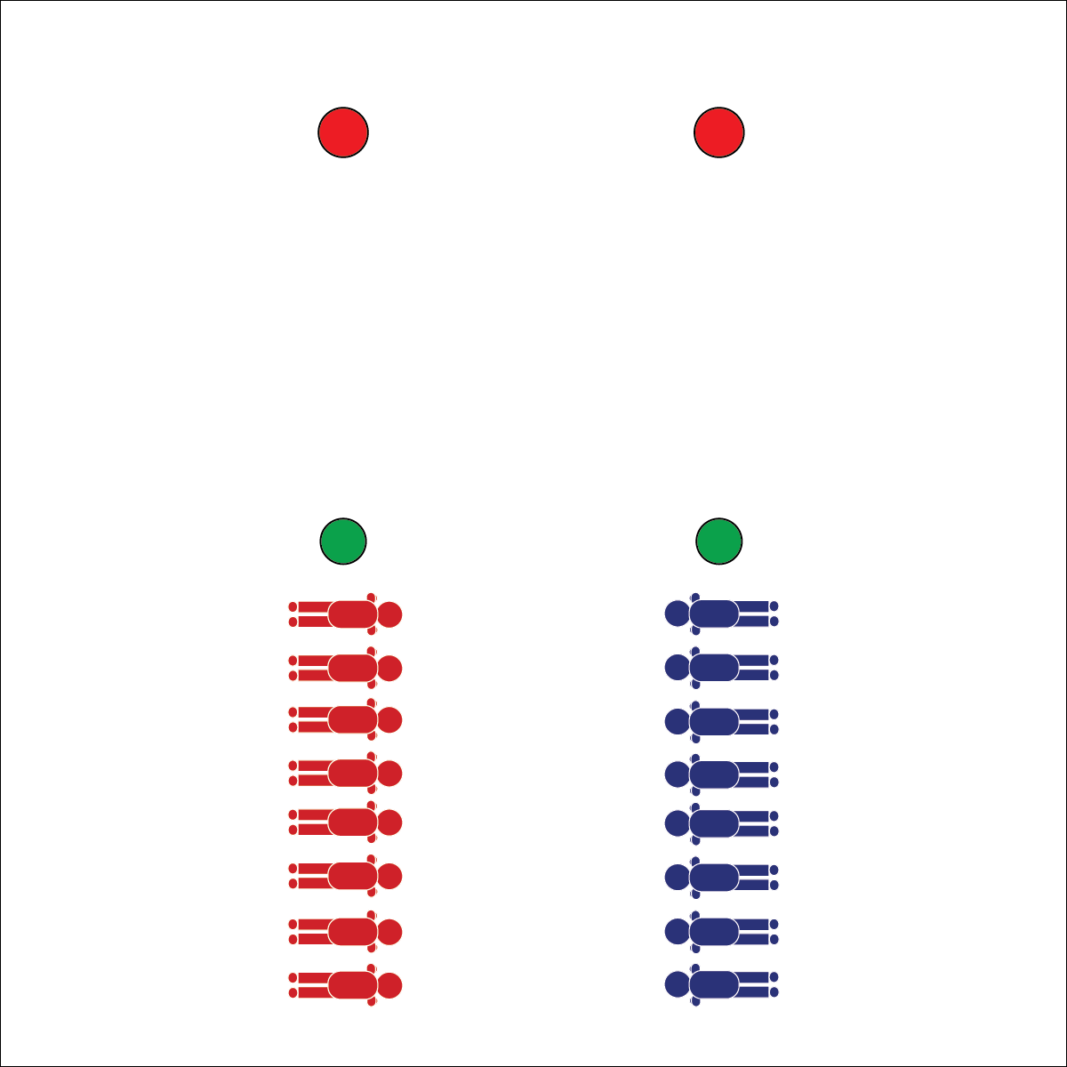

* Focus on Form
* Give Your Best Effort
* Compete with Respect, Kindness, and Fun
* **Skill:** I will perform plank position with perfect technique.
* **Cognitive:** I will identify the energy systems used in muscular strength and endurance activities.
* **Fitness:** I will maintain exercise form and adjust my level of appropriate challenge based on fatigue.
* **Personal & Social Responsibility:** I will participate  
  safely with attention to exercise form and injury   
  prevention.

**PLANK RACES**

**Equipment:**

* 4 cones to create start and finish lines

**Set-Up:**

1. Create 2 parallel lines as start and finish lines. Increase or decrease the distance based on class size and fitness level.
2. Divide the class into 2 teams. Each team in a line behind the starting line.

**Activity Procedures:**

1. It’s time for Plank Races. On the ready signal, all students will drop into plank position, shoulder to shoulder in a single-file line at the starting line.
2. On the go signal, the student at the back of each line will get up, run to the front of the line, and then resume plank position before yelling, “GO!” The next student at the end of the line will then repeat this pattern until all students are across the finish line.

**Grade Level Progression:**

**L1:** Prompt students to describe and demonstrate plank position with an emphasis on proper alignment and injury prevention.

**L2:** Provide instruction and discussion about the energy systems used in muscular strength and muscular endurance activities.

**PLANK RACES**



* Replace planks with another isometric exercise appropriate for all students in your class.
* Modify the distance of the race.
* Modify the size of the teams and method for traveling from end to end.



Adjust, Alignment, Energy Systems, Aerobic Glycolysis, Anaerobic Glycolysis, Exercise Form, Fatigue, Plank, Safety



* **Standard 3 [H8.L1-2]:** Relates physiological responses to individual levels of fitness and nutritional balance (L1); Identifies the different energy systems used in a selected physical activity (e.g., ATP-PC, anaerobic/glycolysis, aerobic) (L2).
* **Standard 4 [H5.L1]** Applies best practices for participating safely in physical activity, exercise, and dance (e.g., injury prevention, proper alignment, hydration, use of equipment, implementation of rules, sun protection) (L1).



* **DOK 1:** What would you include on a list about aerobic glycolysis? What about a list for anaerobic glycolysis?
* **DOK 2:** How would you compare and/or contrast aerobic glycolysis with anaerobic glycolysis?
* **DOK 3:** How are these energy systems related to your personal fitness?



**Help students examine similarities and differences:** Energy systems are big ideas that can be intimidating to students in physical education classes. Provide the definitions of aerobic glycolysis and anaerobic glycolysis, and then use the exploration of the similarities and differences to help students process the information they’re learning.

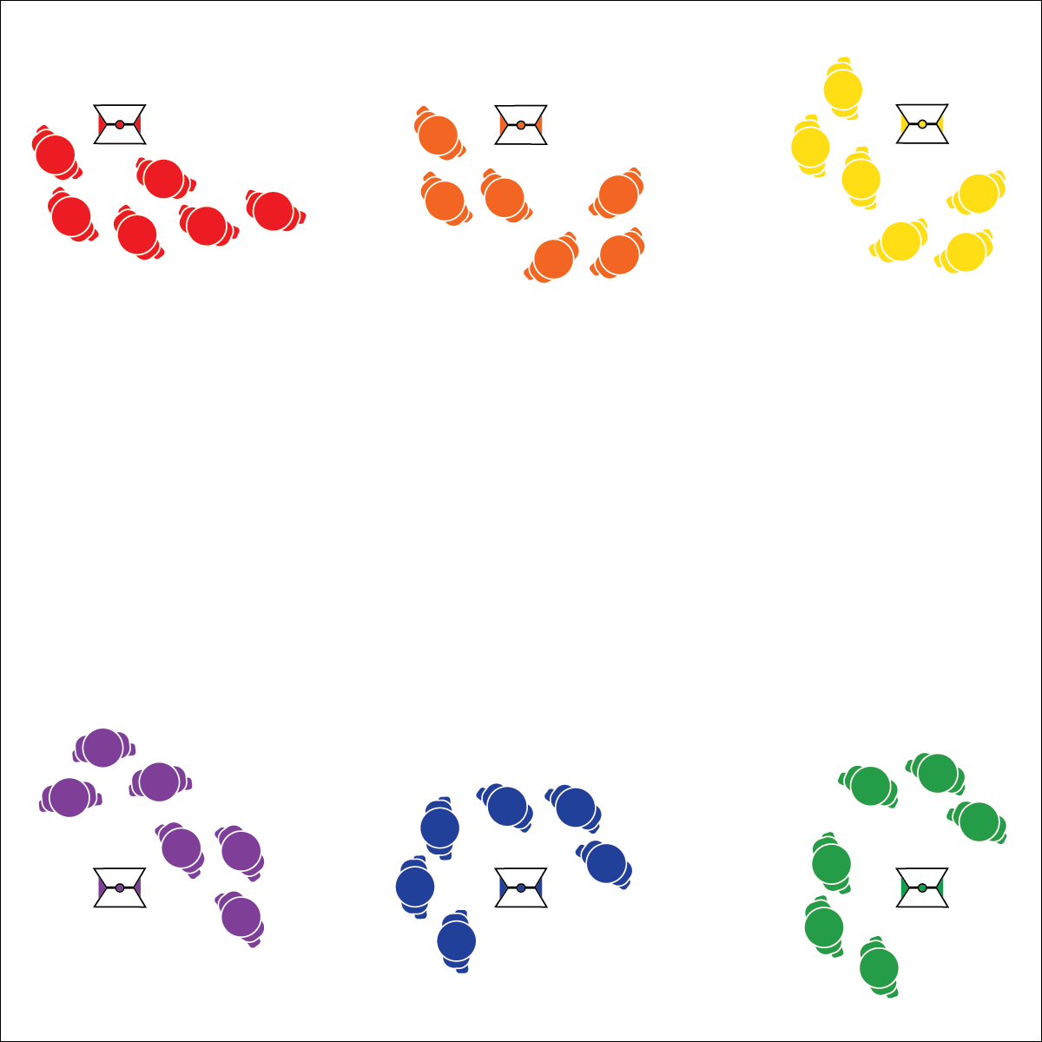

* Focus on Form
* Pace for the Zone
* **Skill:** I will pace activity based on my target heart rate zone.
* **Cognitive:** I will calculate my target heart rate and identify my target zone.
* **Fitness:** I will discuss the concept of perceived exertion with my classmates.
* **Personal & Social Responsibility:** I will participate  
  safely with attention to exercise form and injury   
  prevention.

**PACE STATIONS**

**Equipment:**

* 6 colored cones to create stations
* 6 task tents
* Pace Station Task Cards
* Fitness equipment needed for each fitness station (optional)

**Set-Up:**

1. Create a circuit with 6 stations using cones and task tents.
2. Place Pace Station Task Cards inside the task tent at each station.
3. Divide class into 6 groups, each group at a station.

**Activity Procedures:**

1. It’s time for Pace Stations. One station is designated at the Pace Station; today it’s the blue station.
2. On the start signal, begin the exercise listed on the task card at your station. The Pace Station has a set number of repetitions to complete. As soon as the group at the Pace Station completes their repetitions, the group will yell, “SWITCH!”
3. On the switch signal, all groups will jog a little over 1 lap clockwise around the entire circuit to stop at the next station (just beyond the one completed). This pattern continues until the circuit is complete or the teacher gives the stop signal.

**Grade Level Progression:**

**L1:** Prompt students to describe and demonstrate exercise form at select stations with an emphasis on proper alignment and injury prevention.

**L2:** Prompt students to set an exertion goal for the activity using the perceived exertion card. At the end of the activity, students give thumbs up if they reached their exertion goal. If heart rate monitoring technology is available, students compare their perceived exertion with heart rate zone data.

**PACE STATIONS**



Aerobic, Aerobic Intensity, Fitness, Heart Rate Monitor, Heart Rate Zone, Pace, Perceived Exertion, Physiological Response



* **DOK 1:** What would you include on a list about perceived exertion?
* **DOK 2:** How would you summarize the different levels listed on the Rate of Perceived Exertion Scale?
* **DOK 3:** How would you adapt a station that you completed today to change the intensity of the activity, and therefore your perceived exertion?



* **Standard** **3 [H3.L2]:** Applies rates of perceived exertion and pacing (L2).
* **Standard 3 [H10.L1-2]:** Calculates target heart rate and applies HR information to personal fitness plan (L1); Adjusts pacing to keep heart rate in the target zone, using available technology (e.g., pedometer, heart rate monitor) to self-monitor aerobic intensity (L2).
* **Standard 4 [H5.L1]** Applies best practices for participating safely in physical activity, exercise, and dance (e.g., injury prevention, proper alignment, hydration, use of equipment, implementation of rules, sun protection) (L1).



* Provide a visual cue as a switch signal.
* Modify Pace Station Task Cards to meet the needs of the students in your class.



**Organize students to interact with content:** Much of fitness education is experiential. As students learn and process cognitive concepts, they must experience the physiological response that their body has as it relates to the fitness ideas being studied. Pace stations allow teachers to design fitness circuits that provide beneficial physical activity while also emphasizing critical fitness concepts.

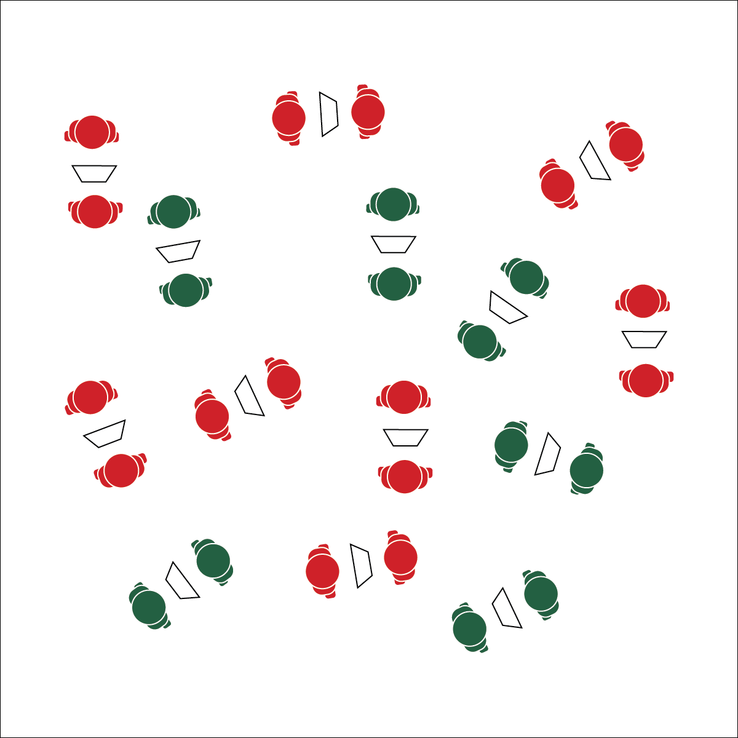

**Activity Procedures:**

1. Let’s get a burst of fitness-enhancing exercise with Down-Up Reps! As soon as you and your partner have a chart and find open space, you can begin your reps. With your partner, choose your level of fitness challenge.
2. Partner A will begin by completing the repetitions for Round 1. When the repetitions are complete, Partner A will rest, and Partner B will begin the exercise. When Partner B has completed the repetitions for Round 1, she/he will rest while Partner A moves on to Round 2. The pattern continues until all 9 rounds have been completed.
3. This is called Down-Up Reps because the number of reps decreases down and then increases back up to the original starting point.

**Grade Level Progression:**

**L1:** Take time to calculate or review personal target heart rate information. Use heart rate monitor technology to monitor time in zone.

**L2:** Prompt students to set an exertion goal for the activity using the perceived exertion card. At the end of the activity, students give thumbs up if they reached their exertion goal. If heart rate monitoring technology is available, students compare their perceived exertion with heart rate zone data.

* Focus on Form
* Pace for the Zone
* **Skill:** I will pace activity based on my target heart rate zone.
* **Cognitive:** I will calculate my target heart rate and identify my target zone.
* **Fitness:** I will discuss the concept of heart rate zones.
* **Personal & Social Responsibility:** I will participate  
  safely with attention to exercise form and injury   
  prevention.

**DOWN-UP REPS**

**Equipment:**

* 1 Down-Up Rep Chart per pair of students

**Set-Up:**

1. Students in pairs scattered in open space.
2. Each pair with a Down-Up Rep Chart.

**DOWN-UP REPS**



Benefit, Fitness, Heart Rate Zone, Perceived Exertion, Repetition, Technique



* **DOK 1:** How would you describe target heart rate?
* **DOK 2:** How is your target heart rate affected by your fitness goals?
* **DOK 3:** How would you adapt a Down-Up Rep Chart based on different fitness goals (e.g., weight loss vs athletic performance)?



* Modify the Down-Up Rep Chart to meet the needs of the students in your class.
* Provide visual and auditory demonstrations for each exercise on the Down-Up Rep Chart.



* **Standard** **3 [H3.L 2]:** Applies rates of perceived exertion and pacing (L2).
* **Standard 3 [H10.L1-2]:** Calculates target heart rate and applies HR information to personal fitness plan (L1); Adjusts pacing to keep heart rate in the target zone, using available technology (e.g., pedometer, heart rate monitor) to self-monitor aerobic intensity (L2).
* **Standard 4 [H5.L1]** Applies best practices for participating safely in physical activity, exercise, and dance (e.g., injury prevention, proper alignment, hydration, use of equipment, implementation of rules, sun protection) (L1).



**Help students record and represent knowledge:** The ultimate goal of fitness education is the routine application of both knowledge and skill in a physically active lifestyle. Providing your students with opportunities to design fitness activities and routines based on what they’ve experienced in class is a great way for them to create their own representations of that they’ve learned.



* **Skill:** I will maintain proper body alignment while performing burpees.
* **Cognitive:** I will discuss the benefits of routine physical activity breaks as related to personal productivity.
* **Fitness:** I will create a Music Moves routine to be used as a physical activity break during my school/work day.
* **Personal & Social Responsibility:** I will participate  
  safely with attention to exercise form and injury   
  prevention.

**MUSIC MOVES**

* Focus on Form
* Build Fun and Vigorous Routines

**Equipment:**

* *Ghostbusters* by Ray Parker Jr.
* Music player

**Set-Up:**

1. Students scattered with room to safely perform a burpee.
2. Music player ready to play.

**Activity Procedures:**

1. We’re going to learn the Music Moves concept using the song *Ghostbusters*. When the music begins, everyone will start doing jumping jacks.
2. Whenever the song gets to the word, “Ghostbusters!” everyone will perform a single burpee and then return to jumping jacks. We’ll continue until the song is over.
3. Once we learn and practice this workout format, we’ll work in pairs to create our own Music Moves routines.

**Grade Level Progression:**

**L1:** Discuss the benefits of routine physical activity breaks and strategies for creating physical activity habits.

**L2:** Have students create multiple Music Moves routines, predict the exertion rate of each, and then perform each routine, checking their perceived exertion level upon completion of the routine.

**MUSIC MOVES**



Aerobic Intensity, Benefit, Burpee, Exercise Form, Fatigue, Muscular Endurance, Physical Activity Break, Routine



* **DOK 1:** How can you recognize a physically active lifestyle?
* **DOK 2:** How would you apply a physical activity break within a physically active lifestyle?
* **DOK 3:** How is routine physical activity related to your productivity? Give specific examples.
* **DOK 4:** Create a list of strengths and weaknesses related to the physical activity levels of your daily personal routine. Identify one area of weakness and a strategy for personal improvement in this area.



**Manage response rates with tiered questioning techniques:** Utilize OPEN’s DOK debrief questions in a purposeful way with attention and patience for complex dialogue. Taking class time for these discussions is essential for understanding your students’ readiness for increasing complexity and the effectiveness of your instruction.



* Modify or replace jumping jacks and burpees so that all students can participate.
* Provide visual signals to indicate when it’s time to change exercise.



* **Standard 3 [H1.L1-2]:** Discusses the benefits of a physically active lifestyle as it relates to college/career productivity (L1).
* **Standard** **3 [H3.L 2]:** Applies rates of perceived exertion and pacing (L2).
* **Standard 4 [H5.L1]** Applies best practices for participating safely in physical activity, exercise, and dance (e.g., injury prevention, proper alignment, hydration, use of equipment, implementation of rules, sun protection) (L1).

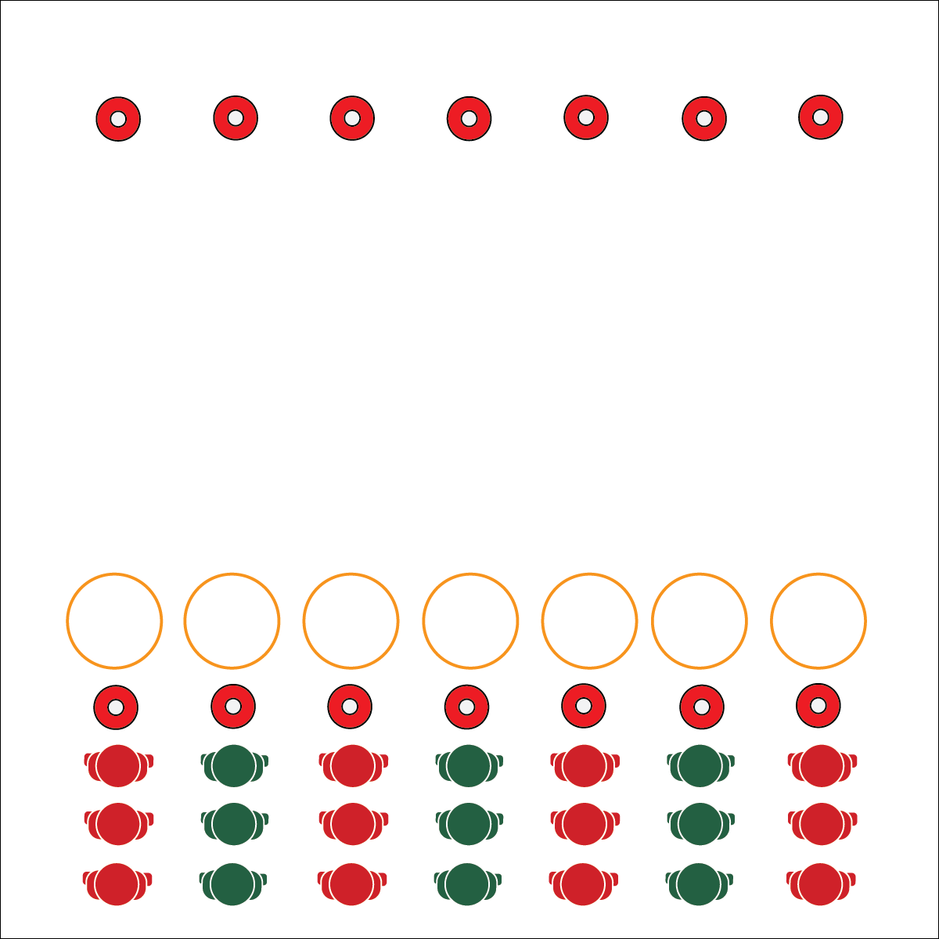

* Pace for the Zone
* Move Safely
* Dive for Deeper Discussion
* **Skill:** I will pace activity based on my target heart rate zone.
* **Cognitive:** I will calculate my target heart rate and identify my target zone.
* **Fitness:** I will discuss possible applications for heart rate technology in my personal fitness routine.
* **Personal & Social Responsibility:** I will participate  
  safely with attention to exercise form and injury   
  prevention.

**FLIPPER SPRINTS**

**Equipment:**

* 2 cones per team
* 1 hoop per team

**Set-Up:**

1. Create 2 parallel lines of cones 20 meters apart.
2. Place a hoop in front of each cone.
3. Create teams of 2–4 players, each team at a cone.

**Activity Procedures:**

1. It’s time for a fun race called Flipper Sprints. The object of the race is to flip your hoop all the way to the other cone.
2. On the start signal, the first person in line will flip the hoop toward the opposite cone, jump in and out of the hoop, and then sprint around the far cone and back again.
3. When the runner returns to the line, the next teammate will run to the hoop, flip it 1 more time toward the opposite cone, jump in and out of the hoop, and then sprint around the far cone and back again.
4. Continue this pattern until the hoop has been flipped all the way to the far cone. The first team whose hoop reaches the far cone wins.

**Grade Level Progression:**

**L1:** Utilize tires or heavy hoops in this activity with an emphasis an exercise alignment for proper squats.

**L2:** Prompt students to develop the application of heart rate monitoring in their out-of-school fitness routines.

**FLIPPER SPRINTS**



Heart Rate Monitor, Heart Rate Zone, Pace, Personal Fitness Plan



* **DOK 1:** What is a heart rate monitor?
* **DOK 2:** How could you apply heart rate monitor technology in your personal fitness plan?
* **DOK 3:** What facts would you select to support the use of a heart rate monitor for personal fitness? Can you elaborate on why you chose those facts?



* Change the locomotor movement used in this activity.
* Modify the distance between cones.



* **Standard 3 [H10.L1-2]:** Calculates target heart rate and applies HR information to personal fitness plan (L1); Adjusts pacing to keep heart rate in the target zone, using available technology (e.g., pedometer, heart rate monitor) to self-monitor aerobic intensity (L2).
* **Standard 4 [H5.L1]** Applies best practices for participating safely in physical activity, exercise, and dance (e.g., injury prevention, proper alignment, hydration, use of equipment, implementation of rules, sun protection) (L1).



**Help students practice skills, strategies, and processes:** Personal fitness devices generate billions of dollars in revenue each year in the home fitness market. Exploring the functionality of these devices is a critical part of modern physical education instruction. By using heart rate monitoring systems as a part of the physical education classroom, you’re helping students practice the skills and strategies commonly used for personal fitness assessment and motivation.

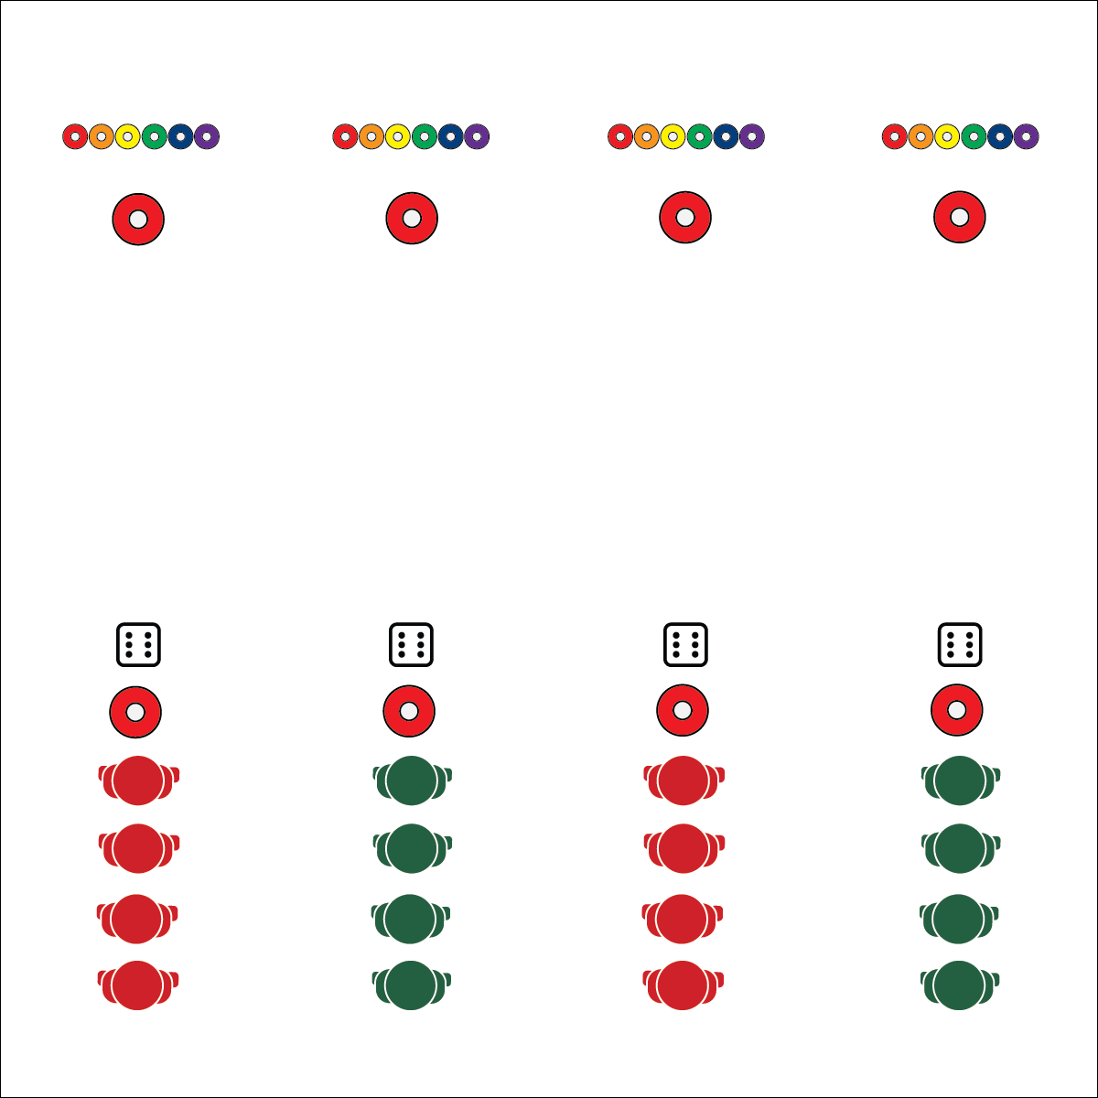

**Activity Procedures:**

1. Let’s work on our 20-meter pacer running with the game Upside Down. The object of the game is to get all of your team’s cones upside down.
2. On the start signal, the first person in line rolls the die and then runs down to flip the cone that corresponds to the number rolled.
3. As soon as that player returns to the line, the next player rolls the die and runs down to flip the appropriate cone.
4. If a number is rolled again, corresponding cones are flipped back right-side up.
5. Play the game until one team gets all cones upside down, or time runs out (set an appropriate amount of time based on your lesson).

**Grade Level Progression:**

**L1:** Use a debrief session to discuss how routine physical activity impacts student productivity and effectiveness in the classroom and/or work environment.

**L2:** Using heart rate monitor technology, challenge students to identify and then work toward their Heart Health Zone with a focus on either basic endurance and fat burning or building aerobic fitness and performance capacity.

* Pace for the Zone
* Move Safely
* Dive for Deeper Discussion

**UPSIDE DOWN**

* **Skill:** I will pace activity based on my target heart rate zone.
* **Cognitive:** I will calculate my target heart rate and identify my target zone.
* **Fitness:** I will discuss the benefits of an active lifestyle.
* **Personal & Social Responsibility:** I will participate  
  safely with attention to exercise form and injury   
  prevention.

**Equipment:**

* 2 large cones per team of 2–4 players
* 6 low-profile cones per team of 2–4 players
* 1 six-sided die per team of 2–4 players

**Set-Up:**

1. Use large cones to create start and finish lines 20 meters apart.
2. Place the dice at each starting cone and 6 low-profile cones at each finish cone. Number each low-profile cone 1 through 6, going from left to right.
3. Create teams of 2–4 players, each team at a starting cone.

**UPSIDE DOWN**



Active Lifestyle, Benefit, Fitness, Heart Rate Zone



* Modify the distance students travel to meet the needs of all participants.
* Use scooters to move through the 20-meter distance between dice and low-profile cones.



* **Standard 3 [H1.L1]:** Discusses the benefits of a physically active lifestyle as it relates to college/career productivity (L1).
* **Standard 3 [H10.L1-2]:** Calculates target heart rate and applies HR information to personal fitness plan (L1); Adjusts pacing to keep heart rate in the target zone, using available technology (e.g., pedometer, heart rate monitor) to self-monitor aerobic intensity (L2).
* **Standard 4 [H5.L1]** Applies best practices for participating safely in physical activity, exercise, and dance (e.g., injury prevention, proper alignment, hydration, use of equipment, implementation of rules, sun protection) (L1).



* **DOK 1:** What would you include on a list about the benefits of an active lifestyle?
* **DOK 2:** How can an active lifestyle affect a person’s social life?
* **DOK 3:** How is an active lifestyle related to a person’s social and emotional well-being?



**Help students examine their reasoning:** By the time students get to high school, they have developed reasoning that either promotes or diminishes their desire to be physically active. While personal health is an important reason to be active, students are often focused more on peer interactions and social consequences. Discussing how regular physical activity can enhance their social and emotional well-being is important for guiding students toward a more complete understanding of physical activity and personal fitness.



* **Skill:** I will perform plank position with perfect technique.
* **Cognitive:** I will identify the energy systems used in different types of physical activity.
* **Fitness:** I will maintain exercise form and adjust my level of appropriate challenge based on fatigue.
* **Personal & Social Responsibility:** I will participate  
  safely with attention to exercise form and injury   
  prevention.

**BEAN BAG BLOCKERS**

* Focus on Form
* Compete with Respect, Kindness, and Fun

**Equipment:**

* 4 hoops per group of 4 students
* 4 bean bags per group of 4 students

**Set-Up:**

1. Create a 2x2 grid using 4 hula hoops, with hoops touching one another.
2. Create groups of 4 students, each group at a hoop grid, and each student with a bean bag.

**Activity Procedures:**

1. This Plug & Play Fitness activity is called Bean Bag Blockers. The object of the game is for you to have an empty hoop when the music stops. You’ll do that by tossing bean bags into other players’ hoops while keeping your hoop free of bean bags.
2. To start the activity, all students are in plank position behind their hoop with a bean bag on the floor in between their hands.
3. When the music starts, all players will toss their bean bags into any opponent’s hoop. When a bean bag lands in their hoop, they pick it up and quickly toss it into an opponent’s hoop.
4. When the music stops, any player with an empty hoop scores a point. If you have a bean bag in your hand or toss it after the music has stopped, you do not score a point.
5. As soon as points are totaled, the music will begin again for a new round of play.

**Grade Level Progression:**

**L1:** Discuss the physiological response to sustaining plank position during this activity and the consequences of a loss of proper alignment.

**L2:** Review energy systems and identity how the body uses each to fuel physical activity.

**BEAN BAG BLOCKERS**



Adjust, Alignment, Anaerobic Glycolysis, Energy Systems, Muscular Endurance, Nutritional Balance, Technique



* **Standard 3 [H8.L1-2]:** Relates physiological responses to individual levels of fitness and nutritional balance (L1); Identifies the different energy systems used in a selected physical activity (e.g., ATP-PC, anaerobic/glycolysis, aerobic) (L2).
* **Standard 4 [H5.L1]** Applies best practices for participating safely in physical activity, exercise, and dance (e.g., injury prevention, proper alignment, hydration, use of equipment, implementation of rules, sun protection) (L1).



* Modify or replace plank position to make this activity appropriate for all students in your class.
* Provide bean bags of different size, weight, and texture.



* **DOK 1:** What would you include on a list about anaerobic glycolysis?
* **DOK 2:** What do you know about anaerobic glycolysis and fatigue?
* **DOK 3:** How would you adapt this activity to shift energy systems from anaerobic glycolysis to aerobic glycolysis?



**Review content:** Energy systems are complex and require multiple touches within a student’s fitness education experience. Although deeper scientific understand of these concepts is beyond the scope of the physical education curriculum, students benefit greatly from a rigorous look at glycolysis and how it relates to the bigger picture of fitness and nutrition education.

## 

**Activity Procedures:**

1. Today’s fitness activity is called Cone Flip Chaos. The object is to compete against a partner by flipping your cone onto its base before your partner does, and then quickly finding a new partner to challenge.
2. The winner of each challenge round will automatically move to find a new partner. The losing partner will perform 10 jumping jacks before looking for a new partner.
3. You earn 1 flip attempt for every 3 jumping jacks you perform. You can perform any number of consecutive jumping jacks you want, as long as you end on a multiple of 3. For example, if you do 3 jumping jacks you earn 1 flip attempt. If you do 9 consecutive jumping jacks you earn 3 flip attempts.
4. The cone MUST flip 1 or more full rotations in order to be considered a fair flip.
5. Jumping jacks are a basic exercise for teaching this activity to students. Once they learn the rules and know how to play, change the activity to develop any area of health- or skill-related fitness you choose.

**Grade Level Progression:**

**L1:** Prompt students to choose an activity to replace jumping jacks in order to improve the health-related fitness component of their choice.

**L2:** Discuss perceived exertion and how it can be used to modify the activity to make it easier or more challenging.

* Pace for the Zone
* Move Safely
* Think Fitness
* **Skill:** I will pace activity based on my target heart rate zone.
* **Cognitive:** I will calculate my target heart rate and identify my target zone.
* **Fitness:** I will discuss the concept of perceived exertion with my classmates.
* **Personal & Social Responsibility:** I will participate  
  safely with attention to exercise form and injury   
  prevention.

**Equipment:**

* 1 cone per student (9” plastic cones are preferred – like [this one](http://www.usgames.com/economy-cones). Experiment with different types of cones to meet the needs of your students.)

**Set-Up:**

1. Students scattered throughout the activity area, each student with a cone.

**CONE FLIP CHAOS**



Energy Systems, Aerobic Glycolysis, Anaerobic Glycolysis, Energy Systems, Health-Related Fitness, Nutritional Balance, Physiological Response



* **Standard 3 [H3.L 2]:** Applies rates of perceived exertion and pacing (L2).
* **Standard 3 [H10.L1-2]:** Calculates target heart rate and applies HR information to personal fitness plan (L1); Adjusts pacing to keep heart rate in the target zone, using available technology (e.g., pedometer, heart rate monitor) to self-monitor aerobic intensity (L2).
* **Standard 4 [H5.L1]** Applies best practices for participating safely in physical activity, exercise, and dance (e.g., injury prevention, proper alignment, hydration, use of equipment, implementation of rules, sun protection) (L1).



* **DOK 1:** How would you perform a set of jumping jacks to illustrate the different levels of the Rate of Perceived Exertion Scale?
* **DOK 2:** How would you compare and/or contrast the various levels of the RPE Scale with one another?
* **DOK 3:** How would you modify this activity if your goal was maintaining your basic aerobic and muscular endurance? How would you modify it if your goal was improving aerobic fitness and performance capacity? Provide reasoning for your modifications.



* Allow students to choose the shape and size of the cone that they use. Provide cones with larger/smaller bases.

**CONE FLIP CHAOS**



**Help students process content:** The set of DOK Debrief Questions that are included with this activity prompt students to systematically engage in drawing conclusions about the RPE Scale. Their responses represent a student-centered approach with the expectation that students will work with and demonstrate understanding of the content, not simply listen to discussion or lecture.