­­­

­

* Plug & Play Fitness DOK Exit Slips
* Pace
* Perceived Exertion
* Repetition
* Technique
* **Skill:** I will pace activity based on my target heart rate zone.
* **Cognitive:** I will calculate my target heart rate and identify my target zone.
* **Fitness:** I will discuss the concept of perceived exertion with my classmates.
* **Personal & Social Responsibility:** I will participate safely with attention to exercise form and injury prevention.
* **Standard 3 [H3.L2]:** Applies rates of perceived exertion and pacing (L2).
* **Standard 3 [H10.L1-2]:** Calculates target heart rate and applies HR information to personal fitness plan (L1); Adjusts pacing to keep heart rate in the target zone, using available technology (e.g., pedometer, heart rate monitor) to self-monitor aerobic intensity (L2).
* **Standard 4 [H5.L1]** Applies best practices for participating safely in physical activity, exercise, and dance (e.g., injury prevention, proper alignment, hydration, use of equipment, implementation of rules, sun protection) (L1).

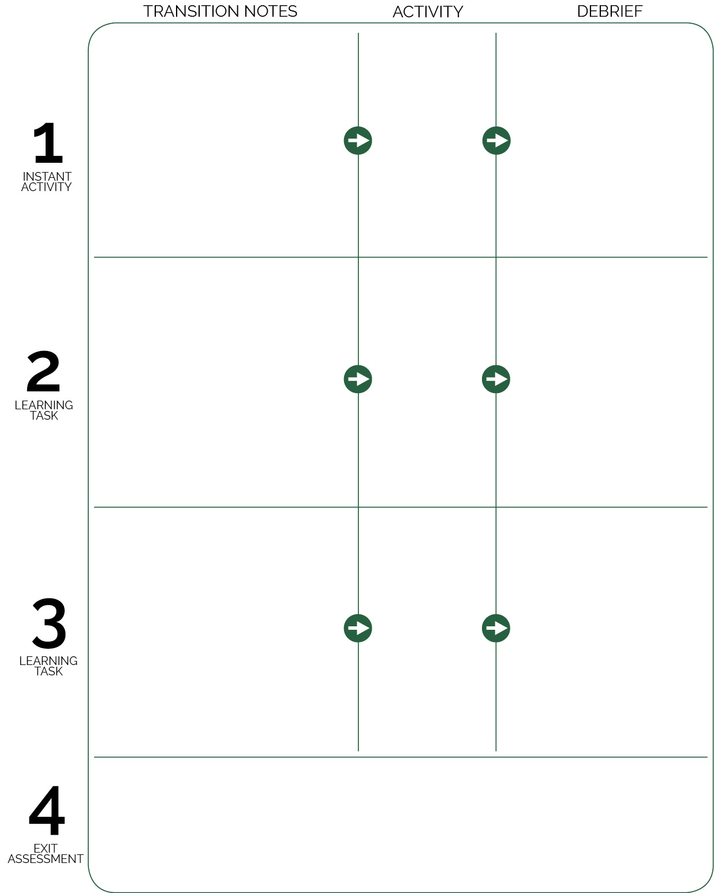

**DOK 1:** What is perceived exertion?

**DOK 2:** What do you know about the different levels of perceived exertion? (RPE Scale 1-10)

**DOK 3:** How is perceived exertion related to exercise intensity?

Partner Rep Burn-Out

Students complete Plug & Play Fitness DOK Exit Slips.

Transition notes for next activity

Several Perceived Exertion Cards are posted around the physical education classroom and activity space for all students to easily view and access. Burn-Out Charts are placed in a pile for students to pick-up as they find a partner and enter the activity area. As soon as partners have a chart they move to a cone and begin working.

Students transition to skill-based activities.

*This space is purposely left for you to complete in order to highlight the intended use of Plug & Play activities. This module is not meant to be done together and in sequence; rather, each Plug & Play activity is meant to be embedded into your skill- based modules throughout the school year.*

Choose an activity from your current skill-based module.

Debrief is focused on skill-based concepts.

Debrief is focused on skill-based concepts.

Choose an activity from your current skill-based module.