­­

SLAM BALL

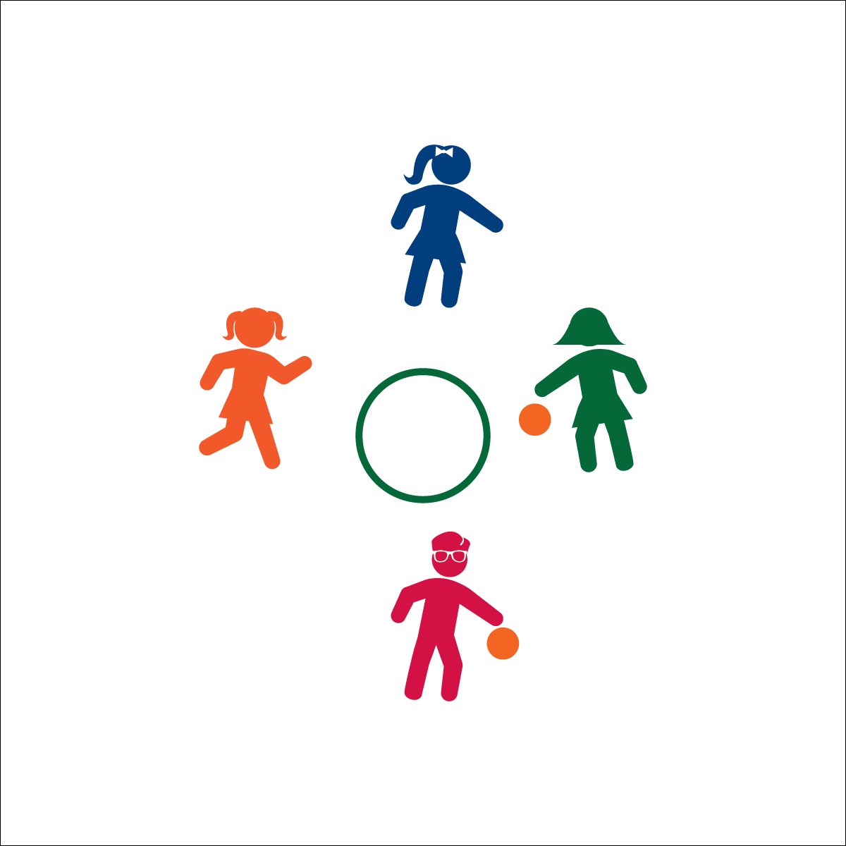

**Activity Procedures:**

1. It’s time to play Slam Ball. The object of the game is to successfully catch the ball after it bounces in the hoop or chalk circle.
2. To start the game, the 1st player throws the ball into the hoop. The 2nd player attempts to catch it.
3. Scoring:
   * Ball does not hit inside the hoop (point for receiving player)
   * Ball hits inside the hoop, but does not bounce at least 1 step away from hoop (point for receiving player)
   * Ball hits inside the hoop and bounces over the head of the receiver (point for receiving player)
   * Ball is not successfully caught by receiving player (point for serving player)
4. If 4 players are sharing a hoop and the 2 balls collide, this is a “slam,” and the 2 players who threw the balls switch opponents.

**Tips:**

* Start with a cooperative version of Slam Ball. How many throws and catches can you make in a row?
* Ready for competition? Get an edge by throwing the ball so that it bounces out of the hoop with different trajectories.

**Equipment:**

* 1 hoop per 2 (or 4) players (or chalk circle on a sidewalk or driveway)
* 1 ball per 2 players (A playground ball or a tennis ball will work. Really, any ball that bounces and can be caught safely.)

**Set-Up:**

1. 2 players stand on opposite sides of a hoop, at least 1 step away.
2. If sharing a hoop, 2 other players can stand perpendicular at the same hoop.
3. 1 player starts holding the ball.

* Aim for Target
* Move to Ball
* Soft Hands to Catch
* **FACT:** Slam ball is fun, but slamming your food isn’t! Everyone can benefit from slowing down a little while they eat. It takes 20 minutes from the time you start to eat for your brain to tell you that you’re full. Eating too quickly can lead to overeating and other digestive problems. So, slow down and enjoy your food!
* I will demonstrate fair play and cooperation with others.