­­

BE HAPPY BEAN BAG

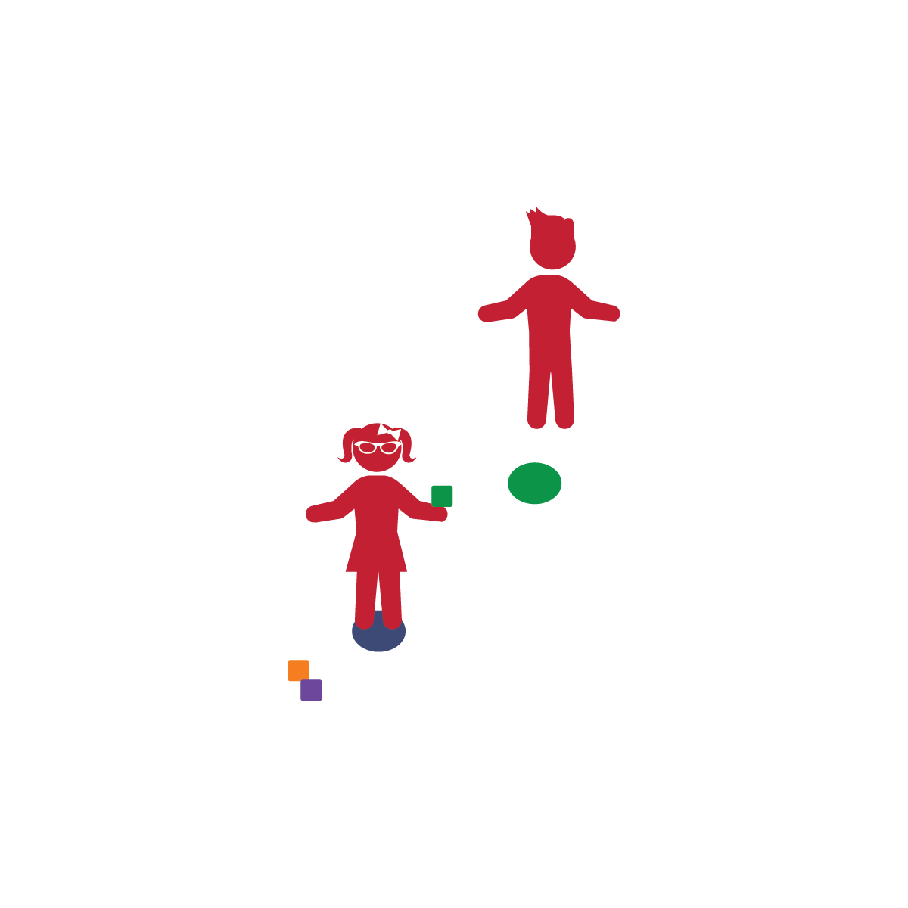

**Activity Procedures:**

1. Today’s activity is called Be Happy Bean Bag. Have your partner stand on the poly spot on the ground with their eyes closed.
2. Walk behind your partner and place the other poly spot somewhere behind them in the field of play.
3. Tell your partner to open their eyes but not to look behind them for the target just yet.
4. Communicate how far away the poly spot is from them. (e.g., “It is 5 feet behind you, straight back.”)
5. Give your partner 1 bean bag. They will toss it over their shoulder to try to hit the target according to the directions given.
6. If they hit the poly spot, switch positions and let them hide the spot. If not, communicate how they missed (e.g., “You threw it 2 feet too far”), hand them another bean bag, and let them try again. (Repeat until you run out of bean bags.)

**Tips:**

* Add an element of success by scoring points for every beanbag tossed that is closer to the spot than the first beanbag tossed. This emphasizes improvement without perfection.

**Equipment:**

* 2 poly spots/paper plates per 2 players
* 3-4 bean bags per 2 players

**Set-Up:**

1. Place 1 poly spot (paper plate) on the ground (for your partner to stand on).
2. Hold the spot, ready to begin the game.

* Be Positive
* Be Encouraging
* **Healthy Eating Tip:** Build positive attitudes through your communication about healthy foods. Encourage young children to try new things with you. Setting an example for them helps to build positive attitudes about trying foods they may be unsure about.
* I will demonstrate good communication and cooperation with others.