­­

BLINDFOLD BUILDING

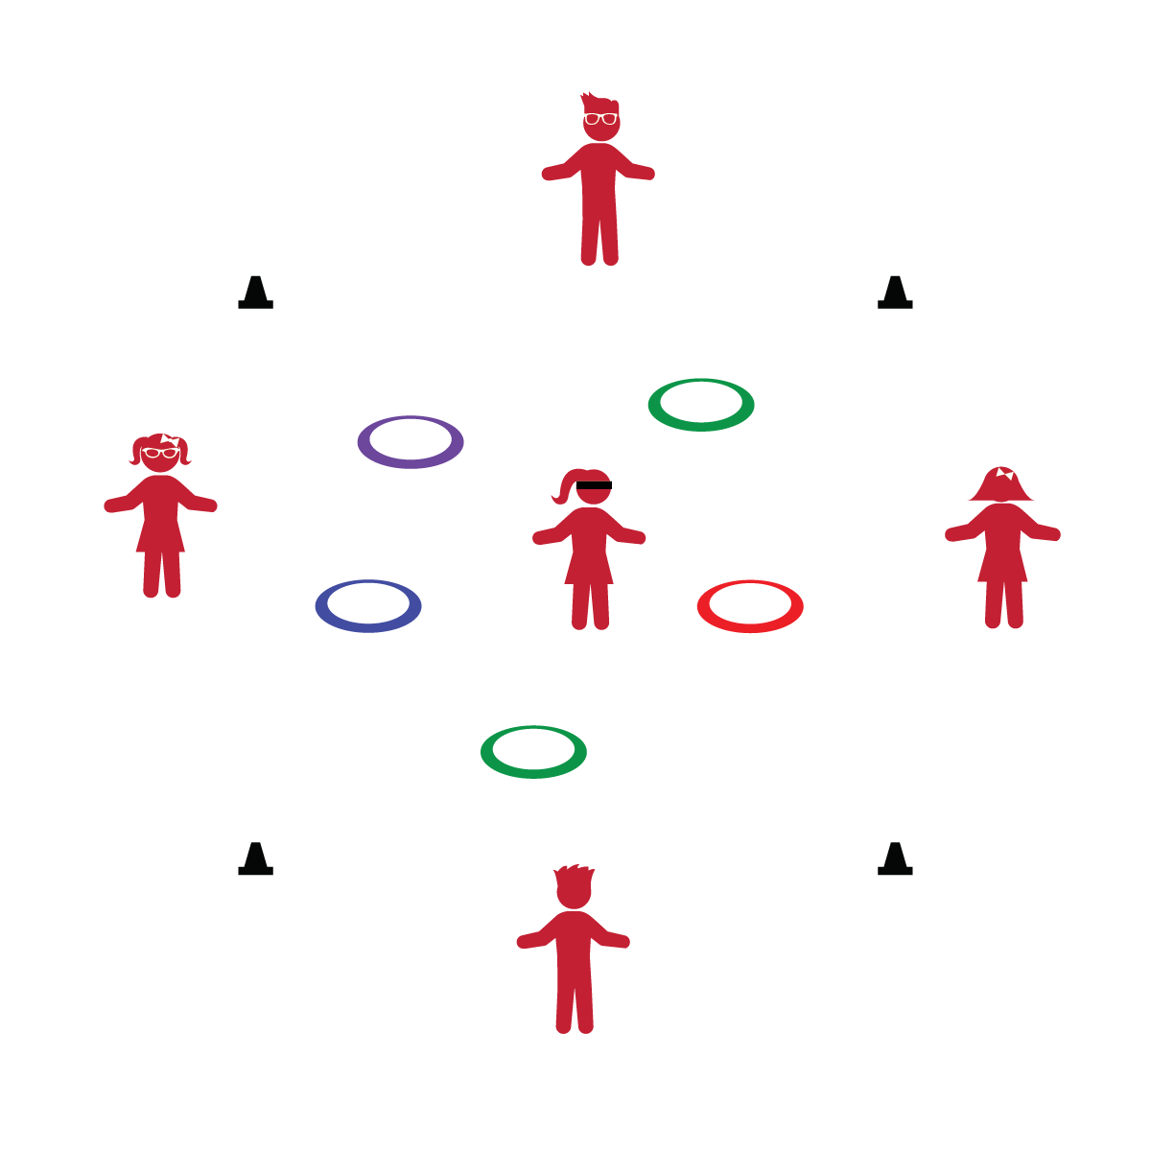

**Activity Procedures:**

1. Today’s activity is call Blindfold Building. The group will use positive communication to guide the blindfolded player through the play area to collect all the hoops.
2. Only the blindfolded player may be inside your team’s play space. The other team members must remain outside the play space.
3. The group may move around the outside of the play space as needed to help guide the blindfolded player safely to the hoops and assembly area.
4. Once the blindfolded player collects all the hoops, the other players will instruct her/him to build a hula hut.

**Tips:**

* Keep players safe by making sure they stay in bounds.
* Keep the activity area quiet during this activity so teams can communicate clearly and effectively.
* If a player doesn't wish to be blindfolded, respect that choice.

**Equipment:**

* 5 hula hoops per team
* 1 blindfold per team per team
* 4 cones or spot markers per team

**Set-Up:**

1. Create an 8’x8’ play space (1 per team) using cones or spot markers.
2. Scatter hoops within the play space.
3. Create teams of 2-5 players.
4. Teams stand outside of the play space with 1 player wearing blindfold.

* Stay Inside Boundaries
* Blindfolds are Optional
* Think “Safety First”
* **Did You Know?** An avocado is high in potassium and low in sugar! Avocados contain 14% of your daily recommendation for potassium. AND, avocados are delish!
* I will demonstrate communication, cooperation, and trust with others.