­­

THE DANCE PARTY

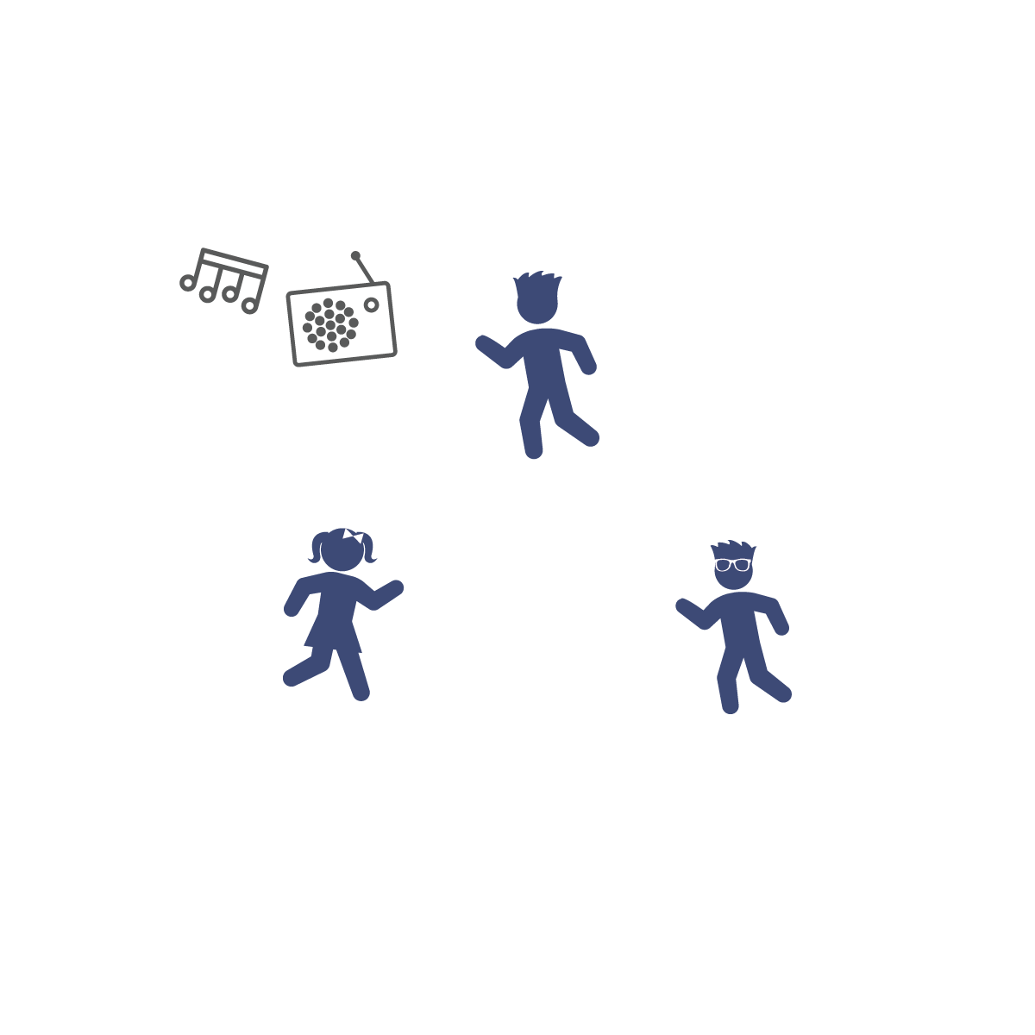

* **Healthy Lifestyle:** Remember to eat at least 5 portions of fruit and veggies every day! It’s easier than it sounds. Why not slice some banana over your breakfast cereal or reach for a piece of fresh fruit for your mid-morning snack?! Keep in mind, unsweetened 100% fruit juice, vegetable juice, and smoothies can only count as 1 of your 5 servings each day. For example, if you have 2 glasses of fruit juice and a glass of vegetable juice, that still only counts as 1 serving of fruit and veggies. Limit the amount of juice you drink; eat fresh fruits and drink water instead.

**Activity Procedures:**

1. It’s time for a dance party!!! You’re going to make this party ROCK by creating your very own dance.
2. You’ll create a dance for 8 counts (beats) using the Dance Card to give you movement ideas.
3. Now it’s time to practice! Start the music and let everyone perform their dance moves at the same time!
4. Then, let’s put our moves together. First, your friend will perform her/his dance for 8 counts. Next, you’ll take a turn and perform yours. Continue through all of your friends’ moves.
5. Next, teach each other your dance moves, put them in a sequence and then complete the entire dance all together! Keep the music pumping and dance!

**Tips:**

* Practice counting 8 beats by clapping and counting to aloud to the music. Next, jump up and down while counting aloud to the music. Finally, jump up and down for 8 counts, clap for 8 counts, and then repeat until everyone understands how to count 8 beats of music.
* I will demonstrate cooperation and positive communication while creating a group dance.
* Stay Inside Boundaries
* Blindfolds are Optional
* Think Safety First

**Equipment:**

* Dance Cards
* Upbeat, fun music and music player

**Set-Up:**

1. Create a safe space large enough to dance with friends.
2. Get your music ready!