­­

LOCOMOTOR SHAPES

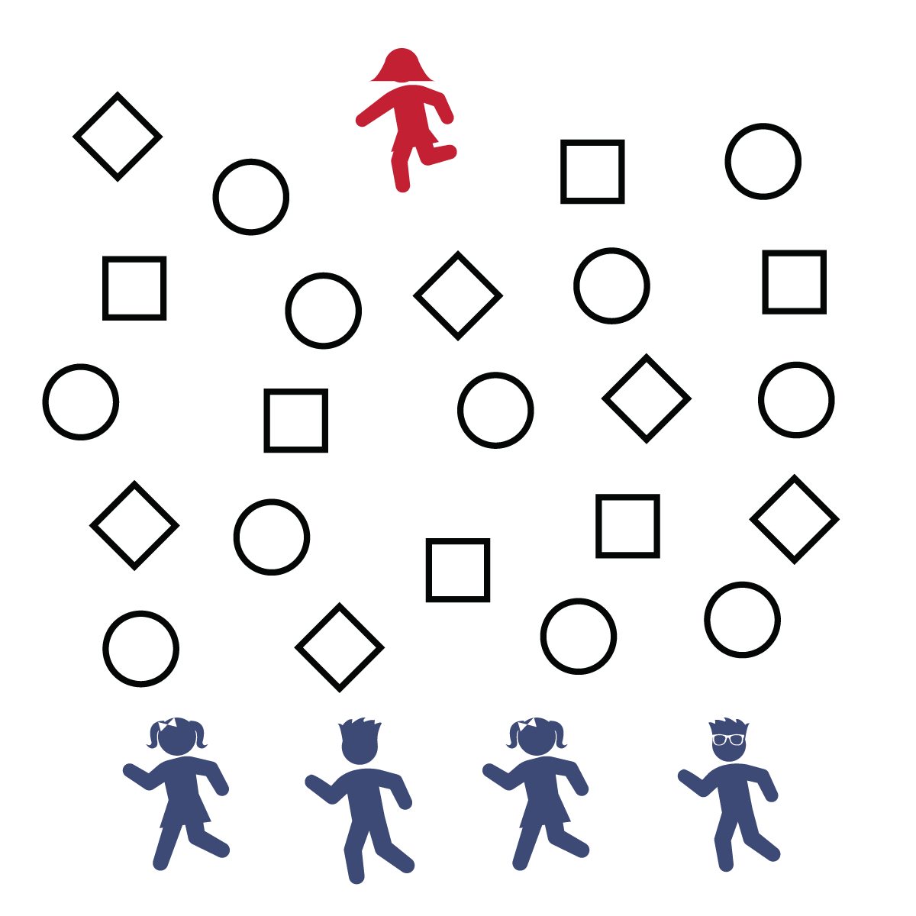

**Equipment:**

* Sidewalk chalk
* Large concrete or blacktop area (like a driveway)

**Set-Up:**

1. Create a large activity area by drawing 20–30 circles and 20–30 squares throughout general space. Leave at least 1 foot in between each shape.
2. One tagger will begin on one side of the area. The rest of the players line up on the opposite side.

**Activity Procedures:**

1. Today activity is call Locomotor Shapes. It’s a tag game with jumping, hopping, and leaping. The object of the game is for all the players to get to the other side of the area without getting tagged.
2. Designate 1 player to be the tagger. The tagger will start on 1 side of the area, and all other players start on the opposite side of the playing area. To begin, the tagger will say, "READY, SET, GO!"
3. To move, the tagger and all other players must jump, hop, or leap and land correctly from shape to shape. You must jump on squares with a 2-foot landing. You can hop or leap onto a circle with a 1-foot landing.
4. When a player is tagged, start the game over. The person who was tagged will be the new tagger. If all players cross without getting tagged, designate a new tagger and play again.

**Tips:**

* Think safety first: Don’t try to land on a shape if another player is jumping or hopping onto that same shape.
* Work on bending knees, swinging arms, and building momentum for longer jumps and hops.
* **Balance Your Moves:** There are lots of ways to stay healthy, and balance is important. You rely on balance when you are hopping on 1 foot, and having balance on your plate is also an important step toward healthy eating. Choose a variety of foods from all the food groups while minimizing fats and oils. Good nutritional balance will keep your body strong and healthy.
* I will move safely, following the rules of the game.
* Land Soft by Bending Knees
* Tag Soft on Shoulders Only