­­

FUN WITH SCOOPS

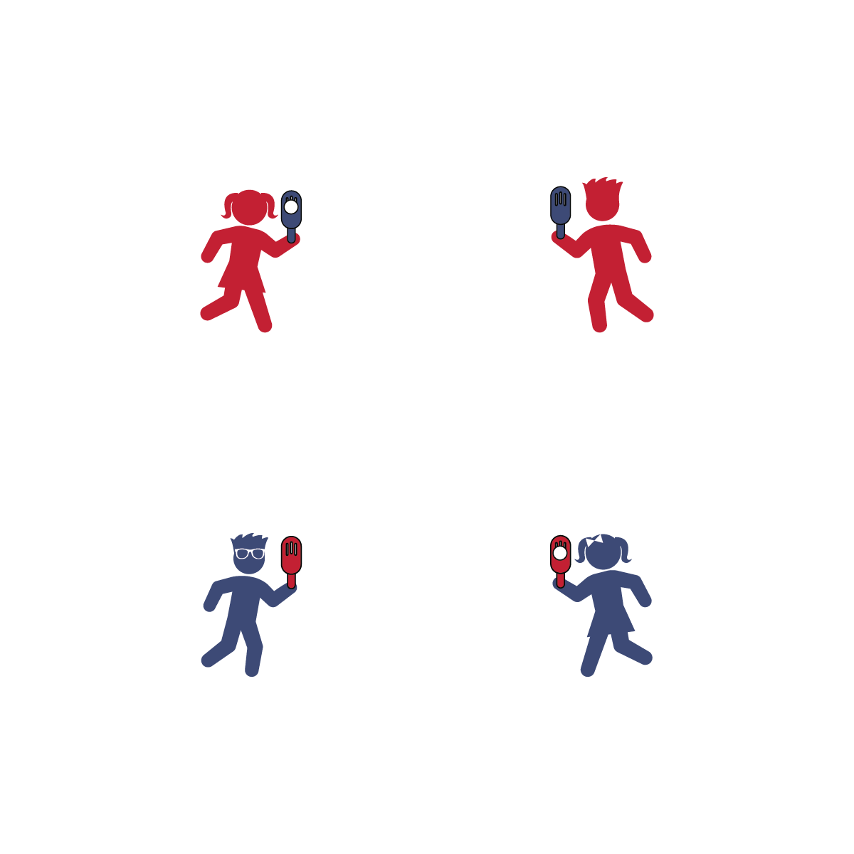

**Activity Procedures:**

1. Today’s activity is Fun with Scoops. We will be working on throwing and catching a ball using a Fun-Air Scoop.
2. Activity 1: Partner 1 will toss the ball underhand, and Partner 2 will catch it in the scoop. Challenge each other to catch 10 good tosses, and then switch roles.
3. Activity 2: Partner 1 holds the scoop with the head up at shoulder height, the open face toward the target, and the ball inside the scoop. Partner 1 will toss the ball using the scoop, and Partner 2 will catch it in her/his hands. Challenge each other to catch 10 good tosses, and then switch roles. Focus on soft and controlled tosses that can be caught.
4. Activity 3: Both partners will have a scoop. Practice passing the ball back and forth using only the scoop to throw and catch. Add a challenge by increasing the distance between partners.

**Tips:**

* Before tossing from the scoop to a partner, try tossing the ball against a wall. Continue against the wall until the tosser can demonstrate safe control and speed.

**Equipment:**

* 1 [Fun-Air Scoop](http://www.usgames.com/fun-air-scoop-ball) per player
* 1 ball per team of 2 players

**Set-Up:**

1. Find an open space with enough room to play catch.
2. Each player with 1 scoop, and each team with 1 ball.

* **Elevate Your Game:** Two cups ofbroccoli contains more Vitamin C than 2 oranges, and it contains about the same amount of Calcium as a cup of whole milk. Increase your Vitamin C and Calcium game with broccoli at lunch or dinner.
* I will demonstrate cooperation by safely practicing throwing and catching with a friend.
* Control Your Scoop
* Control the Ball
* Step to Target with Opposite Foot
* Keep Your Eye on the Ball