­­

PARACHUTE PASS

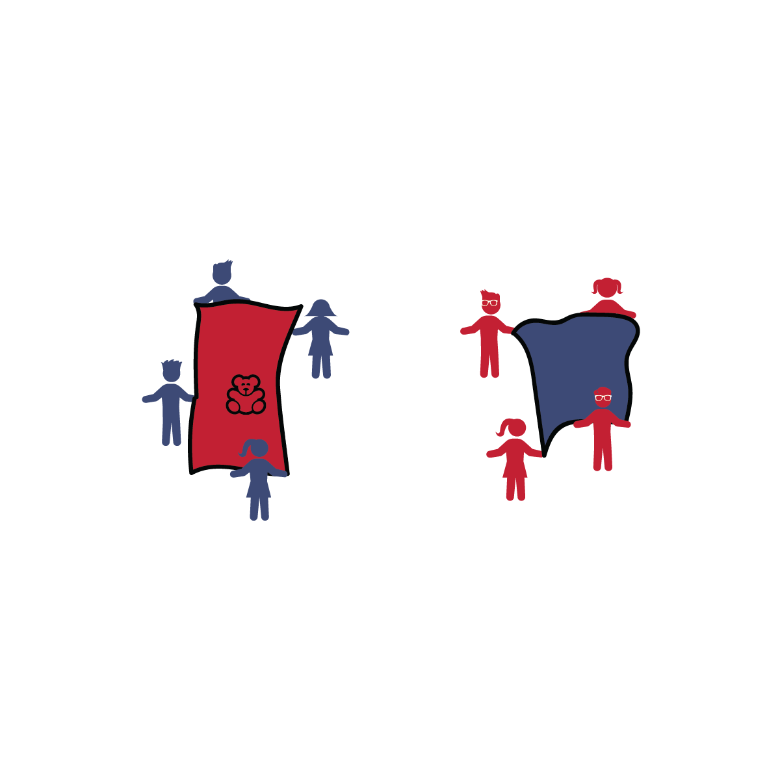

**Activity Procedures:**

1. It's time to play Parachute Pass! Let’s work together to pass the object safely back and forth.
2. On the start signal, the group that has the object on their parachute will try to send it through the air in the direction of their teammates in in the other group, who will try to catch it on their parachute. If a catch is made, the entire team gets a point...no catch, no point.
3. Switch roles so the catching group now tosses and vice versa.
4. Once a team accumulates a total of 5 points, 1 of the groups move back 2 giant steps, increasing the distance between the groups. Continue this pattern.

**Tips:**

* Create additional challenges by trying to pass objects that fly differently through the air. Then try multiple objects at the same time.

**Equipment:**

* 1 mini-parachute, large towel, or small tarp per group of 3–5 players
* 1 medium-sized tossable object (ball, stuffed animal, etc.) per 2 groups of 3–5 players

**Set-Up:**

1. Group players (3-5 per group), each with a mini parachute/large towel.
2. 2 groups will work together as 1 team during this challenge. They will start across from each other, about 8 feet apart.
3. 1 of the groups starts with the tossable object on their mini parachute/towel.

* **Keep Tossing:** You know what’s great about tossed salad? You can toss in all of the veggies and fruit that you like! Try tossing apples or mandarin oranges onto a bed of lettuce and shredded carrots. Yummy!
* I will demonstrate cooperation with teammates in order to master difficult challenges.
* Stay Inside Boundaries
* Blindfolds are Optional
* Think Safety First