­­

QUICK CUTS

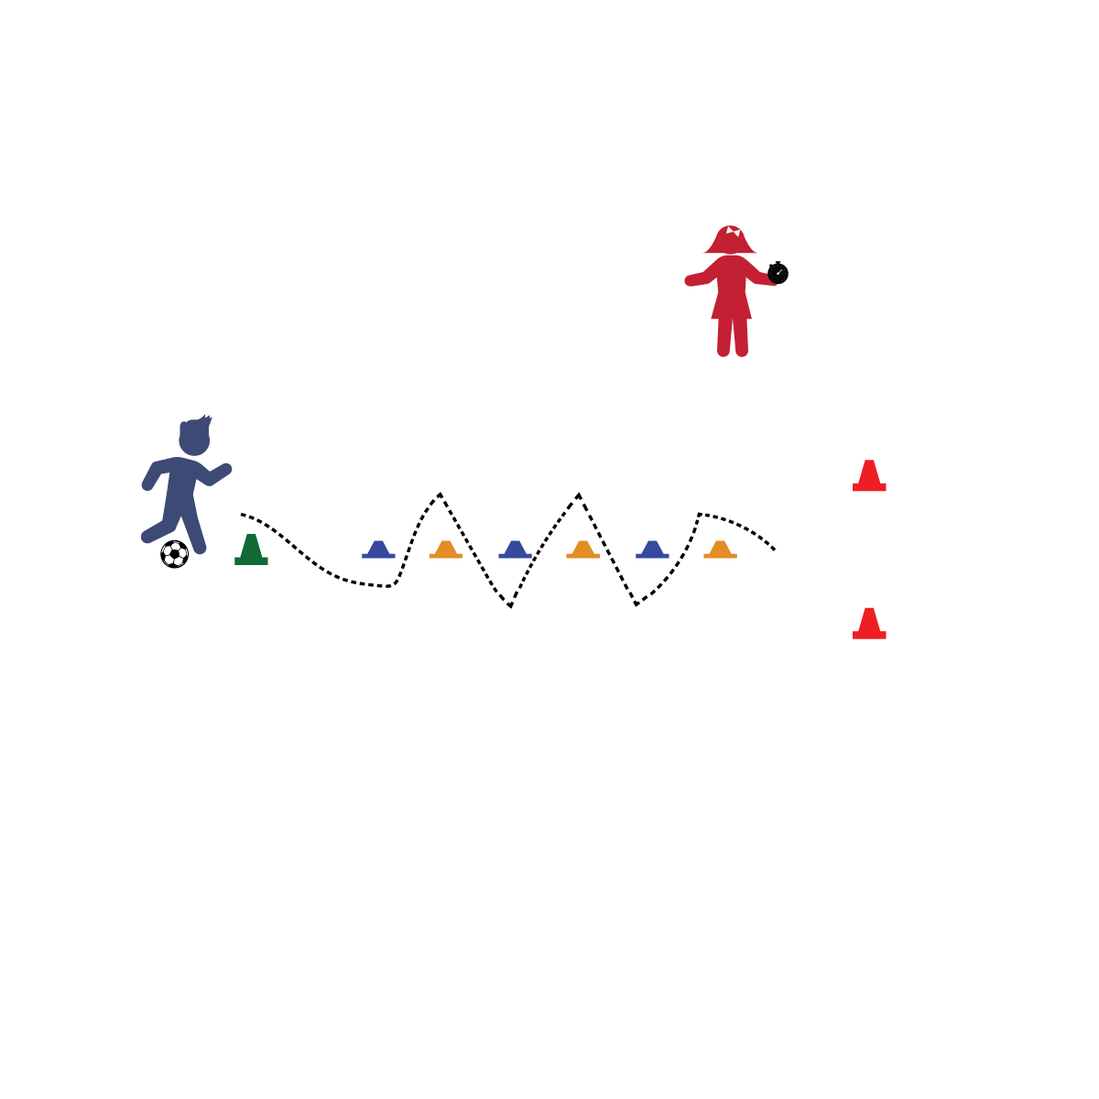

* **Take Your Time:** Time is important! How we spend our time during our day is extremely important, especially when it comes to food. Give yourself time to eat breakfast, lunch, and dinner. In addition, make sure you take your time while you eat: DON’T RUSH! Did you know it takes our brains 20–30 minutes from the time we start eating to tell our stomachs we’re full? Find time each day to sit down and eat a slow and healthy meal!
* I will give my best effort while dribbling through the obstacle course.

**Activity Procedures:**

1. Today’s activity is called Quick Cuts. We are going to have fun practicing our foot dribbling and shooting skills.
2. 1 person will begin at the starting cone with a soccer ball at their feet. On the signal, “Ready, Set Go!” the clock will start. Start dribbling the course by "cutting" in and out of cones and controlling the ball with your feet. If you miss a cone, you must go back and complete it.
3. When you reach the end of the course, shoot and until you score in the goal. Once a goal is scored, the clock will stop.
4. Try to beat your personal time or play with a friend for a competitive dribbling race.
5. Got it down?? Make a new course and try again.

**Tips:**

* Use small touches to maintain control of the ball.
* Use inside, outside, and laces of feet. No toes.
* Use accuracy when shooting at the goal. It’s almost like a pass into the net.
* Try to keep your head up when dribbling.
* Soft Touches Keep Control
* Use All of Your Foot
* Head Up on the Dribble

**Equipment:**

* 15 spot markers, cones, or pinnies
* 1 soccer ball
* 1 "goal"
* 1 stopwatch

**Set-Up:**

1. Set up a speed-dribbling course using the cones: Designate a starting cone, and then place 14 cones in a row after it, about 3–5 feet away from each other. The cones must have enough room for a player to dribble in between them.
2. Place a goal at the end of dribbling course.