­­

SOCCER CROQUET

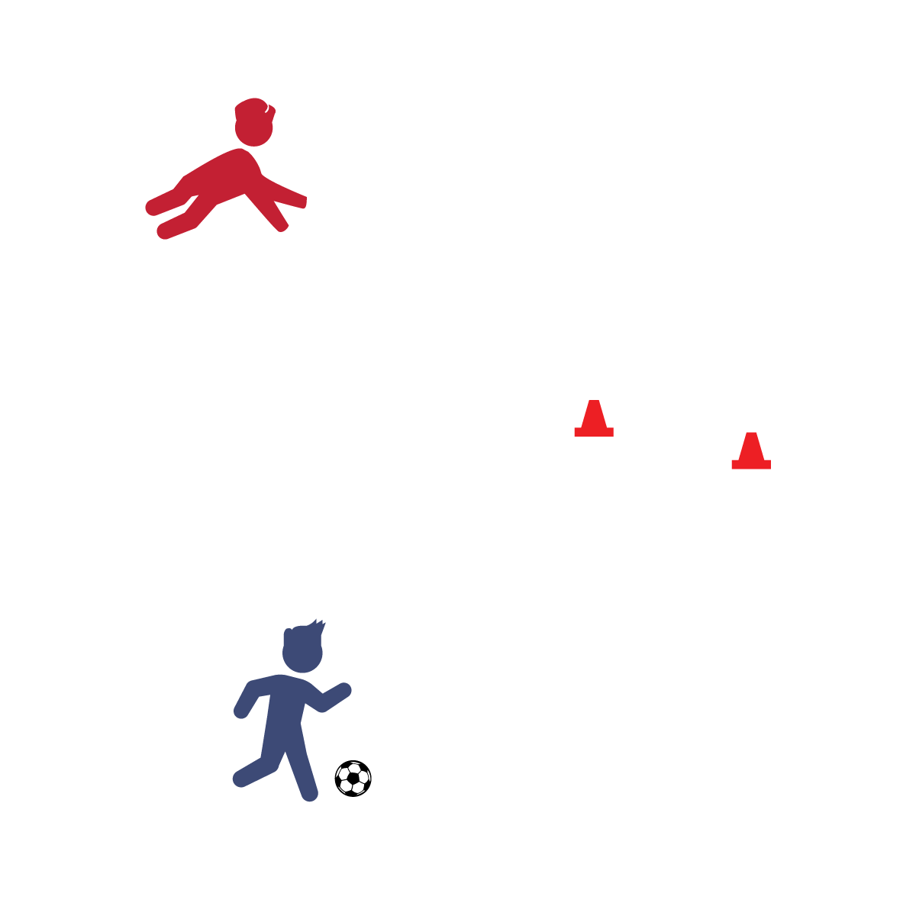

**Activity Procedures:**

1. It's time to play Soccer Croquet! The object of the game is to see how many hits it takes you to pass the soccer ball through the wickets.
2. Player 1 will begin at the starting point. Count how many passes it takes you to pass the ball through the 2 cones (the first wicket).
3. Then, keep counting and see how many more passes it takes you to pass the ball under the player making a crab pose (the second wicket).
4. Switch roles (someone else becomes the wicket) and play again. The player with the lowest score wins that round!

**Tips:**

* Use the inside of your foot to pass the ball. This will improve your accuracy.  
  Vary the distance in between the wickets to increase or decrease the difficulty.
* Change your crab pose to another position that supports muscular endurance (plank, squat, etc.).
* **Balance It Out:** Muscular fitness is only 1 aspect of balanced wellness. We also need to make sure that we are eating a healthy, well-balanced diet. This includes counting the number of sugar-sweetened beverages you drink each day. Just like in Soccer Croquet, the lowest score wins. Aim for a score of zero whenever possible!

**Equipment:**

* 1 soccer ball
* 2 cones or markers

**Set-Up:**

1. Determine a starting point. Place the soccer ball there.
2. Place 2 cones (spaced 2–3 feet apart) approximately 10–20 paces away from the starting point.
3. 1 player assumes a crab position anywhere in the activity area, but not near the cones.

* I will demonstrate ball control and accuracy while working cooperatively with my friends.
* Soft Touches Keep Control
* Use All of Your Foot
* Head Up on the Dribble