**PROTECTING THE ESTUARY**

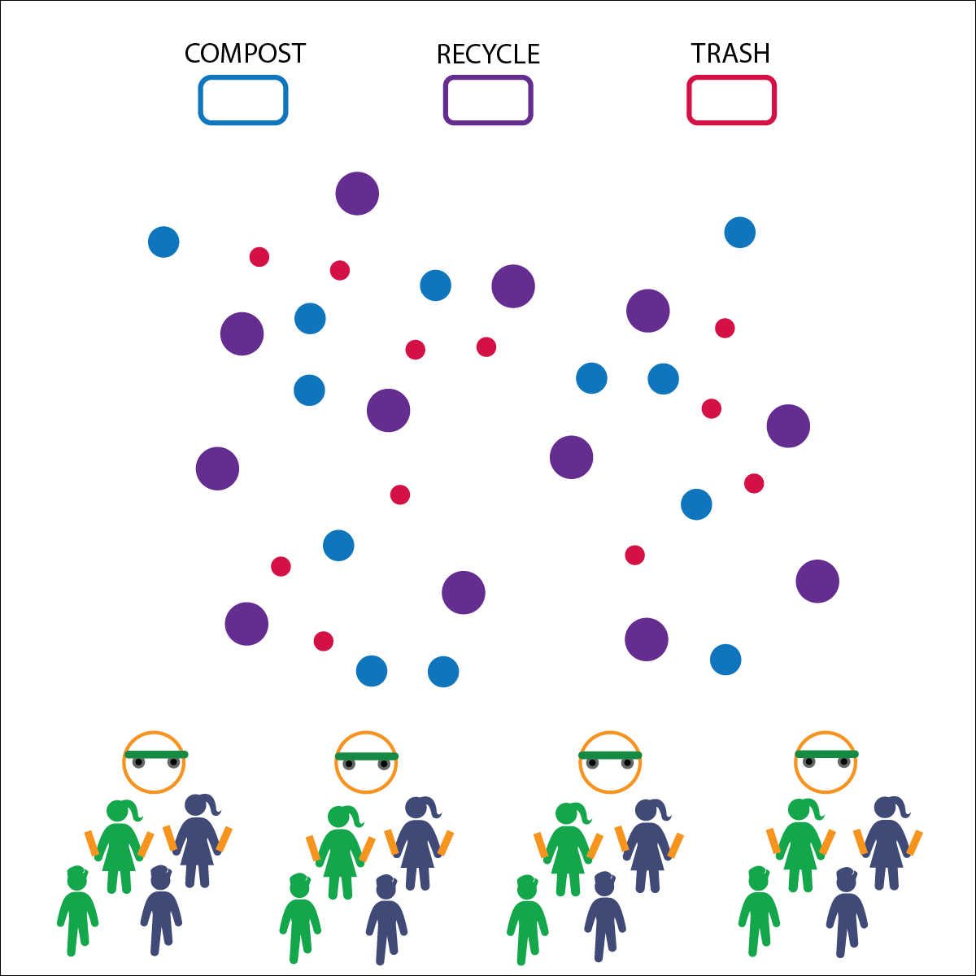

* Scooter Safety (See Poster)
* Work Together
* Reduce, Reuse, Recycle

**Activity Procedures:**

1. Today’s activity is called Protecting the Estuary. In this game, we will learn about conservation and ways to help protect our estuaries.
2. Human activities on land can harm the estuaries’ health and often damage living conditions for the creatures that live in and visit the estuaries. Stream and river banks can be damaged by erosion that comes from outdated agricultural or forestry methods, or by construction too close to the stream. Today we are going to be cleaning up the shores and beaches of the bay (gym floor).
3. When I say, “GO!” 1 set of partners at your dock (hoop) will work together to pick up waste (balls) off the beach. Partner 1 will drive the boat, and Partner 2 will work the nets (noodles) to gather the waste. Do not use your hands.
4. After picking up the waste, bring it back to the docks. Then the next pair will complete the activity. Continue until all waste has been cleaned off the beach.
5. Once all the waste has been picked up, work with other students at your dock to sort the trash into 3 piles: waste, recycling, compost. (Teachers, choose a color or size ball to represent each type of waste.)

**Next Gen Extension:** Develop (and/or promote) in-school recycling and composting programs to emphasize the importance of conservation.

**Equipment:**

* 1 scooter per 4 students
* 2 half-cut noodles per 2 students
* 30–50 balls of different colors or sizes
* 1 hoop per 4 students
* 3 storage bins

**Set-Up:**

1. Place hoops at the end of the activity area with 1 scooter inside each hoop.
2. Place the storage bins at the other end of the activity area. Label them “trash,” “recycle,” and “compost.”
3. Scatter the balls in general space.
4. Pair students, 2 pairs standing behind each hoop. Give 1 person from each pair 2 noodles.

* **Skill:** I will demonstrate balance as I move through open space.
* **Cognitive:** I will learn about activities that protect the estuary while exploring general space.
* **Fitness:** I will demonstrate muscular strength and endurance while pretending to explore an estuary.
* **Personal & Social Responsibility:** I will work safely with my classmates as we learn about the Chesapeake Bay.

**PROTECTING THE ESTUARY**



* Perform the activity without scooters and use only locomotor movements.
* Allow students to pick up and carry objects with their hands.



* **DOK 1:** What are human activities that we could include on a list of things that negatively impact estuaries?
* **DOK 2:** How can human activities positively affect estuaries?
* **DOK 3:** How is the health of our estuaries related to our community’s health?
* **DOK 4:** Let’s create a daily plan that will include 3 things we can do to help keep our environment healthy.

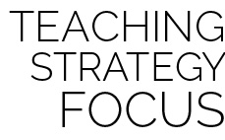

**Make Connections:** Learning about the environment and how it links to the health of the planet is very important to understanding our connection to the environment and our community. Without healthy estuaries, the food chain and water supply suffer and negatively impact our way of life. Helping students understand this link will strengthen our communities and help our local ecosystems thrive. If everybody does their part for the environment, we all win.



* **Standard 2 [E1.3-5]:** Recognizes the concept of open spaces in a movement context (3); Applies the concept of open spaces to combination skills involving traveling (e.g., dribbling and traveling) (4a); Combines spatial concepts with locomotor and non-locomotor movements for small groups in gymnastics, dance, and games environments (5).
* **Standard 2 [E2.3-5]:** Recognizes locomotor skills specific to a wide variety of physical activities (3); Combines movement concepts with skills in small-sided practice tasks, gymnastics, and dance environments (4); Combines movement concepts with skills in small-sided practice tasks/games environments, gymnastics, and dance with self-direction (5).
* **Next Generation Science Standard 5-ESS3.C:** Human activities in agriculture, industry, and everyday life have had major effects on the land, vegetation, streams, ocean, air, and even outer space. But individuals and communities are doing things to help protect Earth’s resources and environments.
* **Next Generation Science Standard 3-LS4.D:** Populations live in a variety of habitats, and change in those habitats affects the organisms living there.



Bay, Compost, Conservation, Estuary, Landfill Waste, Reduce, Reuse, Recycle