**CHESAPEAKE BAY RESTORATION**

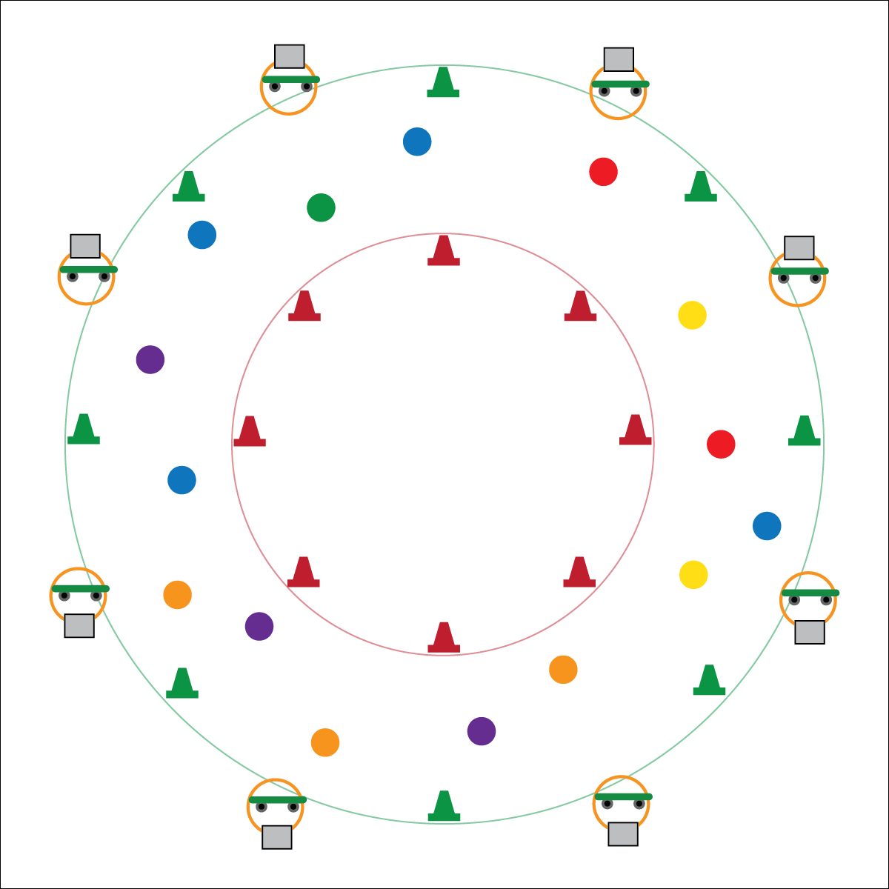

**Activity Procedures:**

1. Today’s activity is called Chesapeake Bay Restoration. The object of the activity is keep the estuary healthy while driving your boat around the bay as many times as you can.
2. You will take turns with the other students in your group by driving the boat (scooter) safely through the channel. Your goal is to avoid the man-made environmental conditions (poly spots) that are causing illness and damage within the bay. Each color represents a different environmental factor.
3. When I say, “GO!” 1 student from each group will begin driving their boat (laying down on the scooter in the prone position or on bottom with feet propelling them forward). Drive your boat in the zone between the red and green cones while trying to avoid the poly spots. If you touch a spot, remember its color.
4. When you return from your lap around the channel, your group must complete the physical challenges from the task card that matches the environmental hazards you touched with your boat. By completing the challenges, you will be working to actively reduce the amount of pollution in the bay (restoration).
5. Your group will take turns driving the boat around the bay. Keep track of the number of laps your group completes without touching a spot. At the end of the time period, the group with the greatest number of clean laps completed will receive the “most responsible boat on the water” award.

**Next Gen Extension:** Take students on a walking field trip in the community to pick up trash and clean up storm runoffs that drain to local waterways.

**Equipment:**

* 1 scooter per group of 3 students
* 4–8 green cones
* 4–8 red cones
* 30–50 poly spots (in 6 colors)
* 1 task card per group of 3 students

**Set-Up:**

1. Develop a circular boating channel using cones: Arrange red cones in a circle in the middle of the activity area, and arrange green cones in a circle around on the outside of the room as a safety zone for the shallow water areas of the bay.
2. Create a series of “docks” by placing 1 hoop and scooter together on the perimeter in between the green cones. Place a task card inside each hoop.
3. Scatter poly spots throughout the boating channel.

* Stay in the Channel
* Scooter Safety
* Move in Personal Space
* **Skill:** I will demonstrate balance and coordination on a scooter.
* **Cognitive:** I will discuss ways to keep an estuary healthy.
* **Fitness:** I will apply muscular strength and endurance to scooter activities.
* **Personal & Social Responsibility:** I will work safely with my classmates as we pretend to swim in the Chesapeake Bay.

**BAY RESTORATION**



* Perform the activity without scooters and use only locomotor movements.
* Use few (or no) poly spot obstacles.
* Use brightly colored spots and boundaries.
* Provide auditory signals to help students with visual impairments move around the channel.



* **DOK 1:** What is restoration?
* **DOK 2:** What does restoration look like in an estuary like the Chesapeake Bay (or name your local estuary)?
* **DOK 3:** How is the use of gasoline related to estuary health?
* **DOK 4:** Let’s identify strengths and weaknesses in our community related to estuary health. What are weaknesses that we can work to improve upon?



* **Standard 1 [E11.3-5]:** Combines locomotor skills and movement concepts (levels, shapes, extensions, pathways, force, time, flow) (3); Combines locomotors and movement concepts (levels, shapes, extensions, pathways, force, time, flow) (4); Combines locomotor skills and movement concepts (levels, shapes, extensions, pathways, force, time, flow) (5)**.**
* **Standard 2 [E1.3-5]:** Recognizes the concept of open spaces in a movement context (3); Applies the concept of open spaces to combination skills involving traveling (4a); Combines spatial concepts with locomotor and non-locomotor movements for small groups in game environments (5).
* **Next Generation Science Standard 5-ESS3.C:** Human activities in agriculture, industry, and everyday life have had major effects on the land, vegetation, streams, ocean, air, and even outer space. But individuals and communities are doing things to help protect Earth’s resources and environments.
* **Next Generation Science Standard 4-ESS3.A:** Energy and fuels that humans use are derived from natural sources, and their use affects the environment in multiple ways. Some resources are renewable over time, and others are not.
* **Next Generation Science Standard 3-LS4.D:** Populations live in a variety of habitats, and change in those habitats affects the organisms living there.

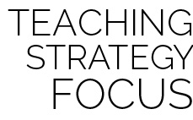

**Cause and effect:** While discussing estuary health, it’s important to help students explore the cause and effect relationships that exist between humans’ use of energy and fuels and their effects on the environment.



Conservation, Dead Zones, Environmental Impact, Estuary, Natural Resource, Plastic, Restoration