­­

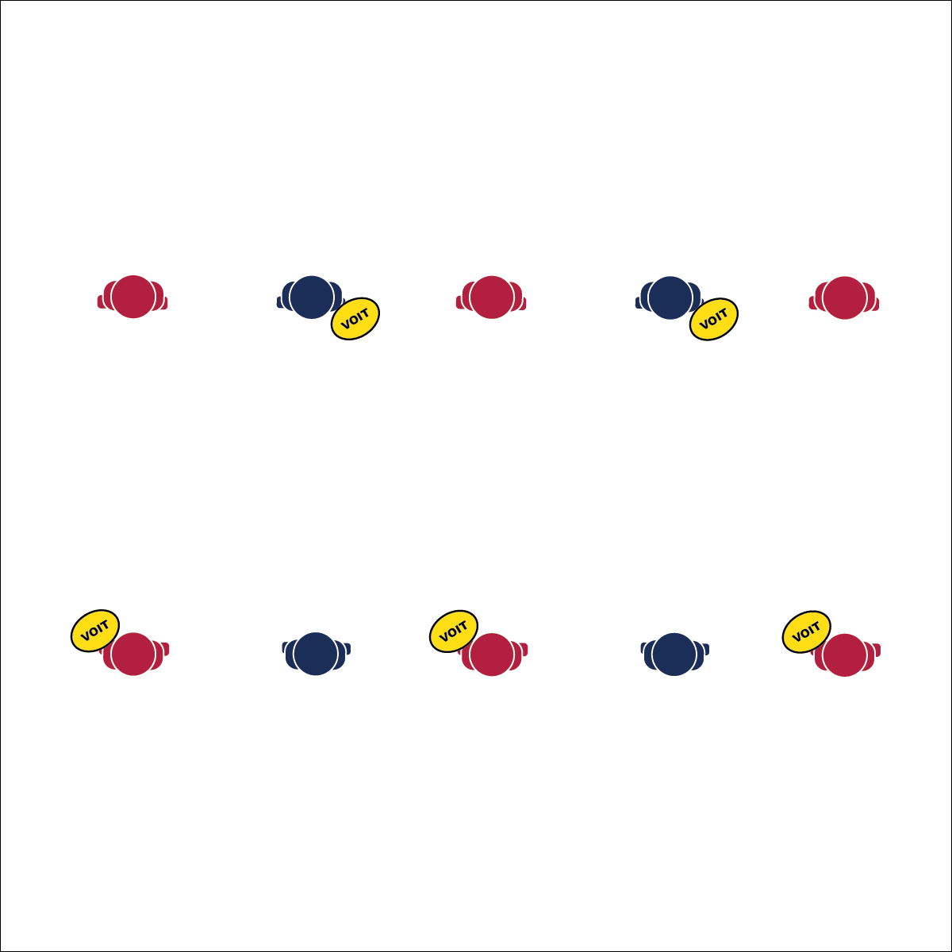

**Throw**

* Thumb on Top
* Curl Disc In, Extend and Snap

**Catch**

* 2 Hands Out in Front
* Palms Facing Each Other
* Snap Together

**Activity Procedures:**

1. Today’s activity is called Toss-Up. The object of the activity is to practice our throws and catches.
2. Let’s make sure we keep our heads up and remember to call our partners’ names to let them know when we’re about to throw the disc.
3. There are 2 types of throws: the backhand and the forehand (flick). When executing a backhand throw, your fingers should be in the cup of the disc, and your thumb should be on top. When executing a forehand throw, your pointer and middle fingers should be under the disc, and your thumb should be on top. Keep the disc parallel to the ground. Apply the proper amount of force.
4. The catch we will be focusing on today is called a pancake/hamburger catch. To execute this catch, you will simply clap your hands on the top and bottom of the disc so that it stops between your palms.
5. On the start signal, practice backhand throws and pancake catches back and forth. After each partner has executed 5 throws, if you feel comfortable, take a few steps back to throw at a longer distance.
6. After each partner has executed 10 total backhand throws, switch and try the forehand throw (flick) at least 5 times before taking a few steps back.

**Grade Level Progression:**

**6th:** Play the activity as written above.

**7th:** Increase the distance between partners.

**8th:** Develop throwing challenges using different distances and numbers of successful throws/catches.

**Equipment:**

* 1 flying disc per pair of students

**Set-Up:**

1. Pair students, each pair with a disc.
2. Arrange partners at least 10 feet away from each other.

* **Skill:** I will demonstrate proper throwing & catching technique.
* **Cognitive:** I will explain proper throwing cues and apply proper technique in game settings.
* **Fitness:** I will demonstrate the health-related fitness components as they relate to Ultimate.
* **Personal & Social Responsibility:** I will be aware of my surroundings and work safely with a partner during skill practice.

**TOSS-UP**

**TOSS-UP**

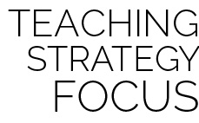

**Identify critical content.** Throwing and catching the disc are critical skills that will determine the level of success that a student has. Provide detailed instructional demonstrations and interact with students during skill practice.



* **DOK 1:** Can you list the components of health-related fitness?
* **DOK 2:** Which component(s) of health-related fitness affects your ability to throw the disc?
* **DOK 3:** How might you change your throw if someone were playing defense on you?



* **Adaptation:** Use foam or smaller-sized discs. Decrease the distance between partners to increase chances of success.
* **Extension:** Students attempt to throw the disc at an arced angle instead of straight ahead. Provide enough space for student to safely experiment with disc angles and arcs.



Backhand, Catch, Disc, Forehand (Flick), Health-Related Fitness, Pancake, Throw

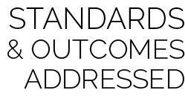

* **Standard 1 [M2.6-8]:** Throws with a mature pattern for distance or power appropriate to the practice task (e.g., distance = outfield to home plate; power = 2nd base to 1st base) (6); Throws with a mature pattern for distance or power appropriate to the activity in a dynamic environment (7); Throws with a mature pattern for distance or power appropriate to the activity during small-sided game play (8).
* **Standard 1 [M3.6-8]:** Catches with a mature pattern from a variety of trajectories using different objects in varying practice tasks (6); Catches with a mature pattern from a variety of trajectories using different objects in small-sided game play (7); Catches using an implement in a dynamic environment or modified game play (8).
* **Standard 3 [M7.6-8]:** Identifies the components of skill-related fitness (6); Distinguishes between health-related and skill-related fitness (7); Compares and contrasts health-related fitness components (8).