­­

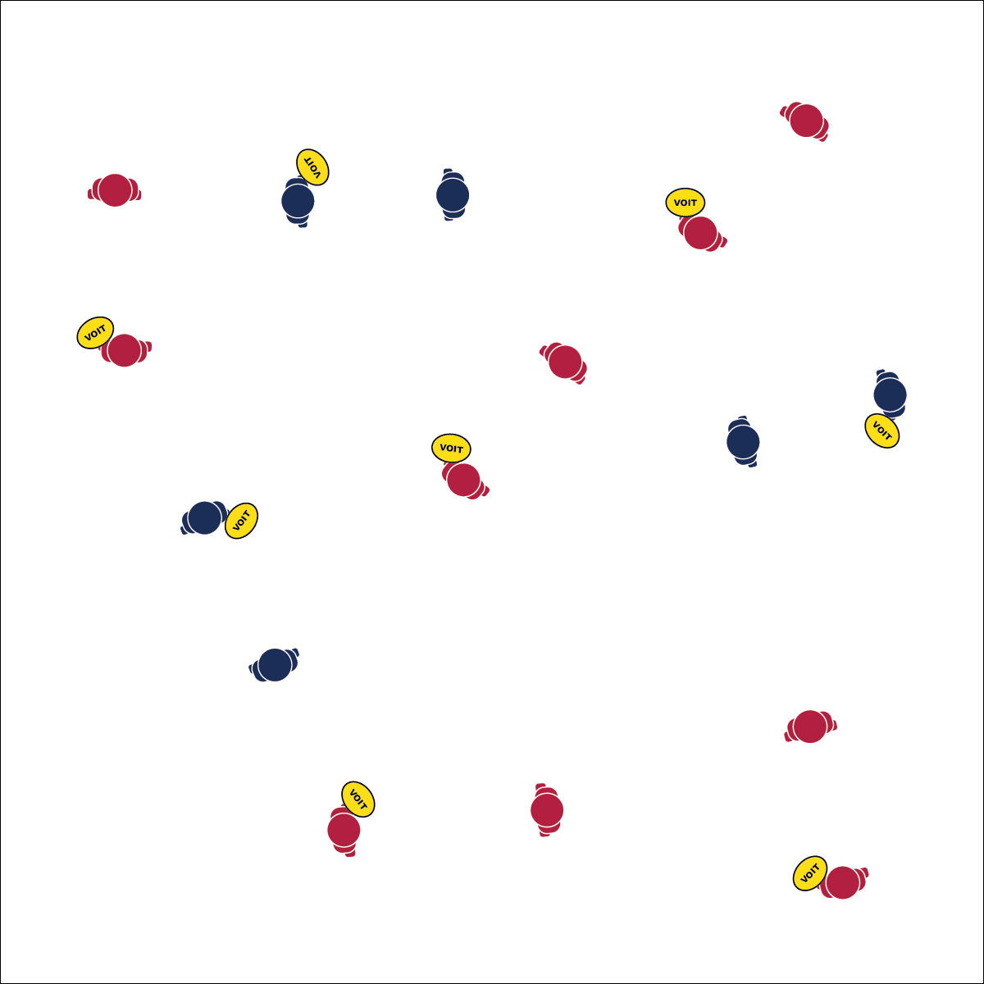

**THROW AND GO**

* **Skill:** I will demonstrate a leading pass to my partner.
* **Cognitive:** I will understand the importance of throwing a leading pass in Ultimate Disc.
* **Fitness:** I will demonstrate cardiorespiratory endurance while participating in partner activities.
* **Personal & Social Responsibility:** I will follow the rules and maintain the spirit of the game.
* Look Up
* Hands Up
* Spirit of the Game

**Equipment:**

* 1 flying disc per pair of students

**Set-Up:**

1. Pair students, each pair with 1 disc.
2. Arrange pairs throughout the activity area with plenty of space for safe play.

**Activity Procedures:**

1. Today’s activity is called Throw and Go.
2. The object of the activity is to throw a leading pass to your partner that they can catch while on the run.
3. When you hear the start signal, the partner without the disc will begin by running in to open space. The partner with the disc will then throw it a few feet in front of the runner, and the runner will attempt to catch it. Throwers, choose a distance that will allow the runner to be successful.
4. After the disc is caught, switch roles. Continue until you hear the stop signal.

**Grade Level Progression:**

**6th:** Play the activity as described above.

**7th:** Increase the distance between partners.

**8th:** Develop gamification challenges by limiting the number or types of throws used by the partners to a marked distance or target.

**THROW AND GO**



Curve, Cut, Cardiorespiratory Endurance, Lead Pass, Pivot, Spirit of the Game



* **Standard 1 [M4.6-8]:** Passes and receives with hands in combination with locomotor patterns of running and change of direction and speed with competency in invasion games such as basketball, fag football, speedball, or team handball (6); Passes and receives with feet in combination with locomotor patterns of running and change of direction and speed with competency in invasion games such as soccer, socci, or speedball (7); Passes and receives with an implement in combination with locomotor patterns of running and change of direction, speed, and/or level with competency in invasion games such as lacrosse or hockey (floor, field, ice) (8).
* **Standard 1 [M5.6-8]:** Throws, while stationary, a leading pass to a moving receiver (6); Throws, while moving, a leading pass to a moving receiver (7); Throws a lead pass to a moving partner of a dribble or pass (8).
* **Standard 4 [M4.6-8]:** Accepts differences among classmates in physical development, maturation and varying skill levels by providing encouragement and positive feedback (6); Demonstrates cooperation skills by establishing rules and guidelines for resolving conflicts (7); Responds appropriately to participants’ ethical and unethical behavior during physical activity by using rules and guidelines for resolving conflicts (8).



* **DOK:** What is a leading pass?
* **DOK 2:** How can you apply what you learned to improve your passes and catches?
* **DOK 3:** How is this activity related to other invasion sports (like soccer or basketball)?



**Help students process content:** Take time to have detailed discussion about the lead pass and its application to all invasion sports. This will allow students to access prior knowledge, process their practice experience, and elaborate on concepts.



* **Adaptation:** Use foam or smaller-sized discs. Decrease the distance between partners to increase chances of success.
* **Extension:** Split students into groups of 3. Play as described above, but with the 3rd student playing defense.