­­



**GOALTIMATE**

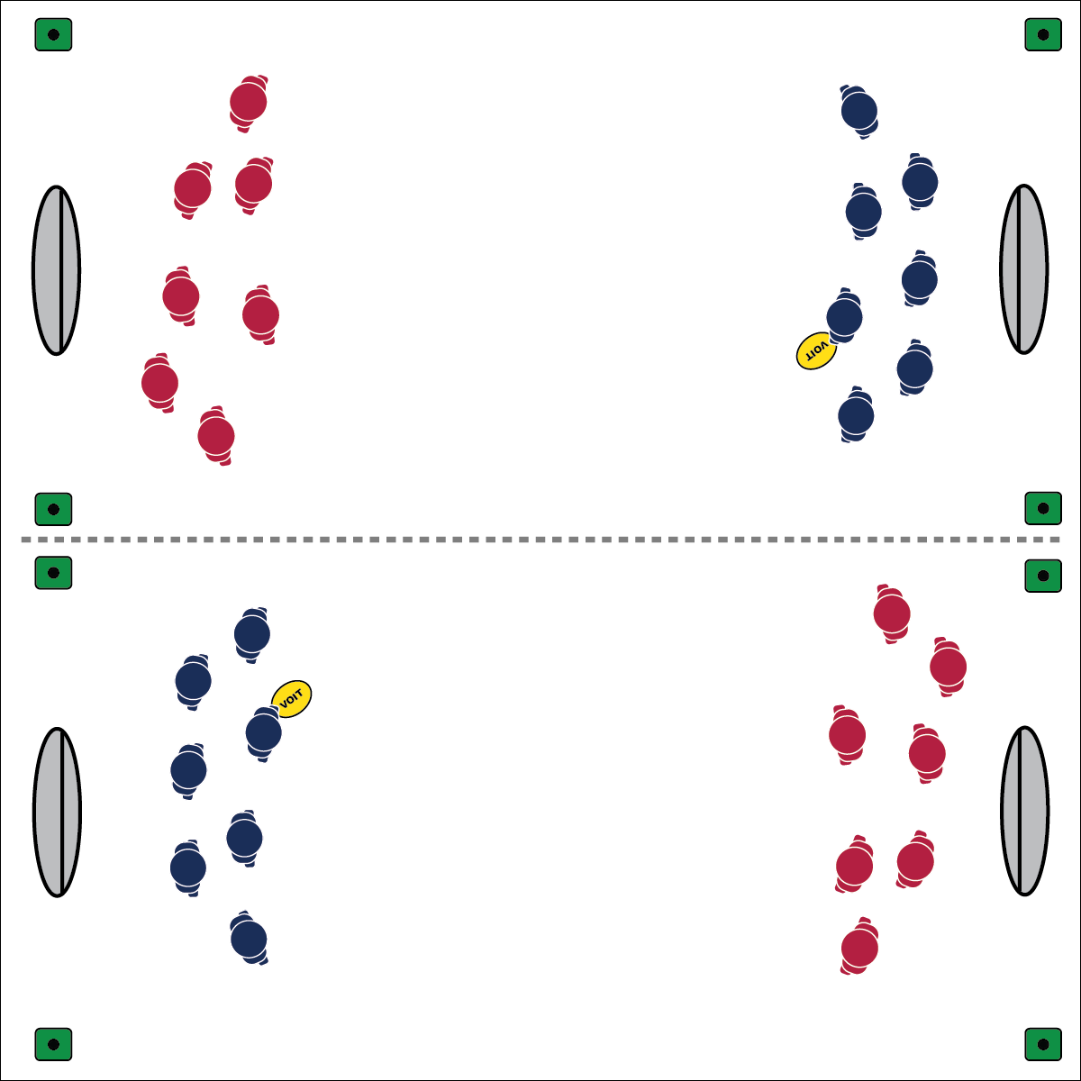

* **Skill:** I will demonstrate proper technique when throwing and catching the disc.
* **Cognitive:** I will discuss the roles of the cutter and the handler in Ultimate Disc.
* **Fitness:** I will participate and remain actively engaged.
* **Personal & Social Responsibility:** I will demonstrate the spirit of the game and respect my peers and the equipment.
* Pivot, Flick, Follow Through
* Move Without The Disc
* Find Open Space (offense)
* Close Space (defense)

**Equipment:**

* 4 cones per group of 14 students
* 2 large pop-up goals per group of 14 students
* 1 flying disc per group of 14 students
* 1 pinnies per 2 students

**Set-Up:**

1. Use cones to create a large (~40’x60’) playing field. 1 field per group of 14 students. Place a goal at either end of each field.
2. Divide students into groups of 14, each group with a disc at a field.
3. Divide each group into 2 teams of 7, 1 team per group in pinnies.

**Activity Procedures:**

1. Today’s activity is called Goaltimate. This activity is a lot like Ultimate Disc, but to score, you must throw the disc into the goal.
2. The object of the activity is to score the most goals before the time runs out.
3. Each team will begin at 1 of the goals. To start the point, 1 of the players on defense will pull (throw) the disc to the other team as far as they can.
4. Once the offense catches the disc or picks it up, the point has started.
5. When marking an offensive player with the disc, the mark will count by saying, “stall 1, stall 2,” etc. If the mark reaches 10 and yells, “stall,” this is a turnover and the other team will get the disc.
6. When a team earns a point (or there is a turnover), the teams will switch roles.
7. You must throw the disc into the goal to get a point. You can’t roll into the goal.
8. Games will be 7 minutes each (or other designated time), and then the next game will start.

**Grade Level Progression:**

**6th:** You must to make passes to 3 different players before scoring on the goal.

**7th:** You can only score a point if you are within 15 feet of the goal.

**8th:** Play activity as described above.

**GOALTIMATE**



Cutter, Defensive Pressure, Handler, Mark, Pivot, Pull, Stall



* **Standard 2 [M4.6-8]:** Reduces open space on defense by making the body larger and reducing passing angles (6); Reduces open space on defense by staying close to the opponent as he/she nears the goal (7); Reduces open space on defense by staying on the goal side of the offensive player and reducing the distance to him/her (third-party perspective) (8).
* **Standard 2 [M5.6-8]:** Reduces open space by not allowing the catch (denial) or by allowing the catch but not the return pass (6); Reduces open space by not allowing the catch (denial) or anticipating the speed of the object or person for the purpose of interception or deflection (7); Reduces open space by not allowing the catch (denial) and anticipating the speed of the object or person for the purpose of interception or deflection (8).
* **Standard 5 [M6.6-8]:** Demonstrates respect for self and others in activities and games by following the rules, encouraging others and playing within the spirit of the game or activity (6); Demonstrates the importance of social interaction by helping and encouraging others, avoiding trash talk and providing support to classmates (7); Demonstrates respect for self by asking for help and helping others in various physical activities (8).



* **DOK 1:** What is the handler role in Ultimate Disc?
* **DOK 1:** What is the cutter role in Ultimate Disc?
* **DOK 2:** How did the stall count affect your throw in the game?
* **DOK 3:** How is defensive pressure related to the game of Ultimate Disc?

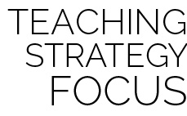

**Strategy Focus:** How to teach the strategy focus



* **Adaptation:** Make the goals bigger. Increase or decrease the size of the field to meet the needs of your students. Use multiple goals for each team. Use a foam ball rather than a disc.
* **Extension:** Have the students develop a different type of end zone for scoring. The students can create multiple goals and end zones in the playing area.