­­



**ULTIMATE DISC**

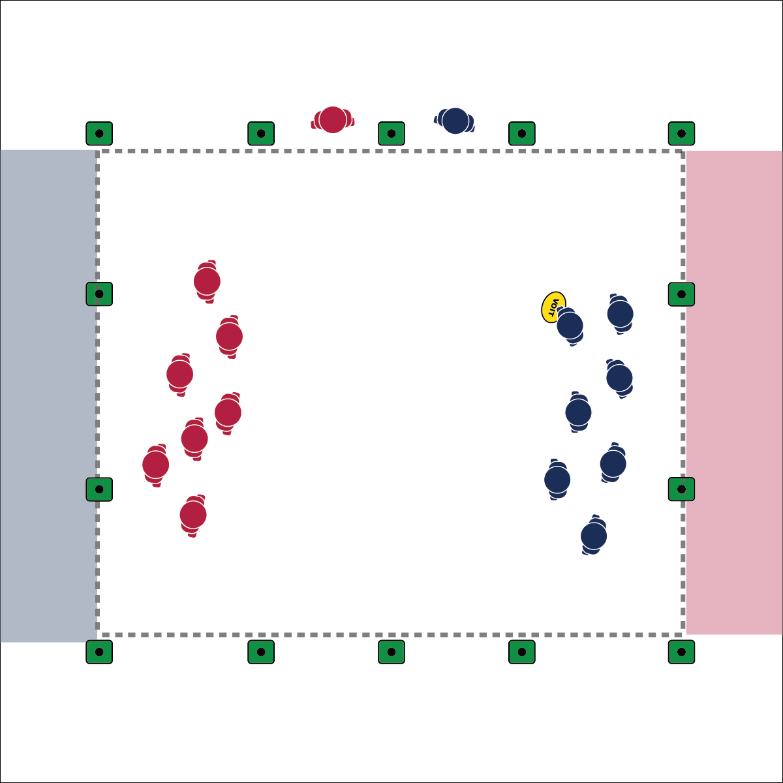

* **Skill:** I will apply my skills in a game of Ultimate Disc.
* **Cognitive:** I apply the strategies I’ve learned in a game of Ultimate Disc.
* **Fitness:** I will discuss health-related fitness as it relates to Ultimate Disc.
* **Personal & Social Responsibility:** I demonstrate good sportsmanship, etiquette, and spirit of the game.
* Spirit of the Game
* Move with Purpose
* Communicate with Teammates

**Equipment:**

* 1 flying disc per group of 16 students
* 12 low-profile cones per group of 16 students
* 1 pinnie per 2 students

**Set-Up:**

1. Set up 1 Ultimate Disc field per 16 students. Each field is marked by 8 cones with 4 cones to make each end zone.
2. Divide students into groups of 16, each group with a disc.
3. Divide each group into 2 teams of 8, 1 team per group in pinnies.

**Activity Procedures:**

1. Today’s it’s time to play of full game of Ultimate Disc. This will be a full-sized ultimate game using 7 players and 1 disc. Each team will have 1 substitute.
2. The object of the activity is to apply everything you’ve learned and try to score more points than the other team.
3. You have 3 minutes to discuss your team’s strategies for scoring points quickly and efficiently. Students will run the game themselves, calling fouls, interceptions, turnovers, and other rules while the teacher observes. Substitute players will active as sideline referees providing the final word on disputed calls. If sideline referees cannot agree, they play rock, paper, scissor to keep the game moving.
4. Games are 8 minutes (or whatever set time you choose). We will break for substitutions at X minutes (you choose substitution timeframe). Teams are allowed 1 timeout.
5. Above all, let’s be respectful and follow the rules. When the game is over, teams will move to another field to face a new team.

**Grade Level Progression:**

**6th:** The teacher will help students officiate the game.

**7th:** Play the activity as described above. Students officiate their own games.

**8th:** Students will develop practice plans and challenge themselves to execute complex plays for scoring.

**ULTIMATE DISC**



Communicate, End Zone, Etiquette, Purpose, Score, Spirit of the Game, Teamwork



* **Standard 1 [M6.6-8]:** Performs pivots, fakes, and jab steps designed to create open space during practice tasks (6); Executes at least one of the following designed to create open space during small-sided game play: pivots, fakes, jab steps (7); Executes at least two of the following to create open space during modified game play: pivots, fakes, jab steps, screens (8).
* **Standard 3 [M5.6-8]:** Participates in a variety of lifetime recreational team sports, outdoor pursuits or dance activities (6); Participates in a variety of lifetime dual and individual sports, martial arts or aquatic activities (7); Participates in a self-selected lifetime sport, dance, aquatic, or outdoor activity outside of the school day (8).
* **Standard 4 [M6.6-8]:** Identifies the rules and etiquette for physical activities/games and dance activities (6); Demonstrates knowledge of rules and etiquette by self-officiating modified physical activities/games or following parameters to create or modify a dance (7); Applies rules and etiquette by acting as an official for modified physical activities/games and creating dance routines within a given set of parameters (8).
* **Standard 5 [M5.6-8]:** Identifies how self-expression and physical activity are related (6); Explains the relationship between self-expression and lifelong enjoyment through physical activity (7); Identifies and participates in an enjoyable activity that prompts individual self-expression (8).



* **DOK 1:** What health-related fitness components did you work to improve during today’s Ultimate Disc game?
* **DOK 2:** How would you compare and contrast Ultimate’s effect on health-related fitness with other sport or activities that you enjoy?
* **DOK 1:** How did you recognize spirit of the game during today’s Ultimate Disc game?
* **DOK 2:** How did classmate’s spirit of the game affect overall game enjoyment?
* **DOK 3:** On a scale from 1 to 10 (10 is the best), rate your overall Ultimate Disc experience. Support your answer with at least 2 specific examples/experiences.



**Manage response rate with tiered questioning techniques:** Utilizing the Depth of Knowledge (DOK) Debrief Questions above provides purposeful discussion points with ascending cognitive complexity. This will help students deepen their thinking about their experiences. Use this modules DOK Exit Slips to ensure that every student responds to these final questions and backs up their answers with evidence.

* **Adaptation:** Increase (or decrease) the size of the field. Use a foam ball or other tossable that encourages success. Provide brightly colored boundary makers. Provide an auditory signal in the end zones.
* **Extension:** Run a multi-day Ultimate Disc tournament. Provide time at the start of each class for students to run a team practice.

