­­



* **Skill:** I will…
* **Cognitive:** I will…
* **Fitness:** I will…
* **Personal & Social Responsibility:** I will…

**Cue Set**

* One
* Two

**Cue Set**

* One
* Two

**Activity Procedures:**

1. Today’s activity is called… The object of the activity is to…
2. On the start signal…
3. On the stop signal…
4. Safety considerations…

**Grade Level Progression:**

**6th:** Progression

**7th:** Progression

**8th:** Progression

**Equipment:**

* Equipment needs 1
* Equipment needs 2

**Set-Up:**

1. Equipment set-up.
2. Student grouping.
3. Student set up.

**BLANK ACTIVTY PLAN**

**BLANK ACTIVITY PLAN**

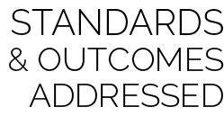

* **Standard X [MX.6-8]:** Text (6); Text (7); Text (8).
* **Standard X [MX.6-8]:** Test (6); Text (7); Text (8).

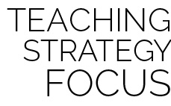

**Strategy Summary Statement.** Strategy description .



* **DOK 1:** Question?
* **DOK 2:** Question?
* **DOK 3:** Question?
* **DOK 4:** Question/Task?



* **Adaptation:** Adaptations go here
* **Extension:** Extenstions go here



Word, Word, More Words