­­

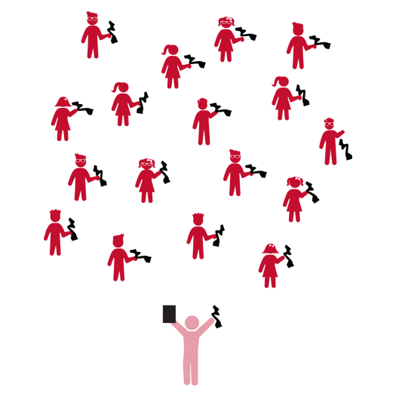

**Juggling Scarf Exploration 1**

* **Skill:** I will practice a variety of locomotor skills using the cues my teacher gives me in class.
* **Cognitive:** I will demonstrate at least 3 different pathways while I move throughout the activity area.
* **Fitness:** I will work to stay actively engaged during all of the scarf activities.
* **Personal & Social Responsibility:** I will demonstrate safe behaviors without being reminded by a teacher.
* Work Safely
* Respect Self-Space
* Actively Engage
* *See Skill Cue Teach Sheets for Skill-Specific Cues*

**Equipment:**

* 1 juggling scarf per student
* Juggling Scarf Activity Card

**Set-Up:**

1. Students scattered in activity area, each with a juggling scarf.
2. Juggling Scarf Activity Card ready on clipboard or tablet.

**Activity Procedures:**

1. Today we’re going to have fun exploring movement with juggling scarves.
2. I will show you a movement activity and then you can begin to move in the same way.
3. Teachers, use Part 1 of the Juggling Scarf Activity Card to follow this activity sequence: 1) Shapes & Directions; 2) Locomotor Moves; 3) Levels; 4) Pathways; 5) Letters & Numbers; 6) Tail Tag (2nd Grade).

**Grade Level Progression:**

**K:** Prompt students to hop, gallop, slide, and run. Focus on basic movement and pathways.

**1st:** Add a jog to the sequence. Focus on mature movement patterns as well as levels and relationships.

**2nd:** Focus on mature movements, including a skip. Students can combine shapes, levels, and pathways into simple travel sequences. Introduce Tail Tag, prompting students to skip during game play.

**Juggling Scarf Exploration 1**

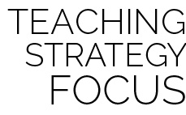

**Identify Critical Content:** As you begin to teach locomotor skills it’s important to take the time to define the elements of each one. This will help students connect concepts with their performance. Start slowly and add different skills over time, when it’s developmentally appropriate for your students. Likewise, helping students examine the differences and similarities between the skills will allow them to understand how and why each skill can be applied.



* **DOK 1:** Can you demonstrate a zigzag pathway? Curved? Straight?
* **DOK 2:** When have you used (or seen) a zigzag pathway? Curved? Straight?
* **DOK 3:** In a game like tag, why is it important to use different pathways for movement? What other games/activities include movement in different pathways?
* **DOK 1:** What is a locomotor skill? What are the different locomotor skills that you’ve learned?
* **DOK 2:** How is walking different than galloping? How are they the same?
* **DOK 2:** How is hopping different than jumping? How are they the same?

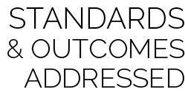

**Physical Education Priority Outcomes:**

* (K) Performs locomotor skills with balance.
* (1) Travels with balance using a variety of locomotor skills in dynamic environments.
* (2) Performs locomotor skills using a mature pattern and in rhythm.



* Demonstrate basic movements while holding 1 scarf. Allow students to explore the ways that the scarf moves during these movements with few specific expectations.



* Give students a second scarf. Prompt them to complete each challenge with 1 scarf in each hand.
* Prompt students to create their own movements and challenges to share with the class.



Actively Engage, Clockwise, Counter-Clockwise, General Space, Locomotor Skill, Gallop, Hop, Jog, Jump, Leap, Run, Side-Slide, Skip, Walk, Pathways, Safe, Self Space

**Juggling Scarf Exploration 2**

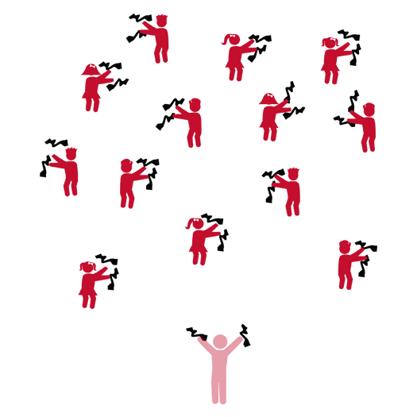

* **Skill:** I will experiment with different ways of tossing and then catching a scarf.
* **Cognitive:** I will explain the difference between self space and general space.
* **Fitness:** I will give at least one example of how I can be physically active outside of school.
* **Personal & Social Responsibility:** I will follow all directions.
* Work Safely
* Respect Self-Space
* Actively Engage
* *See Skill Cue Teach Sheets for Skill-Specific Cues*

**Equipment:**

* 2 juggling scarves per student
* Juggling Scarf Activity Card
* Up-tempo music

**Set-Up:**

1. Students scattered in activity area, each with 2 juggling scarves.
2. Juggling Scarf Activity Card ready on clipboard or tablet.

**Activity Procedures:**

1. Today we’re going to have more fun exploring movement with juggling scarves.
2. I will show you a movement activity and then you’ll repeat after me.
3. Teachers, use Part 2 of the Juggling Scarf Activity Card to follow this activity sequence: 1) Toss & Catch; 2) Toss Two 3) Partner Mirror; 4) Partner Lead; 5) Partner Juggle; 6) Group Juggle (2nd Grade).

**Grade Level Progression:**

**K:** Perform all activities with 1 scarf only. Introduce music and prompt students to move to the rhythm.

**1st:** Introduce the second scarf in Toss Two and continue with 2 scarves during partner activities.

**2nd:** Extend the Partner Lead activity to include various locomotor activities performed to the rhythm of music.

**Juggling Scarf Exploration 2**



**Help students elaborate on content:** Helping students elaborate and expand on their original thinking can be as simple as asking the question, “why?” As student process and make specific inferences prompt them to think even deeper and provide evidence to support their answers.



* **DOK 1:** What does self-space mean? What does general space mean?
* **DOK 2:** How are self-space and general space alike? How are they different?
* **DOK 3:** How does it make you feel if someone moves into your personal space? Why?
* **DOK 3:** If general space was crowded, describe some of the things you’d have to think about as you moved through the space.



**Physical Education Priority Outcomes:**

* (K) Safely moves in both personal and general space using different pathways and

speeds.

* (1) Safely moves demonstrating a variety of relationships with people and objects.
* (2) Controls force (strong and light) and speed (fast and slow) while moving in static and dynamic environments.



* Use music with basic rhythms and slow to medium tempos.
* Focusing on tossing the scarves, allowing them to fall to the floor without a catch.



* Use different music with a variety of rhythms and tempos.
* Prompt students to create movement routines they can practice and then perform.



Control, General Space, Manipulative Skill, Rhythm, Self Space

**Bean Bag Exploration 1**

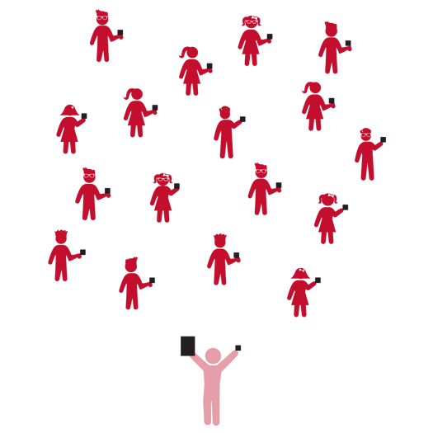

* **Skill:** I will keep the beanbag under control as I toss it in the air.
* **Cognitive:** I will discuss the different locomotor skills that I used in class.
* **Fitness:** I will work to stay actively engaged during all of the beanbag activities.
* **Personal & Social Responsibility:** I will use the equipment and activity space appropriately.
* Work Safely
* Respect Self-Space
* Actively Engage
* *See Skill Cue Teach Sheets for Skill-Specific Cues*

**Equipment:**

* 1 bean bag per student
* Bean Bag Activity Card
* Up-tempo Music

**Set-Up:**

1. Students scattered in activity area, each with a bean bag.
2. Bean Bag Activity Card ready on clipboard or tablet.

**Activity Procedures:**

1. Today we’re going to have fun exploring movement with bean bags.
2. I will show you a movement activity and then you’ll repeat after me.
3. Teachers, use the following activity sequence: 1) Locomotor Moves; 2) Toss and Try; 3) Super Moves (Grades 1 & 2).

**Grade Level Progression:**

**K:** Prompt students to perform locomotor skills and movements safely with balance.

**1st:** Students perform with developing maturity, control, and increasing complexity. Introduce Super Moves.

**2nd:** Students demonstrate mature movements and successful tosses with catches and can also stay on task during practice with minimal reminders.

**Bean Bag Exploration 1**



**Review content:** Now that students have worked with and explored several different locomotor skills it’s important to review what they’ve learned in order to highlight the idea that they are building their “movement vocabularies.” Provide activity time in which all students choose their favorite movement and share the ways they’ve discovered their new skills can be used.



* **DOK 1:** What is a locomotor skill? What are examples of locomotor skills?
* **DOK 2:** When do you perform locomotor skills?
* **DOK 2:** What are the differences between a skip and a gallop? Walk and run?
* **DOK 1:** What does demonstrate mean?
* **DOK 2:** How do you demonstrate appropriate behavior in physical education class?
* **DOK 3:** How is appropriate behavior related to physical education equipment?



**Physical Education Priority Outcomes:**

* (K) Follows directions for safe participation and proper use of equipment with minimal reminders.
* (1) Follows directions for safe participation and proper use of equipment without

reminders.

* (2) Works independently and safely in physical education.



* Provide a variety of small manipulatives for students to choose from with variations in weight, texture, and size.



* Prompt students to create their own movements and challenges to share with the class.
* Move more quickly through the series of challenges with a focus on mastery performances.



Control, Demonstrate, Locomotor Skill, Gallop, Hop, Jog, Jump, Leap, Run, Side-Slide, Skip, Walk

**Bean Bag Exploration 2**



* **Skill:** I will use the cues for underhand tossing in order to hit a target with the beanbag.
* **Cognitive:** I will be able to repeat the cues for underhand tossing.
* **Fitness:** I will work to stay actively engaged during all of the beanbag activities.
* **Personal & Social Responsibility:** I will share my beanbag with a partner with no reminders from the teacher.
* Work Safely
* Respect Self-Space
* Actively Engage
* *See Skill Cue Teach Sheets for Skill-Specific Cues*

**Equipment:**

* 1 bean bag per student
* Bean Bag Activity Card
* Up-tempo music

**Set-Up:**

1. Students scattered in activity area, each with a bean bag.
2. Bean Bag Activity Card ready on clipboard or tablet.

**Activity Procedures:**

1. Today we’re going to have more fun exploring movement with Bean Bags.
2. I will show you a movement activity, and then you’ll repeat after me.
3. Teachers, use the following activity sequence: 1) Balancing Act; 2) Slow and Fast; 3) Push Passes; 4) Target Practice; 5) Partner Fun (Grades 1 & 2).

**Grade Level Progression:**

**K:** Focus on safe movement and travel at different speeds. During Target Practice focus on stepping toward the target with the opposite foot.

**1st:** Introduce strong and light force during push passes. Emphasize the critical elements of an underhand throw.

**2nd:** Prompt students to focus on a mature underhand throwing pattern along with gradual variations in both speed and force.

**Bean Bag Exploration 2**



Balance, Effort, Mature, Movement Concepts, Relationship, Transfer of Weight



* Provide a towel or net to students during catching activities. Students hold the towel out in front of them and use it to catch gently tossed beanbags.



* Allow skilled students to act as peer coaches.



**Help students practice skills:** In order to develop mature skill patterns students need time to practice and develop their abilities. Although you may feel like you need to cover a certain amount of content in a short timeframe, sometimes it pays to be patient, practice and review skills and cues in order to help students to progress toward desired outcomes. Underhand tossing is a good example of a skill that might be covered quickly with few students truly reaching set targets and outcomes. However, if students are provided an ample amount of deliberate practice time, skill and concept transfer will strengthen future development down the road.



* **DOK 1:** What are the cues for underhand tossing?
* **DOK 2:** What do you know about the word mature?
* **DOK 3:** How are skill cues related to mature skill performance?
* **DOK 1:** How do you recognize when people are sharing equipment in physical education?
* **DOK 2:** How does sharing equipment affect our ability to learn new skills in physical education class?



**Physical Education Priority Outcomes:**

* (K) Shares equipment and space with others.
* (1) Works independently with others in a variety of class environments.
* (2) Accepts responsibility for class protocols with personal and cooperative behavior as well as performance actions.

**Ball Skills 1**

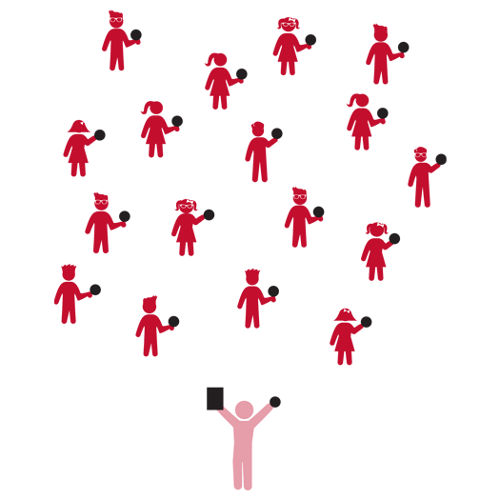

* **Skill:** I will keep my ball under control as I work to toss and catch it.
* **Cognitive:** I will demonstrate the difference between clockwise and counter clockwise using the ball.
* **Fitness:** I will work to stay active during all activities.
* **Personal & Social Responsibility:** I will listen to feedback from my teacher and work to make my performance better based on suggestions.
* Work Safely
* Respect Self-Space
* Actively Engage
* *See Skill Cue Teach Sheets for Skill-Specific Cues*

**Equipment:**

* 1 foam ball per student
* Ball Skills Activity Card
* Up-tempo music

**Set-Up:**

1. Students scattered in activity area, each with a foam ball.
2. Ball Skills Activity Card ready on clipboard or tablet.

**Activity Procedures:**

1. Today we’re going to have fun exploring movement with foam balls.
2. I will show you a movement activity, and then you’ll repeat after me.
3. Teachers, use the following activity sequence: 1) Toss and Try; 2) Sorta Sporty; 3) Cool It Down.

**Grade Level Progression:**

**K:** As students complete Toss and Try activities, move to each student and toss them a ball for catching with both hands and arms against the body.

**1st:** Prompts students to catch a self-tossed ball before it bounces.

**2nd:** Prompt students to catch with their hands out in front of their bodies (rather than cradling against their bodies).

**Ball Skills 1**



**Help students examine their reasoning:** The word control can mean different things in different contexts. Prompt students to explore those various meanings and listen attentively to their responses. As you listen, carefully question the logic that students use within their answers and prompt them to examine their overall logic. This requires careful interaction between teacher and student but is essential to applying rigor in a developmentally appropriate way.



* **DOK 1:** What does clockwise mean? Counter-clockwise?
* **DOK 2:** Why is it important to know the difference between the two directions?
* **DOK 3:** What might happen if everyone in our class were trying to move around the activity area and we didn’t know the difference between clockwise and counter-clockwise?
* **DOK 1:** What does control mean?
* **DOK 2:** What are the different things that we control during physical education class? What things do we control during the school day?



* Remove challenges that involve catching. Allow tosses to fall to the ground.



**Physical Education Priority Outcomes:**

* (K) Safely manipulates objects using underhand throws, two-hand catches, hand and foot dribbles and underhand volleys/strikes.
* (1) Manipulates and controls objects using underhand throws, two-hand catches, hand and foot dribbles and underhand volleys/strikes.
* (2) Demonstrates control while combining locomotor and manipulative skills in self space and general space.



* Play up-tempo music and progress through each challenge to a rhythm. As students master each challenge, increase the tempo of the music and try again.



Clockwise, Counter-Clockwise, Control, Demonstrate, Direction, Manipulative Skill

**Ball Skills 2**

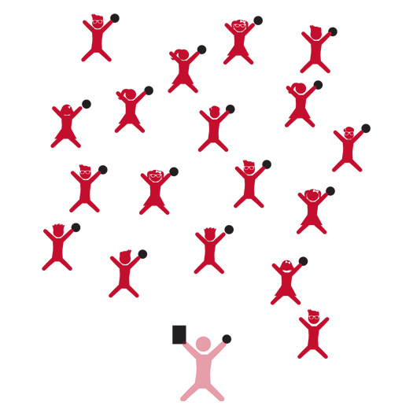

* **Skill:** I will use the cues for underhand tossing during partner activities.
* **Cognitive:** I will be able to repeat the cues for tossing.
* **Fitness:** I will work to stay actively engaged during all activities.
* **Personal & Social Responsibility:** I will work with my partner independently without reminders from the teacher.
* Work Safely
* Respect Self-Space
* Actively Engage
* *See Skill Cue Teach Sheets for Skill-Specific Cues*

**Equipment:**

* 1 foam ball per student
* Ball Skills Activity Card
* Up-tempo music

**Set-Up:**

1. Students scattered in activity area, each with a foam ball.
2. Ball Skills Activity Card ready on clipboard or tablet.

**Activity Procedures:**

1. Today we’re going to have more fun exploring movement with foam balls.
2. I will show you a movement activity, and then you’ll repeat after me. As we move through space, we’ll work to move our bodies to the rhythm of the music.
3. Teachers, use the following activity sequence: 1) Rolling Around; 2) Partner Passes; 3) Double Trouble (Grade 2).

**Grade Level Progression:**

**K:** Focus on underhand tossing with opposition as well as safe and controlled travel in general space.

**1st:** Introduce strong and light force during rolling and tossing activities. Emphasize critical elements of underhand throw.

**2nd:** Prompt students to focus on a mature underhand throwing pattern along with gradual variations in both speed and force.

**Ball Skills 2**



* **DOK 1:** What are the cues for underhand tossing?
* **DOK 1:** What is a manipulative skill?
* **DOK 2:** How does using the cues affect how well you toss a ball?
* **DOK 2:** How is underhand tossing similar to/different from other manipulative skills?
* **DOK 3:** How is effort related to skill cues when tossing a ball?



**Help students revise knowledge:** Most students have had some sort of interaction/play experience with a ball. Oftentimes this interaction is generally positive. However, most students will come to physical education with bad habits with respect to tossing, throwing, and catching. Helping them identify and correct errors and bad habits is critical to developing mature skills. While you’re correcting these errors try to infuse new content into your interaction. Work to help students view each skill from an alternative perspective in order to overcome resistance to change.



**Physical Education Priority Outcomes:**

* (K) Discusses the enjoyment of playing with family and friends.
* (1) Discusses the reasons for participating in physical activity with friends.
* (2) Discusses ways to encourage others to be physically activity with friends.



* Allow all students to choose whether to work with a ball or a scarf during toss and catch activities.



* Progressively increase the distance between students as they toss and catch the ball.



Control, Demonstrate, Direction, Effort, Manipulative Skill, Mature, Relationship

**Hula Hoop 1**

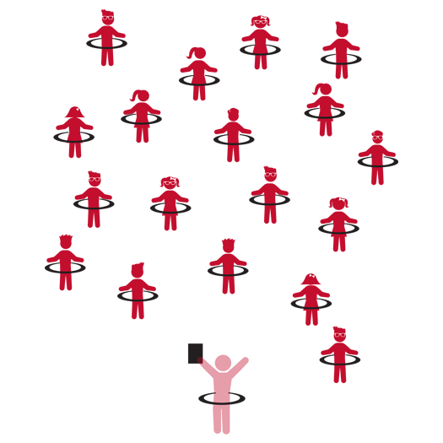

* **Skill:** I will work to maintain my balance during all movement activities.
* **Cognitive:** I will define and discuss balance.
* **Fitness:** I will work to increase my heart rate during movement activities.
* **Personal & Social Responsibility:** I will work safely by following all instructions.
* Work Safely
* Respect Self-Space
* Actively Engage
* *See Skill Cue Teach Sheets for Skill-Specific Cues*

**Equipment:**

* 1 Hula Hoop per student
* Hula Hoop Activity Card
* Up-tempo music

**Set-Up:**

1. Students scattered in activity area, each with a Hula Hoop.
2. Hula Hoop Activity Card ready on clipboard or tablet.

**Activity Procedures:**

1. Today we’re going to have fun exploring movement with Hula Hoops.
2. I will show you a movement activity, and then you’ll repeat after me.
3. Teachers, use the following activity sequence: 1) Puddles; 2) Walk Around the World; 3) Cliff Hanger; 4) Blast Off; 5) Musical Hoops.

**Grade Level Progression:**

**K:** Focus on jumping and landing actions while maintaining balance.

**1st:** Prompt students to perform jumping and landing with developing maturity, focusing on critical elements.

**2nd:** Prompt students to focus on mature patterns for all locomotor skills used.

**Hula Hoop 1**



* **DOK 1:** How would you describe balance?
* **DOK 2:** How does balance affect the way you move?
* **DOK 3:** How can you change the way you move or stand still in order to improve (or keep) your balance?



**Help students engage in cognitively complex tasks:** As students progress and experience a variety of movement experiences it’s helpful to ask them to verbally and physically respond to discussion questions. “How does balance affect the way you move?” leads to, “Show me how you can change the way that you move (or stand still) in order to improve (or lose) your balance.”



**Physical Education Priority Outcomes:**

* (K) Safely moves in both personal and general space using different pathways and speeds.
* (1) Safely moves demonstrating a variety of relationships with people and objects.
* (2) Controls force (strong and light) and speed (fast and slow) while moving in static and dynamic environments.



Balance, Horizontal, Jump, Level, Locomotor Skill, Pathways, Safety, Transfer of Weight, Vertical



* Many of the hoop challenges can be done with a flat poly spot.



* Prompt students to create their own movements and challenges to share with the class.

**Hula Hoop 2**

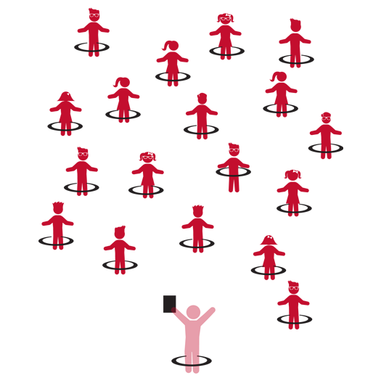

* **Skill:** I will keep my body balanced and still during the Balancing Act activity.
* **Cognitive:** I will discuss why a strong base of support is important to balance.
* **Fitness:** I will work to stay actively engaged.
* **Personal & Social Responsibility:** I will use equipment appropriately.
* Work Safely
* Respect Self-Space
* Actively Engage
* *See Skill Cue Teach Sheets for Skill-Specific Cues*

**Equipment:**

* 1 Hula Hoop per student
* Hula Hoop Activity Card
* Up-tempo music

**Set-Up:**

1. Students scattered in activity area, each with a Hula Hoop.
2. Hula Hoop Activity Card ready on clipboard or tablet.

**Activity Procedures:**

1. Today we’re going to have fun exploring movement with Hula Hoops.
2. I will show you a movement activity, and then you’ll repeat after me.
3. Teachers, use the following activity sequence: 1) Shuffle Around; 2) Bus Driver; 3) Helicopter; 4) Lucky Coin; 5) Balancing Act; 6) Bumper Hoops (Grades 1 & 2).

**Grade Level Progression:**

**K:** Focus on safe travel using a variety of pathways, shapes, and levels.

**1st:** Prompt students to demonstrate and verbally discuss how they are applying levels and relationships.

**2nd:** Prompt students to demonstrate and verbally discuss the application of balance, levels, pathways, and weight transfer.

**Hula Hoop 2**



**Manage response rate with tiered questioning techniques:** Each set of debrief questions in this module works to move students from Depth of Knowledge (DOK) Level 1 to Level 3. This type of purposeful scaffold helps deepen student thinking about the content that is presented. Engage the students with your own active listening so that they can see and hear your participation. Young students often crave that level of engagement, and their cognitive and skill development will benefit from this type of interaction.



* **DOK 1:** What is a base of support? What are all of the things you can tell me about a base of support?
* **DOK 2:** How does a base of support affect balance?
* **DOK 3:** (Demonstrate different bases of support) Do you think this balance pose is a good base of support? Why or why not? How could we improve it?



**Physical Education Priority Outcomes:**

* (K) Performs locomotor skills with balance.
* (1) Travels with balance using a variety of locomotor skills in dynamic environments.
* (2) Performs locomotor skills using a mature pattern and in rhythm.



Balance, Control, Direction, Level, General Space, Self Space



* Perform challenges with no equipment.



* Prompt students to create challenges that combine hoops with another object from this module, such as a ball or a beanbag.

­­

**NOODLES 1**



* **Skill:** I will follow the cues and instructions of the teacher for using the foam noodle.
* **Cognitive:** I will demonstrate my understanding of levels and pathways.
* **Fitness:** I will work to stay active during all activities.
* **Personal & Social Responsibility:** I will listen to feedback from my teacher and work to make my movements better.



* Work Safely
* Respect Self-Space
* Actively Engage
* *See Skill Cue Teach Sheets for Skill-Specific Cues*



**Equipment:**

* 1 foam noodle per student
* Noodles Activity Card
* Up-tempo music

**Set-Up:**

1. Students scattered in activity area, each with a foam noodle.
2. Noodles Activity Card ready on clipboard or tablet.

**Activity Procedures:**

1. Today we’re going to have fun exploring movement with foam noodles.
2. I will show you a movement activity, and then you’ll repeat after me.
3. Teachers, use the following activity sequence: 1) Tracks; 2) Move It, Move It; 3) Balancing Act. If time permits: 4) Motocross; 5) Gymnast.

**Grade Level Progression:**

**K:** As students complete Tracks and Move It, Move It activities.

**1st:** Review K activities and add Balancing Act activity.

**2nd:** Quickly review K-1 activities and progress to Motocross and Gymnast..

**NOODLES 1**



* Play up-tempo music and progress through each challenge to a rhythm. As students master each challenge, increase the tempo of the music and try again.



**Help students practice skills, strategies, and processes:** Physical Literacy is developed through success and enjoyment, within a purposeful practice environment. Noodle activities provide enjoyment and challenge while providing students an opportunity to move in space in a variety of creative and playful ways.



**Physical Education Priority Outcomes:**

* (K) Acknowledges that some physical activities are challenging/difficult.
* (1) Recognizes that challenges can lead to success.
* (2) Participates in physical activities that bring confidence and challenge.



Balance, Control, Curved, Demonstrate, Direction, Manipulative Skill, Pathway, Straight, Transfer Weight, Zig-Zag



* **DOK 1:** What is a pathway?
* **DOK 2:** What do you know about different pathways?
* **DOK 3:** What might make you change your pathway while you’re moving? Elaborate on how you’d change it.
* **DOK 1:** How would you describe transferring weight?
* **DOK 2:** What are the different ways you transferred weight in today’s class?



* Provide different length noodles. Give students assistance with balance activities.

­­

**NOODLES 2**



* **Skill:** I will follow the cues and instructions of the teacher for using the foam noodle.
* **Cognitive:** I will demonstrate my understanding of mirroring.
* **Personal & Social Responsibility:** I will follow teacher directions and use equipment safely with control.



* Work Safely
* Respect Self-Space
* Actively Engage
* *See Skill Cue Teach Sheets for Skill-Specific Cues*



**Equipment:**

* 1 foam noodle per student
* Noodles Activity Card
* Up-tempo music

**Set-Up:**

1. Students scattered in activity area, each with a foam noodle.
2. Noodles Activity Card ready on clipboard or tablet.

**Activity Procedures:**

1. Today we’re going to have fun exploring movement with foam noodles.
2. I will show you a movement activity, and then you’ll repeat after me.
3. Teachers, use the following activity sequence: 1) Mirror This; 2) Falling Down; 3) Hockey. If time permits and your students are ready for advanced striding skills: 4) Tennis; 5) Baseball; Clean the Locker Room.
4. Play Noodle Tag as an extension is students in your class are not ready for advanced striking.

**Grade Level Progression:**

**K:** As students complete Mirror This and Falling Down activities.

**1st:** Review K activities and add Hockey activity.

**2nd:** Quickly review K-1 activities and progress to Motocross and Gymnast. Allow students to hit fluffballs off of a Tee or cone, providing enough space for students to swing the foam noodles safely.

**NOODLES 2**



* Play up-tempo music and progress through each challenge to a rhythm. As students master each challenge, increase the tempo of the music and try again.



Balance, Horizontal, Mirror, Relationships, Safety, Stick-Dribbling, Strike, Vertical



* Provide different length noodles. Give students assistance with balance activities.



**Help students examine their reasoning:** Safe behavior can look differently in different environments. Prompt students to explore those various meanings and listen attentively to their responses. As you listen, carefully question the logic that students use within their answers and prompt them to examine their overall logic. This requires careful interaction between teacher and student but is essential to applying rigor in a developmentally appropriate way.



* **DOK 1:** How can you recognize safe participation with a foam noodle?
* **DOK 2:** How does safety affect our enjoyment of physical activity?
* **DOK 3:** How is your behavior related to the safety of others?



**Physical Education Priority Outcomes:**

* (K) Shares equipment and space with others.
* (1) Works independently with others in a variety of class environments.
* (2) Accepts responsibility for class protocols with personal and cooperative behavior as well as performance actions.

**Station Day**

## 

* **Skill:** I will perform skill assessments to the best of my ability.
* **Cognitive:** I will follow the instructions on each station card in order to stay actively engaged with my team.
* **Fitness:** I will find my pulse/heart rate after each station to see if it is beating faster than when I’m sitting or resting.
* **Personal & Social Responsibility:** I will follow the rules and parameters of the Station Day learning environment.
* Start Activity With Music
* When Music Stops: Clean the Area and Rotate

**Equipment:**

* Station music and music player
* See station cards for equipment needs

**Set-Up:**

1. Create 6-10 grids (depending on size of class and activity area).
2. Set up station cards in each grid.
3. Set up each station according to its station card.
4. Designate one station as an assessment station.
5. Create groups of 2-4 students, each group at a different station.

**Activity Procedures:**

1. Today is a Station Day. We’ll complete each station for 2 (or 3) minutes. One station is an assessment station, where you’ll be given feedback based on your skill performance.
2. *Teacher: Talk through and/or demonstrate each station. Emphasize expectations at the assessment station.*
3. When the music starts, begin working at your station. When it stops, you’ll have 1 minute to clean up the station equipment and rotate to the next station. Wait until the music begins again before you start the activity at the new station.
4. While we’re learning this station format, I’ll pause the music for a longer period of time so that every team is able to clean up their area and rotate.



**Organizing students to interact with content:** The use of grids to organize students into learning stations is an effective way to manage activity, assessment, and cooperative learning opportunities. Practice using this format several times, especially with young children, before attempting to facilitate an assessment experience. Students need time to master the management aspects of station work. However, once this routine is learned, it often becomes an essential management tool in physical education.



* Some students may need step-by-step assistance during cleaning-up and rotation. Pause the music and don’t restart until every group has safely
* transitioned.



* *Select questions from the module that you’re teaching or the assessment that you’re using*



**Physical Education Priority Outcomes:**

* (K) Acknowledges responsibility for behavior when prompted.
* (1) Responds appropriately to general feedback from the teacher.
* (2) Accepts specific corrective feedback from the teacher.



* Challenge older students (stronger readers) to complete the task written on each card without an explanation or demonstration.



*Select words from the module that you’re teaching.*

**Station Day**