­­

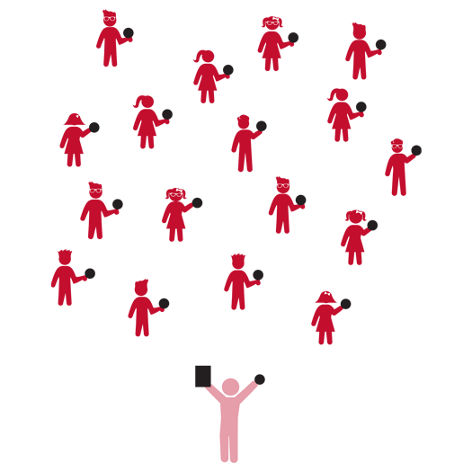

**Ball Skills 1**



* **Skill:** I will keep my ball under control as I work to toss and catch it.
* **Cognitive:** I will demonstrate the difference between clockwise and counter clockwise using the ball.
* **Fitness:** I will work to stay active during all activities.
* **Personal & Social Responsibility:** I will listen to feedback from my teacher and work to make my performance better based on suggestions.



* Work Safely
* Respect Self-Space
* Actively Engage
* *See Skill Cue Teach Sheets for Skill-Specific Cues*



**Equipment:**

* 1 foam ball per student
* Ball Skills Activity Card
* Up-tempo music

**Set-Up:**

1. Students scattered in activity area, each with a foam ball.
2. Ball Skills Activity Card ready on clipboard or tablet.

**Activity Procedures:**

1. Today we’re going to have fun exploring movement with foam balls.
2. I will show you a movement activity, and then you’ll repeat after me.
3. Teachers, use the following activity sequence: 1) Toss and Try; 2) Sorta Sporty; 3) Cool It Down.

**Grade Level Progression:**

**K:** As students complete Toss and Try activities, move to each student and toss them a ball for catching with both hands and arms against the body.

**1st:** Prompts students to catch a self-tossed ball before it bounces.

**2nd:** Prompt students to catch with their hands out in front of their bodies (rather than cradling against their bodies).

**Ball Skills 1**



* Play up-tempo music and progress through each challenge to a rhythm. As students master each challenge, increase the tempo of the music and try again.



* Remove challenges that involve catching. Allow tosses to fall to the ground.

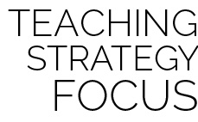

**Help students examine their reasoning:** The word control can mean different things in different contexts. Prompt students to explore those various meanings and listen attentively to their responses. As you listen, carefully question the logic that students use within their answers and prompt them to examine their overall logic. This requires careful interaction between teacher and student, but is essential to applying rigor in a developmentally appropriate way.



Clockwise, Counter-Clockwise, Control, Demonstrate, Direction, Manipulative Skill



* **DOK 1:** What does clockwise mean? Counter-clockwise?
* **DOK 2:** Why is it important to know the difference between the two directions?
* **DOK 3:** What might happen if everyone in our class were trying to move around the activity area and we didn’t know the difference between clockwise and counter-clockwise?
* **DOK 1:** What does control mean?
* **DOK 2:** What are the different things that we control during physical education class? What things do we control during the school day?

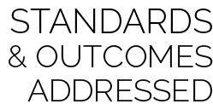

**Physical Education Priority Outcomes:**

* (K) Safely manipulates objects using underhand throws, two-hand catches, hand and foot dribbles and underhand volleys/strikes.
* (1) Manipulates and controls objects using underhand throws, two-hand catches, hand and foot dribbles and underhand volleys/strikes.
* (2) Demonstrates control while combining locomotor and manipulative skills in self space and general space.