­­

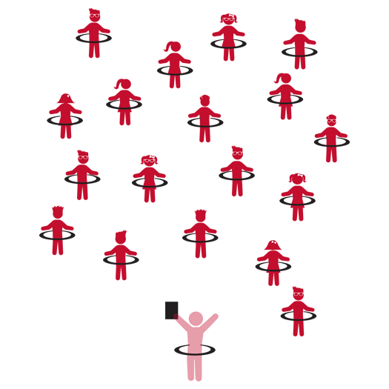

**Hula Hoop 1**



* **Skill:** I will work to maintain my balance during all movement activities.
* **Cognitive:** I will define and discuss balance.
* **Fitness:** I will work to increase my heart rate during movement activities.
* **Personal & Social Responsibility:** I will work safely by following all instructions.



* Work Safely
* Respect Self-Space
* Actively Engage
* *See Skill Cue Teach Sheets for Skill-Specific Cues*



**Equipment:**

* 1 Hula Hoop per student
* Hula Hoop Activity Card
* Up-tempo music

**Set-Up:**

1. Students scattered in activity area, each with a Hula Hoop.
2. Hula Hoop Activity Card ready on clipboard or tablet.

**Activity Procedures:**

1. Today we’re going to have fun exploring movement with Hula Hoops.
2. I will show you a movement activity, and then you’ll repeat after me.
3. Teachers, use the following activity sequence: 1) Puddles; 2) Walk Around the World; 3) Cliff Hanger; 4) Blast Off; 5) Musical Hoops.

**Grade Level Progression:**

**K:** Focus on jumping and landing actions while maintaining balance.

**1st:** Prompt students to perform jumping and landing with developing maturity, focusing on critical elements.

**2nd:** Prompt students to focus on mature patterns for all locomotor skills used.

**Hula Hoop 1**



* Prompt students to create their own movements and challenges to share with the class.

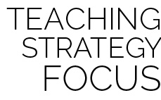

**Help students engage in cognitively complex tasks:** As students progress and experience a variety of movement experiences it’s helpful to ask them to verbally and physically respond to discussion questions. “How does balance affect the way you move?” leads to, “Show me how you can change the way that you move (or stand still) in order to improve (or lose) your balance.”



* **DOK 1:** How would you describe balance?
* **DOK 2:** How does balance affect the way you move?
* **DOK 3:** How can you change the way you move or stand still in order to improve (or keep) your balance?

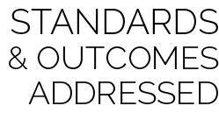

**Physical Education Priority Outcomes:**

* (K) Safely moves in both personal and general space using different pathways and speeds.
* (1) Safely moves demonstrating a variety of relationships with people and objects.
* (2) Controls force (strong and light) and speed (fast and slow) while moving in static and dynamic environments.



Balance, Horizontal, Jump, Level, Locomotor Skill, Pathways, Safety, Transfer of Weight, Vertical



* Many of the hoop challenges can be done with a flat poly spot.