­­

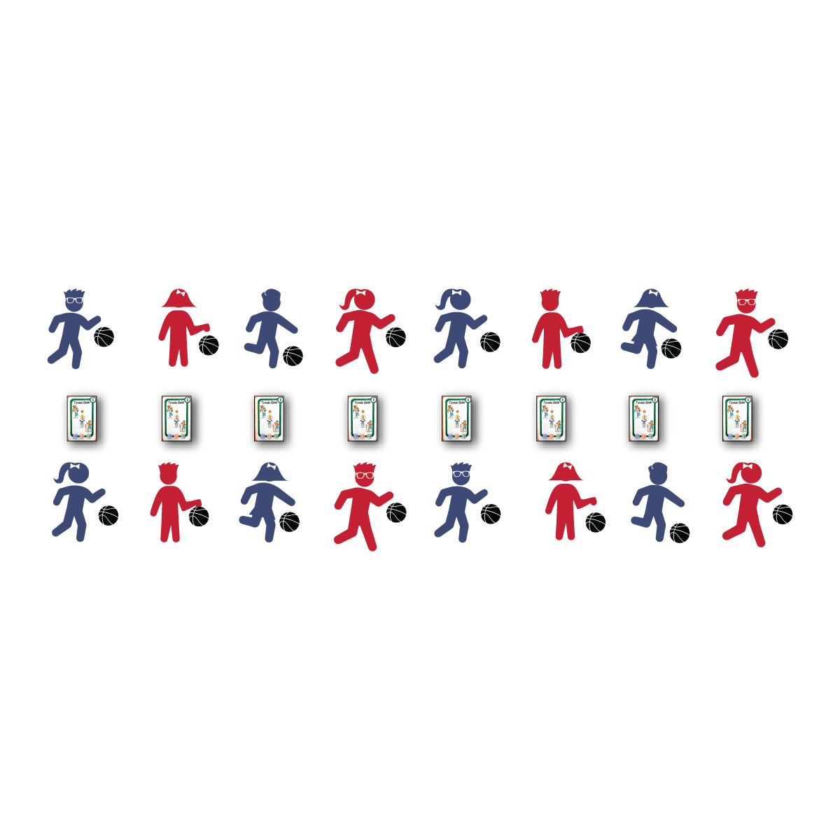

* Knees Bent, Eyes Up
* Finger Pad Push
* Give to Your Waist
* Protect the Ball

**MIRROR MIRROR ON THE COURT**

* **Skill:** I will dribble a basketball with a mature pattern and with control.
* **Cognitive:** I will tell my partner the critical cues for dribbling.
* **Fitness:** I will stay actively engaged throughout the activity.
* **Personal & Social Responsibility:** I will work safely and independently with my partner and my classmates.

**Equipment:**

* 26 Skillastics® Basketball Task Cards
* 1 basketball per student

**Set-Up:**

1. Lay Skillastics® Basketball Task Cards in a line in the middle of the activity area. Provide enough room in between each task card for students to perform basketball activity.
2. Pair students, each pair next to a Skillastics® Basketball Task Card.

**Activity Procedures:**

1. It’s time to play Mirror Mirror on the Court. The object of the game is for one partner to perform the skill on the task card while the other partner mirrors her/his movement. Play Rock, Paper, Scissors (RPS) to determine who will perform the task card movement first.
2. On the start signal, the partner who won the game of RPS will begin performing the skill on the task card. The other student will look at their partner only (not the skill card) and begin to mirror the activity.
3. On the stop signal, rotate to the next card, switch roles, and wait for the start signal to begin the new task card movement.

**Grade Level Progression:**

**3rd:** Sort Skillastics® Basketball Task Cards and use only those that include ball-handling skills while remaining static (e.g., Kneel Dribbling, Both Hands).

**4th:** Progress with task cards that include dribbling while moving (e.g., Dribble Right Hand, Moving).

**5th:** Utilize all task cards.

**MIRROR MIRROR ON THE COURT**

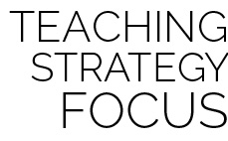

**Help students identify critical content.** Set the stage for students to succeed by identifying critical content in the first lesson of this Skillastics® Basketball Module. Dribbling is a foundational skill that will help students feel successful in future practice activities as well as small-sided games. It’s also a skill that should be somewhat of a review for most of your students. Reintroduce the skill, emphasize the critical cues, and provide meaningful performance feedback. It’s also important for students to understand why working independently with a partner will help them succeed in physical education—Skillastics® Basketball specifically. Provide time to discuss what this means and how it applies in the physical education classroom.



* **Standard 1 [E20.4-5]:** Dribbles with hand/feet in combination with other skills (e.g., passing, receiving, shooting) (4); Hand/foot-dribbles with mature patterns in a variety of small-sided game forms (5).
* **Standard 3 [E2.3-5]:** Engages in the activities of physical education class without teacher prompting (3); Actively engages in the activities of physical education class, both teacher-directed and independent (4); Actively engages in all the activities of physical education (5).
* **Standard 4 [E1.3-5]:** Exhibits personal responsibility in teacher-directed activities (3); Exhibits responsible behavior in independent group situations (4); Engages in physical activity with responsible interpersonal behavior (e.g., peer to peer, student to teacher, student to referee) (5).



Actively Engage, Ball Handling, Control, Critical Cues, Dribble, Finger Pad, Independent, Mature Pattern, Mirror, Safe



**BASKETBALL Depth of Knowledge**

* **DOK 1:** Can you remember the cues for dribbling?
* **DOK 2:** How does using finger pads to push the ball affect the way you dribble?
* **DOK 3:** How is control related to dribbling?

**SOCIAL AND EMOTIONAL LEARNING Depth of Knowledge**

* **DOK 1:** What does it mean to work independently with your partner?
* **DOK 2:** How do you apply responsible behavior when you’re working independently?
* **DOK 3:** What facts would you select to support the importance of working independently to creating a positive learning environment?



* Complete a mirroring activity without the complex skill of dribbling or ball handling.
* Provide a variety of balls that can be dribbled. Allow students to select the ball that will give them the best chance for success.
* Complete this activity in small groups with an adult leading and students mirroring.