­­

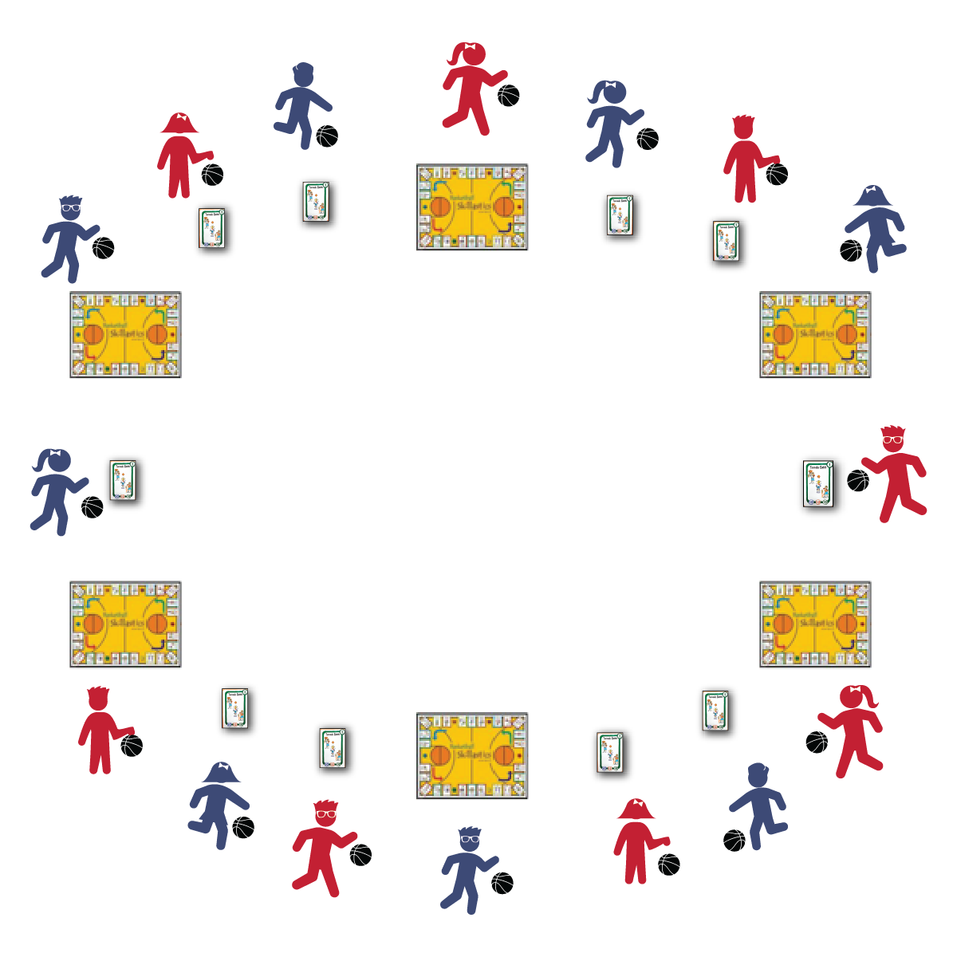

**BASKETBALL ROUNDABOUT**

* **Skill:** I will complete each basketball task using mature patterns and perfect form.
* **Cognitive:** I will discuss the rules and etiquette for participating in Skillastics® Basketball activities.
* **Fitness:** I will work to increase my heart rate.
* **Personal & Social Responsibility:** I will follow the rules and etiquette for Skillastics® Basketball.
* Knees Bent, Eyes Up
* Finger Pad Push
* Give to Your Waist
* Protect the Ball

**Equipment:**

* 26 Skillastics® Basketball Task Cards
* 6 Skillastics® Miniature Mats
* 6 colored dice
* 6 beanbag markers
* 1 basketball per student

**Set-Up:**

1. Place the Skillastics® Miniature Mats in a large circle around the activity area. Space Skillastics® Basketball Task Cards evenly between the mats.
2. Pace a matching color die and beanbag on each mini-mat.
3. Send each student, with a ball, to a task card or mini-mat.

**Activity Procedures:**

1. This activity is called Basketball Roundabout. It is a station-style activity.
2. On the start signal, all students on a mini-mat will roll their die, move the beanbag that number of spaces on the mini-mat, and begin the task listed on the space the beanbag lands on. All students at a task card will perform the activity on the card.
3. We will perform each task for 1 minute (or other designated length of time). On the stop signal, bring your ball with you as you rotate clockwise. Wait for the start signal to roll your die and/or start a new task.

**Grade Level Progression:**

**3rd:** Play the activity as described above.

**4th:** Prompt students to change their locomotor movements while dribbling from mini-mats to task cards.

**5th:** Use a change of direction and/or speed signal. When students hear the signal, they will change direction and/or speed.

**BASKETBALL ROUNDABOUT**



Actively Engage, Ball Handling, Control, Critical Cues, Dribble, Etiquette, Finger Pad, Independent



* **Standard 1 [E6.3-4]:** Performs a sequence of locomotor skills, transitioning from one skill to another smoothly/without hesitation (3); Combines traveling with manipulative skills of dribbling, throwing, catching, and striking in teacher- and/or student-designed small-sided practice tasks (4).
* **Standard 1 [E17.3-5]:** Dribbles and travels in general space at slow to moderate jogging speed with control of ball and body (3); Dribbles in self-space with both the preferred and the non-preferred hand using a mature pattern (4a); Dribbles in general space with control of ball and body while increasing and decreasing speed (4b); Combines hand dribbling with other skills during one-on-one practice tasks (5).
* **Standard 4 [E5.3-5]:** Recognizes the role of rules and etiquette in physical activity with peers (3); Exhibits etiquette and adherence to rules in a variety of physical activities (4); Critiques the etiquette involved in rules of various game activities (5).



**BASKETBALL Depth of Knowledge**

* **DOK 1:** How can you recognize perfect form?
* **DOK 2:** How can you improve your control when performing practice tasks?
* **DOK 3:** How would you describe your effort to keep control of the basketball? Use specific examples to support your answer.

**SOCIAL AND EMOTIONAL LEARNING Depth of Knowledge**

* **DOK 1:** What does etiquette mean?
* **DOK 2:** How would you compare/contrast etiquette and rules?
* **DOK 2:** How is the etiquette of basketball different than the etiquette of the classroom? How is it the same?
* **DOK 3:** How is etiquette related to enjoyment?

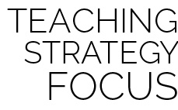

**Help students practice skills, strategies, and processes.** This activity provides a management system that allows students to practice basketball-specific skills while also practicing the etiquette and process of Skillastics® Basketball participation. Remember to reinforce positive behaviors and skill performances while purposefully correcting both skill and behavior errors.



* Provide a variety of balls that can be dribbled. Allow students to select the ball that will give them the best chance for success.
* Provide peer or adult coaches at mini-mats and task cards.