­­

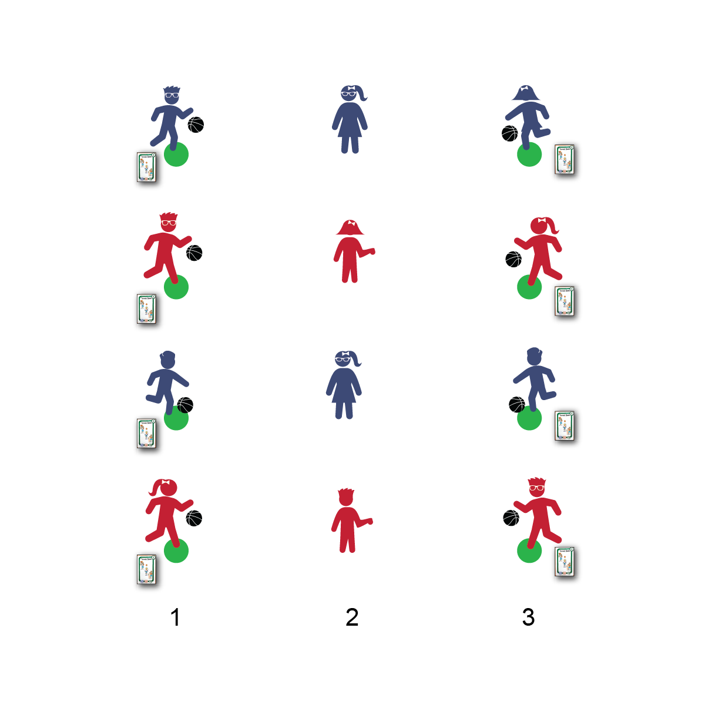

**PASSING FRENZY**

* **Skill:** I will pass accurately, following skill cues for chest and bounce passes.
* **Cognitive:** I will list the skill cues for passing.
* **Fitness:** I will work to improve my skill-related fitness (specifically, coordination).
* **Personal & Social Responsibility:** I will discuss ways to overcome challenges when learning new skills.
* 2 Hands on the Ball
* Step Toward Your Target
* Extend Arms Straight Out
* Rotate Palms Outward
* Push the Ball to Your Target
* Extend to Follow Through (Palms Out)

**Equipment:**

* 26 Skillastics® Basketball Task Cards
* 1 basketball per student for ⅔ of the students (⅓ of the students without at ball)

**Set-Up:**

1. Create 2 parallel lines of task cards, 15–20 feet apart.
2. Send 1 student to each task card.
3. Send the remaining students in a line down the center of the task card activity area. This will create passing lines of 3 students lined up from task card to task card.

**Activity Procedures:**

1. This activity is called Passing Frenzy. The purpose of the activity is to practice our passing and complete Skillastics® Basketball Task Cards. We’ll start with chest passing.
2. On the start signal, students in row 1 will pass the ball to the students in center row 2. Row 2 students will quickly pass the ball back and then turn and show hands to the students in row 3.
3. As soon as students in row 3 see hands, they’ll pass their balls to row 2. Row 2 students will then quickly pass pack to row 3.
4. As soon as passes are made back to row 3, students in row 2 will do jumping jacks (or other exercise) while students in rows 1 and 2 perform the activity on the task cards.
5. On the stop signal (every 60 seconds), all players will move 1 space forward, and the players at the front will jog to the open space at the back. (You can repeat this activity using bounce passes, 2-handed overhead passes, and 1-handed baseball passes.)

**Grade Level Progression:**

**3rd:** Play the activity using chest and bounce passes.

**4th–5th:** Play the activity, progressing to overhead and baseball passes as students display readiness.

**PASSING FRENZY**



Accept, Accurate, Bounce Pass, Challenge, Chest Pass, Dynamic, Enjoyment, Express, Growth Mindset, Overcome, Praise

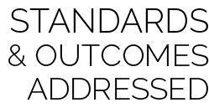

* **Standard 1 [E15.4-5]:** Throws to a moving partner with reasonable accuracy in a non-dynamic environment (4); Throws with accuracy, both partners moving (5a); Throws with reasonable accuracy in dynamic, small-sided practice tasks (5b).
* **Standard 4 [E4.3-5]:** Works cooperatively with others (3a); Praises others for their success in movement performance (3b); Praises the movement performance of others both more and less-skilled (4a); Accepts “players” of all skill levels into the physical activity (4b); Accepts, recognizes, and actively involves others with both higher and lower skill abilities into physical activities and group projects (5).
* **Standard 5 [E2.3-5]:** Discusses the challenge that comes from learning a new physical activity (3); Rates the enjoyment of participating in challenging and mastered physical activities (4); Expresses (via written essay, visual art, creative dance) the enjoyment and/or challenge of participating in a favorite physical activity. (5).



**BASKETBALL Depth of Knowledge**

* **DOK 1:** Can you remember the skill cues for passing?
* **DOK 2:** What do you notice about your passes when you don’t follow certain cues?
* **DOK 3:** How is body control related to passing accuracy?

**SOCIAL AND EMOTIONAL LEARNING Depth of Knowledge**

* **DOK 1:** How can you recognize something that’s challenging?
* **DOK 2:** How can you apply what you’ve learned about purposeful practice when you’re faced with a challenge?
* **DOK 3:** How is a growth mindset related to your ability to overcome a challenge?

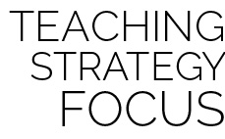

**Help students process content.** The introduction of passing can be very challenging for some students. It can also cause higher-skilled students to become frustrated with their lower-skilled classmates. It’s critical to take time to debrief class performance and discuss the importance of a growth mindset as well as the encouragement of classmates with positive language. Challenging tasks without proper debrief and processing can open the door for a negative sport experience and discourage future participation.



* Provide a variety of balls that can be dribbled and passed. Allow student to select the ball that will give them the best chance for success.
* Decrease the distance between rows.