­­

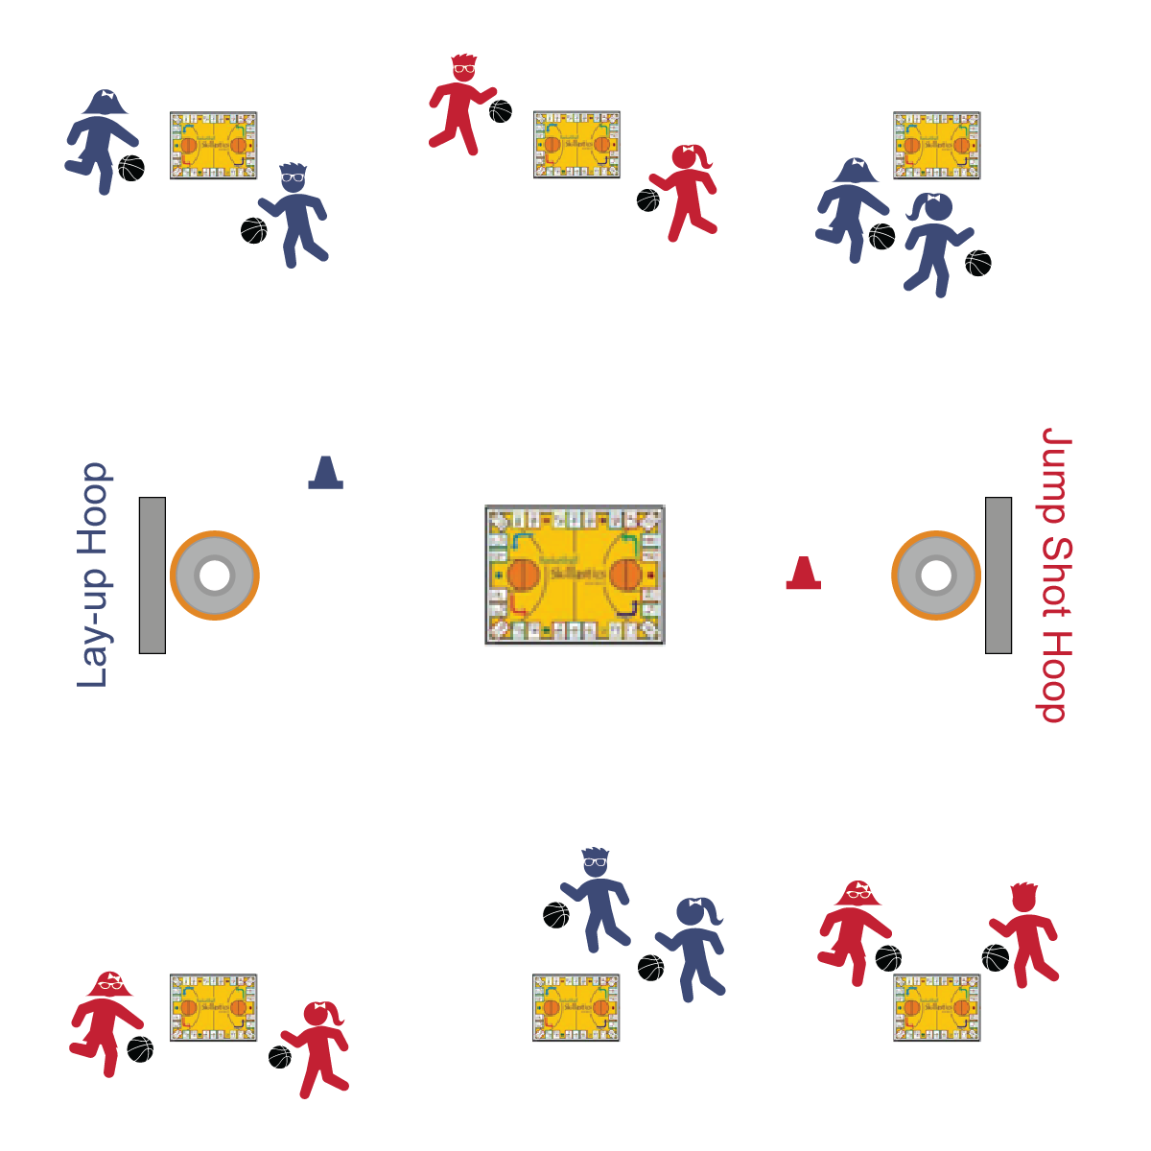

**HOT SPOT, TAKE A SHOT**

* **Skill:** I will shoot a lay-up and a jump shot following skill cues.
* **Cognitive:** I will list the skill cues for shooting.
* **Fitness:** I will work to increase my heart rate.
* **Personal & Social Responsibility:** I will work cooperatively with my classmates, following the rules and etiquette of Skillastics®.

BEEF

* Balance on the Platter
* Elbow Under the Ball
* Eyes on Target
* Follow-Through Snap

**Equipment:**

* Complete Skillastics® Basketball game set.
* 2 baskets/hoops
* 1 basketball per student
* 1 blue cone to create a lay-up starting line
* 1 red cone to create a jump shot starting line

**Set-Up:**

1. Set up the Skillastics® Basketball game as described in the set instructions.
2. Create even teams, 1 team at each of the mini-mat team areas.
3. Each student with a basketball.

**Activity Procedures:**

1. This activity is called Hot Spot, Take a Shot. It’s a variation of a regulation game of Skillastics® Basketball.
2. On the start signal (music), begin playing Skillastics® Basketball as described in the set instructions.
3. As your team moves your beanbag marker around the game board, pay attention to the “start spots” that you land on. If your team lands on the blue start spot, everyone on your team must dribble to the blue hoop, form a line, and attempt to make a lay-up. Every student gets 1 shot only.
4. If your team lands on the red start spot, everyone on your team must dribble to the red hoop, form a line, and attempt to make a jump shot from 5’ away. Every student gets 1 shot only.
5. As soon as your team is done shooting, return to your mini-mat team area and continue playing Skillastics® Basketball.

**Grade Level Progression:**

**3rd–4th:** Use baskets at a height that promotes success. If adjustable baskets are not available, use hula hoops placed on the floor with a focus on form, arc, and follow-through.

**5th:** Play the activity as described above.

**HOT SPOT, TAKE A SHOT**



Accept, Balance, Challenge, Combine, Cooperate, Etiquette, Follow-Through, Jump Shot, Lay-Up



* **Standard 1 [E15.4-5]:** Throws to a moving partner with reasonable accuracy in a non-dynamic environment (4); Throws with accuracy, both partners moving (5a); Throws with reasonable accuracy in dynamic, small-sided practice tasks (5b).
* **Standard 1 [E26.4-5]:** Combines traveling with the manipulative skills of dribbling, throwing, catching, and striking in teacher- and/or student-designed small-sided practice task environments (4); Combines manipulative skills and traveling for execution to a target (e.g., scoring in soccer, hockey, and basketball) (5).
* **Standard 4 [E4.3-5]:** Works cooperatively with others (3a); Praises others for their success in movement performance (3b); Praises the movement performance of others both more and less-skilled (4a); Accepts “players” of all skill levels into the physical activity (4b); Accepts, recognizes, and actively involves others with both higher and lower skill abilities into physical activities and group projects (5).



**BASKETBALL Depth of Knowledge**

* **DOK 1:** Can you remember the skill cues for shooting?
* **DOK 2:** What do you notice about your shots if you don’t follow certain cues?
* **DOK 3:** How is balance related to shooting accuracy?

**SOCIAL AND EMOTIONAL LEARNING Depth of Knowledge**

* **DOK 1:** How can you recognize a team or group that is working cooperatively?
* **DOK 2:** How would you summarize the importance of cooperation in basketball?
* **DOK 3:** Can you predict the outcome of a basketball game in which a team that cooperates plays against a team that doesn’t cooperate? What might be some specific example of things that would happen during a game like that?



**Help students practice skills, strategies, and processes.** Teaching shooting to elementary students presents basketball excitement as well as challenges. Regulation baskets are not developmentally appropriate, nor do they promote student success. The most important aspect of shooting is proper form and mechanics. Help students by creating targets that promote purposeful practice and success, and therefore learning.



* Provide a variety of balls that can be dribbled and shot. Allow students to select the ball that will give them the best chance for success.
* Modify the size and type of goal students shoot at. Examples include wall marks, hula hoops on the floor, floor spots, etc.
* Use auditory signals on goals/targets.