­­­

* Control
* Dribble
* Finger Pad
* Mirror
* Safe

­

* **Standard 1 [E20.4-5]:** Dribbles with hand/feet in combination with other skills (e.g., passing, receiving, shooting) (4); Hand/foot-dribbles with mature patterns in a variety of small-sided game forms (5).
* **Standard 3 [E2.3-5]:** Engages in the activities of physical education class without teacher prompting (3); Actively engages in the activities of physical education class, both teacher-directed and independent (4); Actively engages in all the activities of physical education (5).
* **Standard 4 [E1.3-5]:** Exhibits personal responsibility in teacher-directed activities (3); Exhibits responsible behavior in independent group situations (4); Engages in physical activity with responsible interpersonal behavior (e.g., peer to peer, student to teacher, student to referee) (5).
* **Skill:** I will dribble a basketball with a mature pattern and with control.
* **Cognitive:** I will tell my partner the critical cues for dribbling.
* **Fitness:** I will stay actively engaged throughout the activity.
* **Personal & Social Responsibility:** I will work safely and independently with my partner and my classmates.
* Self-Assessment

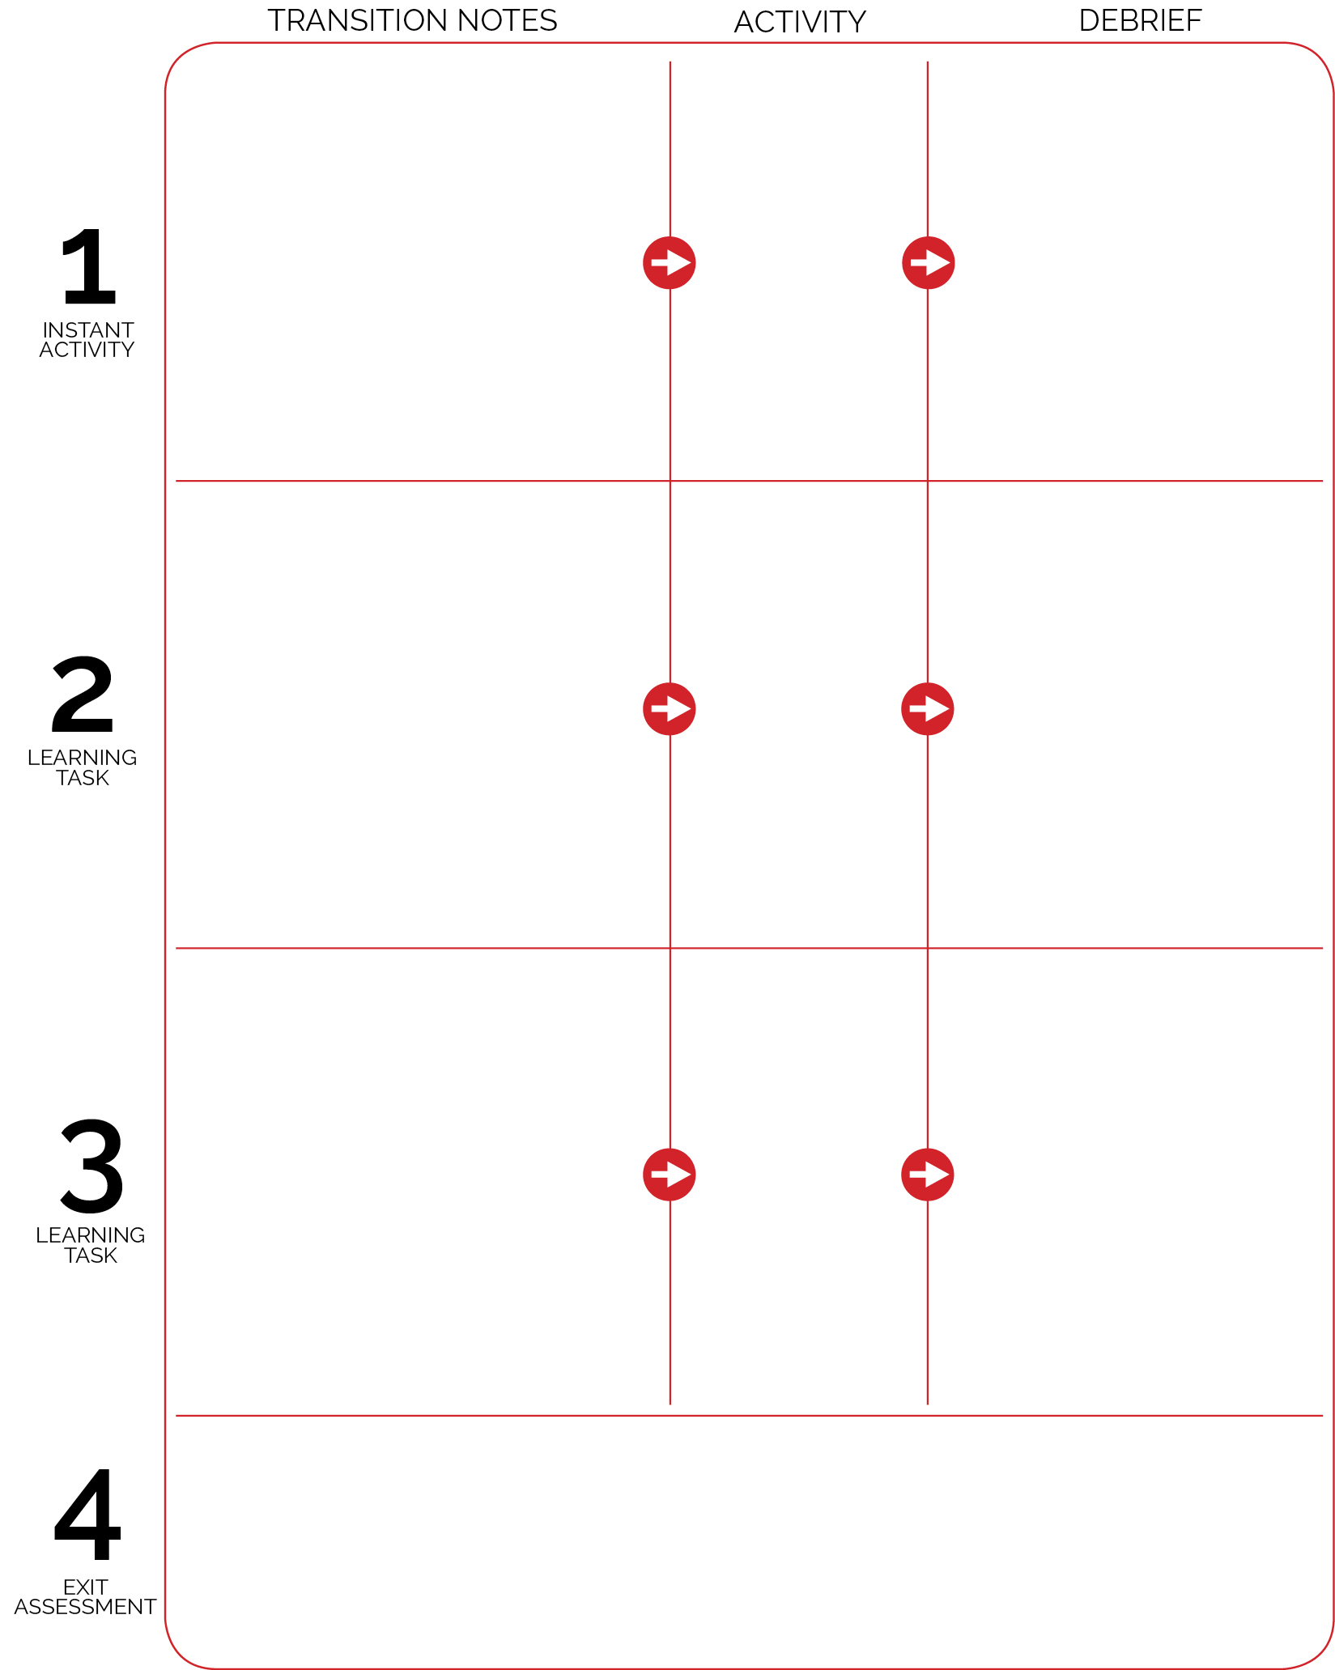

**DOK 1:** What is a warm-up?

**DOK 2:** Why is it important to warm-up your body before exercise/physical activity?

**DOK 3:** What fitness concepts could we address using this activity?

Mirror Mirror on the Court

**Self-Assessment** (Dribbling & Personal Behavior)

Assessment stations are set up on open sidelines. Each station includes 4 piles of worksheets and 4 boxes of pencils. When I say “GO,” return your ball to an equipment station. Next, move to an assessment station. Collect a worksheet and pencil. When you’re finished filling it out, give your worksheet to me and then line up.

Spots and word cards are already set up along the perimeter. Prompt one partner to set up task cards while the other helps to set up the alphabet cards.

Pair students, each pair with a card. Create 2 parallel lines with task cards in the center of the two lines (see activity set-up).

As students enter the activity area the pick up a basketball from the equipment zone and then begin dribbling within boundaries set by cones. When all students arrive begin High-Five Bank Account (basketball style).

**DOK 1:** What would you include on a list about appropriate personal behavior in basketball activities?

**DOK 2:** How do your personal behavior choices affect your classmates?

**DOK 1:** Can you remember the cues for dribbling?

**DOK 2:** How does using finger pads to push the ball affect the way you dribble?

**DOK 3:** How is control related to dribbling?

High-Five Bank Account

Basketball Know How