­­­

­

* **Skill:** I will demonstrate critical cues for passing, receiving, and dribbling.
* **Cognitive:** I will discuss the importance of critical cues and their role in skill development.
* **Fitness:** I will remain active and accumulate MVPA minutes.
* **Personal & Social Responsibility:** I will cooperate with a variety of partners, respecting all skill levels.
* Basketball
* Cooperate
* Critical Cue
* Dominant Hand
* Dribble
* Non-Dominant Hand
* Respect
* **Standard 1 [M4.6]:** Passes and receives with hands in combination with locomotor patterns of running and change of direction and speed with competency in invasion games such as basketball, flag football, speedball, or team handball (6).
* **Standard** **1 [M8.6-8]:** Dribbles with dominant hand using a change of speed and direction in a variety of practice tasks (6); Dribbles with dominant and non-dominant hand using a change of speed and direction in a variety of practice tasks (7); Dribbles with dominant and non-dominant hand using a change of speed and direction in small-sided game play (8).
* Self-Assessment
* Basketball SEL Journal

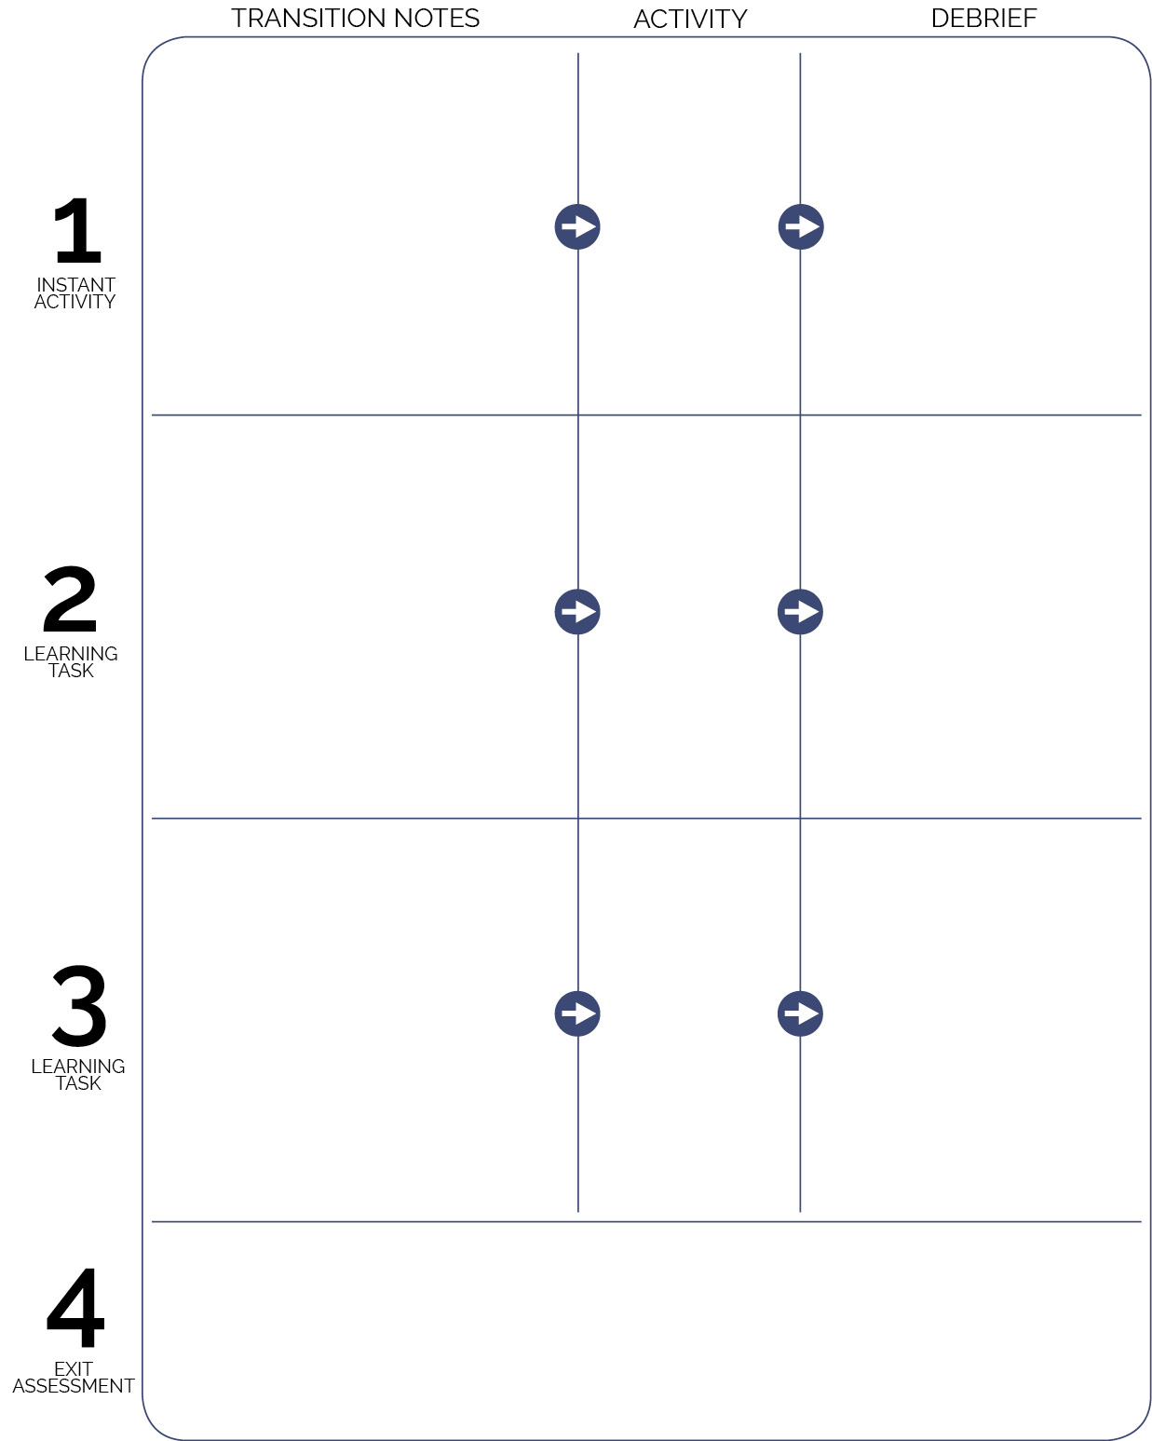

**SAMPLE LESSON PLAN**

Each student receives a Basketball SEL Journal and pen/pencil. Give students 5 minutes at the end of the lesson to complete page 1 of the journal with a focus on self-reflection. Read and then discuss journal entries at the start of the next class. It’s important to keep discussion about journals general so that students feel they can write without fear of exposure. If you’d like a student to share a specific entry, ask them in private before the next class, allowing them time to prepare.

* **DOK 1:** What is personal responsibility?
* **DOK 2:** Summarize the importance of personal responsibility in physical education class.
* **DOK 3:** How is personal responsibility related to participation in basketball?
* **DOK 1:** What is a critical cue?
* **DOK 2:** How can you apply critical cues in practice?
* **DOK 3:** How well were you able to perform passing critical cues during today’s activity? Give details about your performance.
* Use debrief time for students to complete Self-Assessment.

Introduce the basketball module with an emphasis on lifelong physical activity and social and emotional learning (SEL). Briefly discuss the SEL Journal and Self-Assessment.

Pair students, each pair with 1 ball standing together in the activity area.

Dribble Stoppers

All-Star Passing

Toss 3

(Secondary Instant Activity Module)

Pair students with the last partner they passed with in Toss 3. Pairs move to a spot marker. Review critical cues for bounce pass. Begin activity.

Pairs pick up floor spots and stack them in the equipment area. All players with a ball on the end line. Choose 3 players as Dribble Stoppers; they return balls to ball rack.