­­

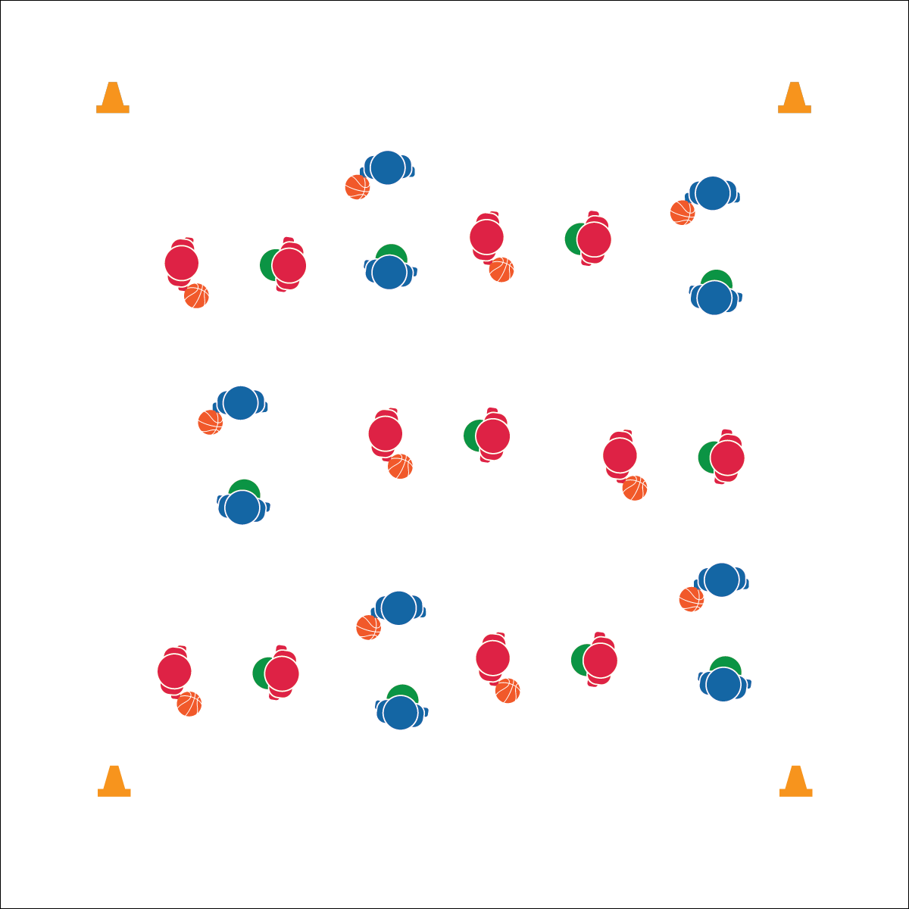

**Equipment:**

* 1 Equipment
* 2 Equipment
* 3 Equipment

**Set-Up:**

1. Create area.
2. Organize equipment.
3. Organize students.

**Activity Procedures:**

1. Today’s activity is called… The object of this activity is….
2. On the start signal…
3. Next…
4. On the stop signal…

**Grade Level Progression:**

**6th:** Progression 1

**7th:** Progression 2

**8th:** Progression 3

* Cue 1
* Cue 2
* Cue 3
* Cue 4
* **Skill:** I will…
* **Cognitive:** I will…
* **Fitness:** I will…
* **Personal & Social Responsibility:** I will…

**ACTIVITY NAME**

**ALL-STAR PASSING**



* **DOK 1:** Question…
* **DOK 2:** Question…
* **DOK 3:** Question…



Word, Word, Word



* UDA 1
* UDA 2

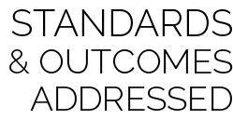

* **Standard X [CODE]:** Outcome Text Here.
* **Standard X [CODE]:** Outcome Text Here.
* **Standard X [CODE]:** Outcome Text Here.



**Rigor strategy here.** Strategy in action here…