­­

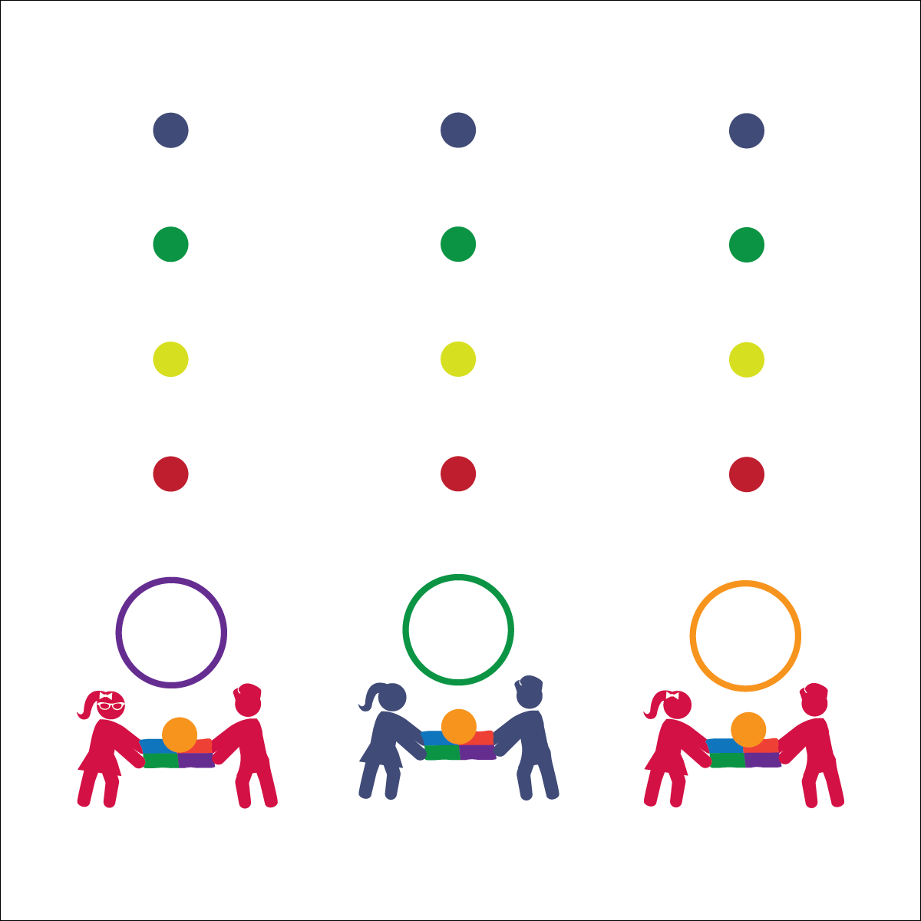

**Equipment:**

* 1 partner parachute per 2–4 students
* 1 hoop per 2–4 students
* 1 6” Voit Bouncee Foam Ball per 2–4 students
* 4 poly spots (red, yellow, green, blue)

**Set-Up:**

1. Place hula hoops, parachute, and balls along the perimeter of the boundary area.
2. Place students into groups of 2–4; each group with 1 ball and 1 partner parachute.
3. Measure 4 distances from the hula hoop, each distance marked with a colored spot. Place the red spot 5’ away from the hoop, the yellow spot 5’ away from the red spot, the green spot 5’ away from the yellow spot, and the blue spot 5’ away from the green spot.

* **Skill:** I will move with my classmates to send objects upward.
* **Cognitive:** I will learn about force.
* **Fitness:** I will demonstrate muscular strength and endurance while exploring force with parachutes.
* **Personal & Social Responsibility:** I will share equipment safely with my classmates.

**Activity Procedures:**

1. Today’s activity is called Rocket Launch. Our goal is to launch our rockets (foam balls) into outer space. This will help us learn about how force affects an object. If an object touches or collides with another object, there is a reaction. For example, 1 object can push on another object, which will change the 1st object’s motion. We will use this concept to get our rocket into the outer orbit of the Earth.
2. Begin by placing 1 rocket in the center of the parachute. Your group will work together to launch the rocket into space by sending it flying from your hoop and past your cone. (Now your rocket is in the Troposphere — lower orbit.)
3. Once you’re able to launch into space, work with your team to complete all 3 challenges.
   1. Launch past the red color spot (Troposphere — lower orbit)
   2. Launch past the yellow spot (Thermosphere — middle orbit)
   3. Launch past the green spot (Thermosphere — middle orbit)
   4. Launch past the blue spot (Exosphere — where most satellites orbit the earth)

**Grade Level Progressions:**

* **K:** Reduce the distance between the spots and reduce the number of challenges to 3 (Troposphere, Thermosphere, Exosphere).
* **1st:** Play the activity as described above.
* **2nd:** Place hoops as “landing pads.” Students try to launch from their “launch pad” to their “landing pad.”
* Work Cooperatively
* Share Safely
* Launch to the Stars

**ROCKET LAUNCH**