­­

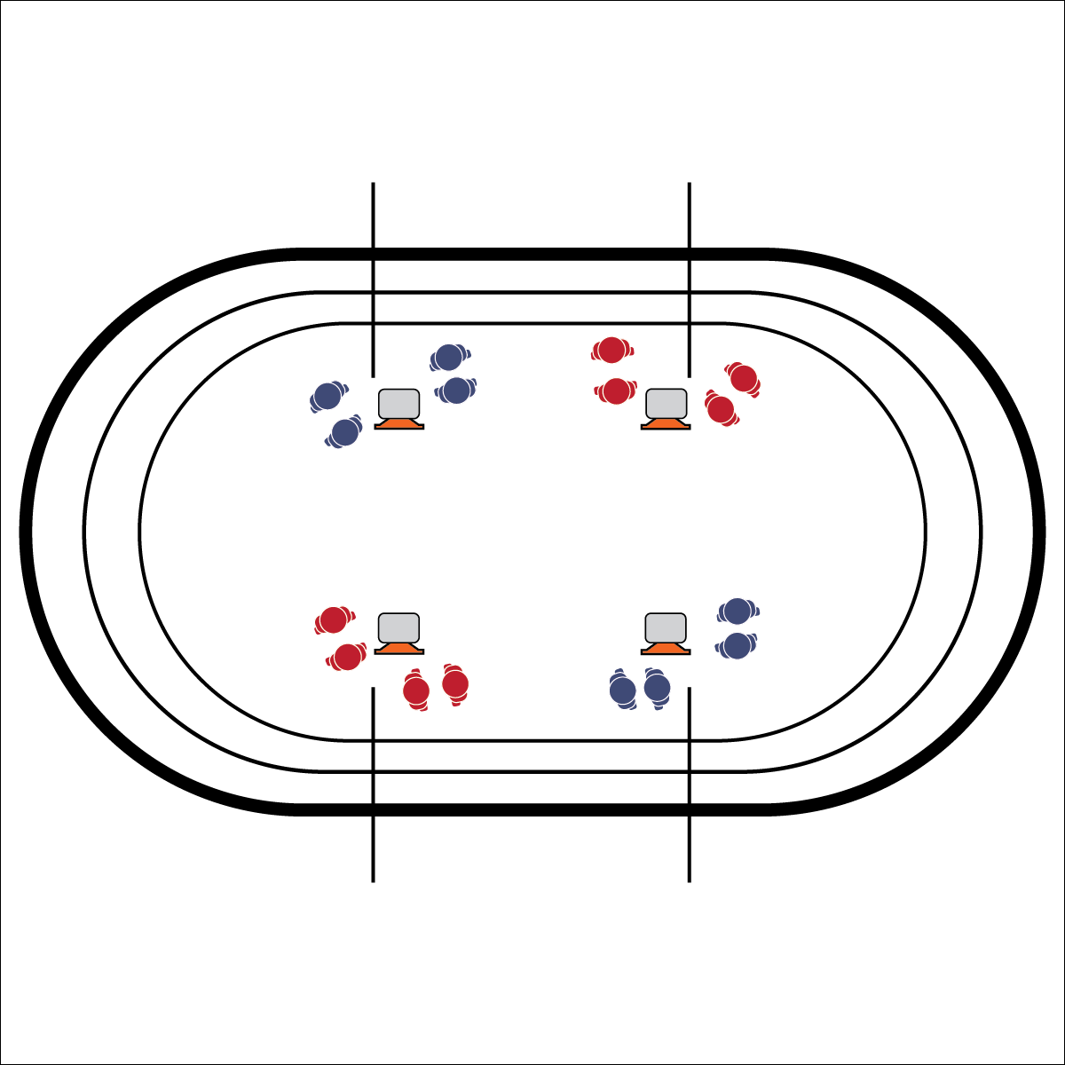

* Focus on Form
* Move Safely
* Have Fun

**AROUND THE WORLD RPS (WARM-UP)**

**Equipment:**

* 4 large cones
* 4 task tents
* 4 Dynamic Warm-Up Exercise Posters

**Set-Up:**

1. Using 4 large cones, create a medium square activity area on the infield of the track.
2. Place task tents on the cones with exercise posters displayed.
3. Divide the students into 4 even groups. Each group at a cone.

**Activity Procedures:**

1. Today we will play Around the World RPS as our dynamic warm-up.
2. The object of Around the World RPS is to move “around the world” from cone to cone as many times as possible during our 5-minute warm-up.
3. On the start signal, find any partner at your cone. Play a game of RPS. The winner of the game will perform the warm-up exercise on the card as they move to the next cone. The player who didn’t won will stay, find a new partner, and then play again.
4. Continue until you hear the stop signal.

**Standards & Outcomes:**

**Standard 3 [H9.L1]:** Identifies types of strength exercises (isometric, concentric, eccentric) and stretching exercises (static, PNF, dynamic) for personal fitness development (e.g., strength, endurance, range of motion) (L1).

* **Skill:** I will demonstrate proper exercise form, focusing on warming up my muscles.
* **Cognitive:** I will discuss why it’s important to warm up my muscles before participating in vigorous physical activity.
* **Fitness:** I will remain actively engaged.
* **Personal & Social Responsibility:** I will follow the protocols and etiquette of physical education class.