­­

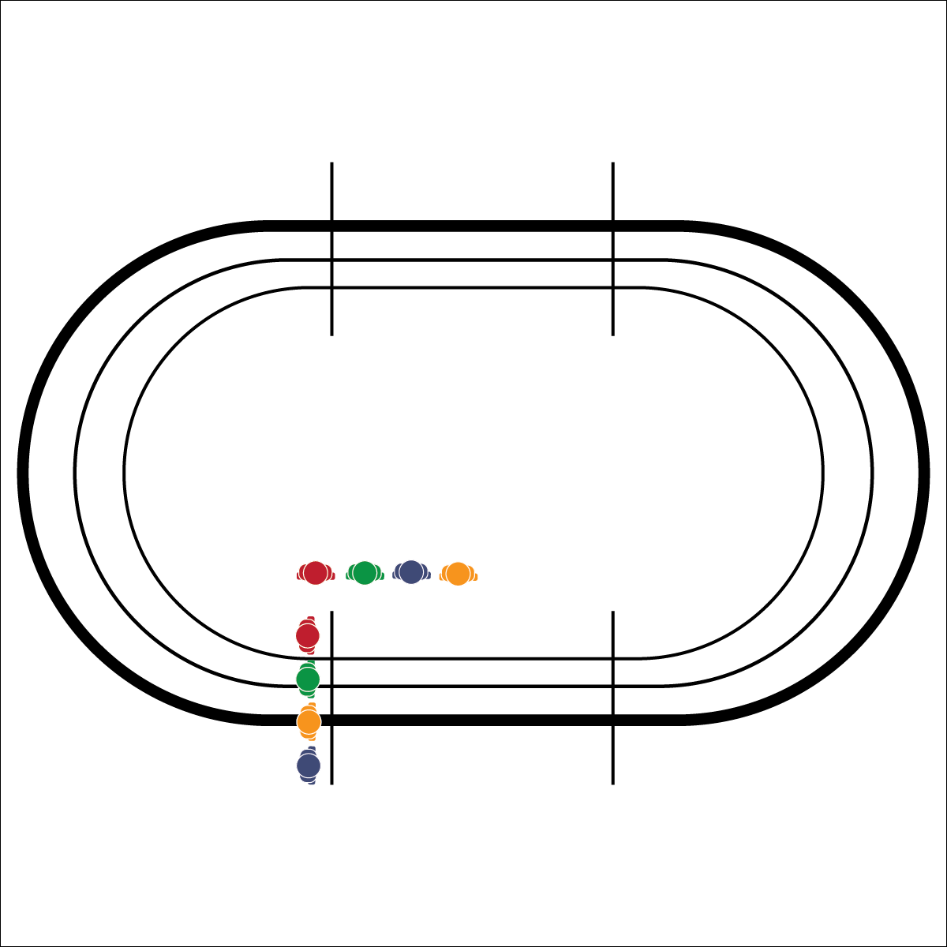

**Equipment:**

* 1 stopwatch
* 1 Prediction Run Improvement Plan (in portfolio) per student
* Pens/Pencils

**Set-Up:**

1. Pair students, each pair with a pencil and 2 Prediction Run Improvement Plans.
2. Send 1 student to the starting line, ready to run. The other student should have a pencil and Prediction Run Improvement Plan at the finish.

**Watch These NYRR Videos:**

* [Time Trials](https://www.nyrr.org/youth-and-schools/running-start/coaching-videos/high-school/pacing/time-trials)
* [Pacing Video Series](https://www.nyrr.org/youth-and-schools/running-start/coaching-videos/high-school/pacing)

**1600 METER PREDICTION RUN**

* **Skill:** I will adjust my pacing based on cues and feedback from my body.
* **Cognitive:** I will create a plan to improve my 1-mile run time.
* **Fitness:** I will discuss perceived exertion and how it relates to my run performance.
* **Personal & Social Responsibility:** I will focus on my goals and embrace the challenge of improving my run time.
* Set a Challenging Pace
* Focus on Form and Breathing
* Give Your Best Effort

**Activity Procedures:**

1. Today we’ll complete a 1600 Meter Prediction Run. We’ll complete this run again in 2 weeks and work toward the goal of improving today’s time.
2. The object of the activity is to accurately predict and then record how fast you run 1600M. Setting a challenging but realistic pace to complete the full 1600M run will be critical to your success.
3. Write your name and prediction on your Prediction Run Improvement Plan. Your partner will listen for and record your time when you cross the finish line. Then you’ll switch roles with your partner and record her/his time. When both pairs are finished, the class will take time to discuss and then set goals and create plans for improvement. We will complete this run again in a few weeks to see if you can beat the personal best time that you establish today.

**Grade Level Progression:**

**L1:** Complete the activity as described above.

**L2:** Allow students to choose their level of challenge: 400M, 1600M, or 3K.

**1600 METER PREDICTION RUN**



**Help students process content.** By providing students with the time and guidance needed to complete an improvement plan, you’re setting the expectation that students will work with and elaborate on fitness running content that is relevant to their own experiences and applicable to their own health. Be sure you schedule enough time for students to think about their work, ask questions, and revise their thinking.



Challenge, Desire, Fitness Portfolio, 5K Race, Pace, Perceived Exertion

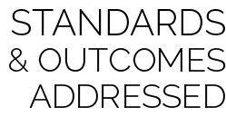

* **Standard** **3 [H3.L2]** Applies rates of perceived exertion and pacing (L2).
* **Standard 3 [H6.L1-2]** Creates a plan, trains for, and participates in a community event with a focus on physical activity (e.g., 5K, triathlon, tournament, dance performance, cycling event) (L2).
* **Standard 3 [H11.L2]** Develops and maintains a fitness portfolio (e.g., assessment scores, goals for improvement, plan of activities for improvement, log of activities being done to reach goals, timeline for improvement) (L2).
* **Standard 5 [H2.L2]** Chooses an appropriate level of challenge to experience success and desire to participate in a self-selected physical activity (L2).



* **DOK** **1:** What is perceived exertion?
* **DOK 2:** How did perceived exertion affect your pace?
* **DOK 3:** How is perceived exertion related to your improvement plan and goal?
* **DOK 4:** Identify areas of opportunity and design a plan for personal improvement.



* Shorten the distance of the run.
* Students run the event as a relay with 2–4 teammates working together.